

**0113 258 1150**

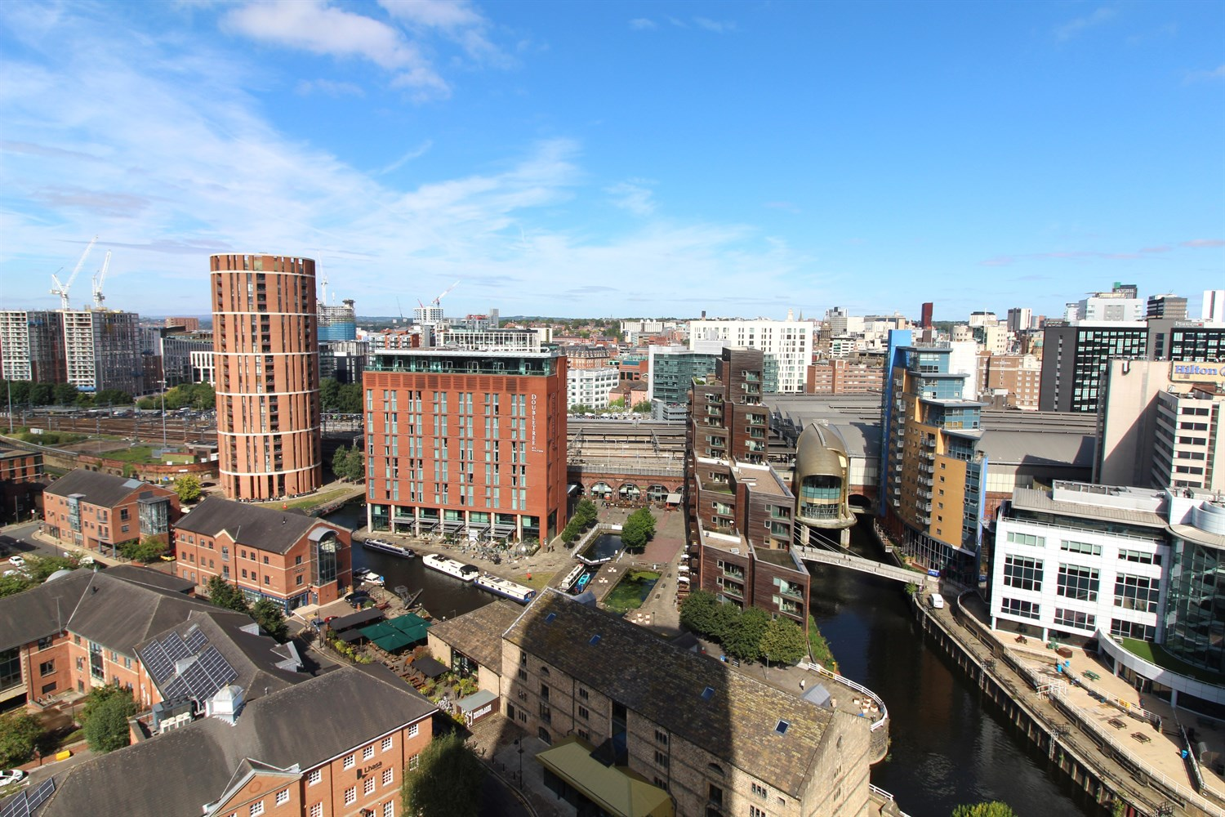



**For Sale £214,000.00**

**Bridgewater Place, Leeds**

**SPACIOUS TWO BEDROOM, TWO BATHROOM APARTMENT with PANORAMIC VIEWS - 14th FLOOR** Offered to the market with no onward chain is this spacious apartment, situated in Bridgewater Place. The apartment briefly comprises; Communal entrance, private hallway, open plan living room/kitchen with great views, master bedroom with en-suite shower room, second double bedroom with access to Jack and Jill Bathroom. This development benefits from having on-site concierge and on-site retail for your convenience.

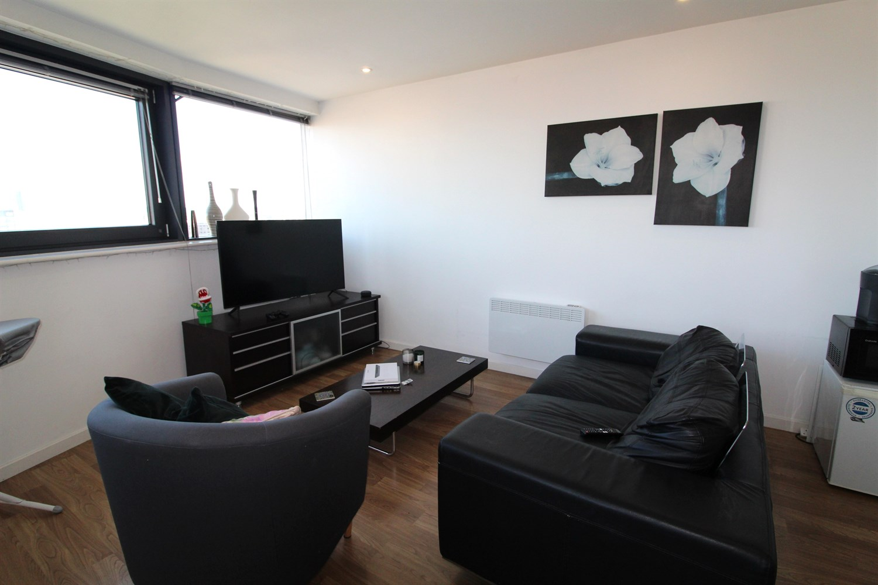

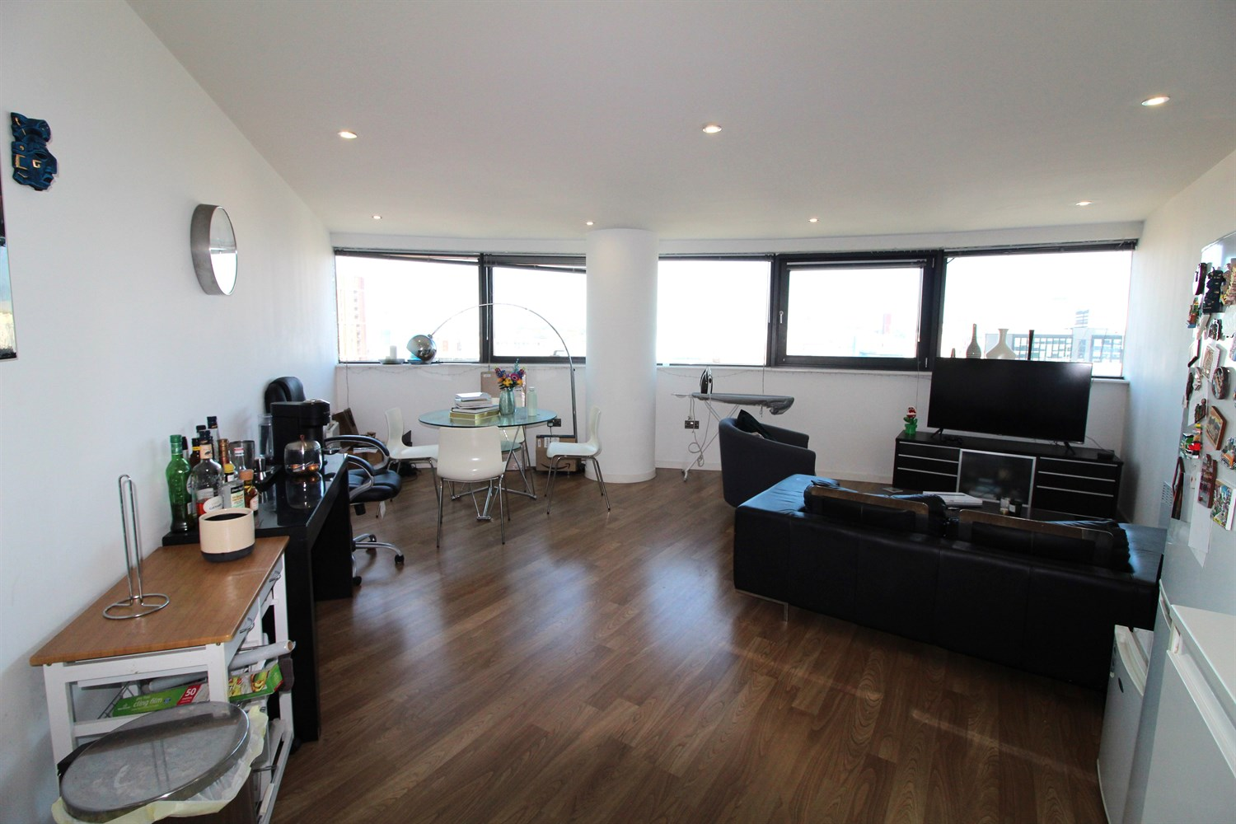

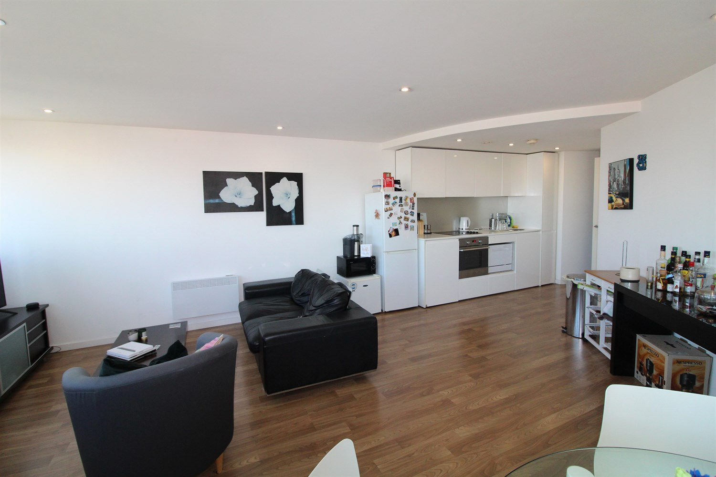

2 Bathroom(s)

1 Reception(s)

2 Bedroom(s)

00

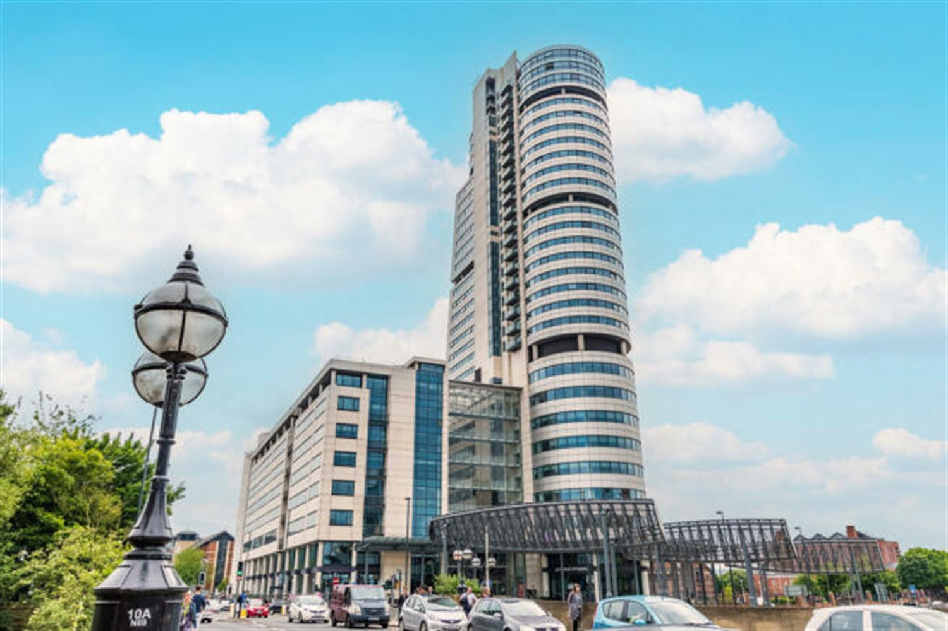

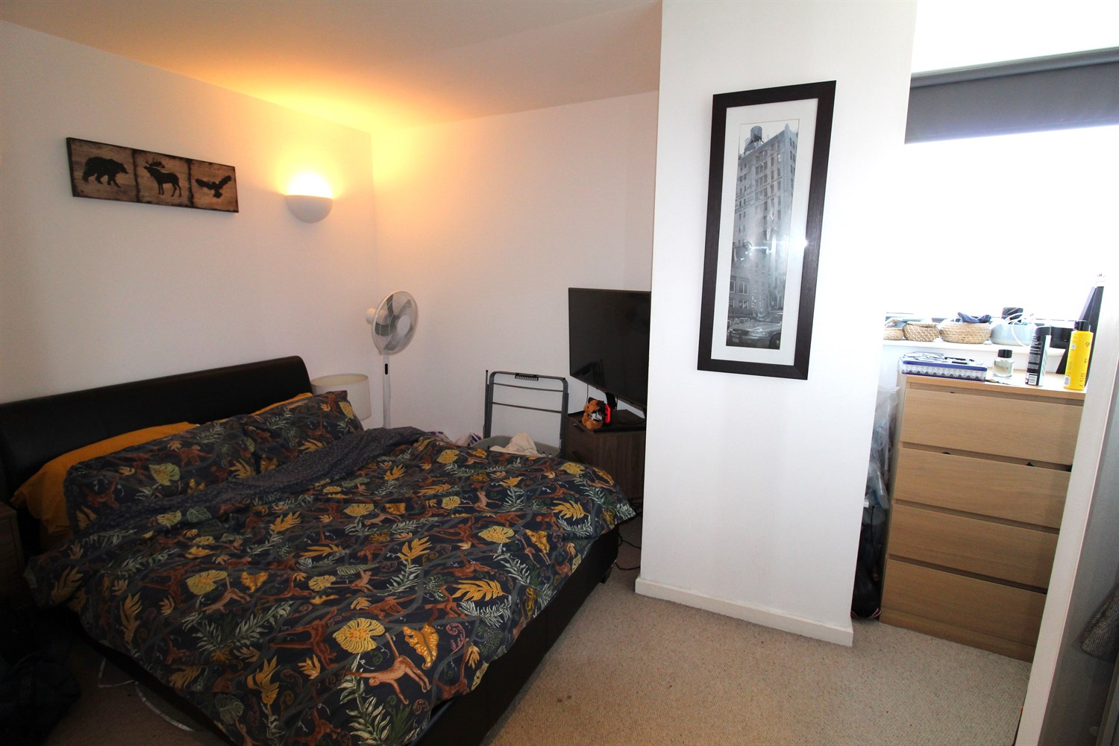

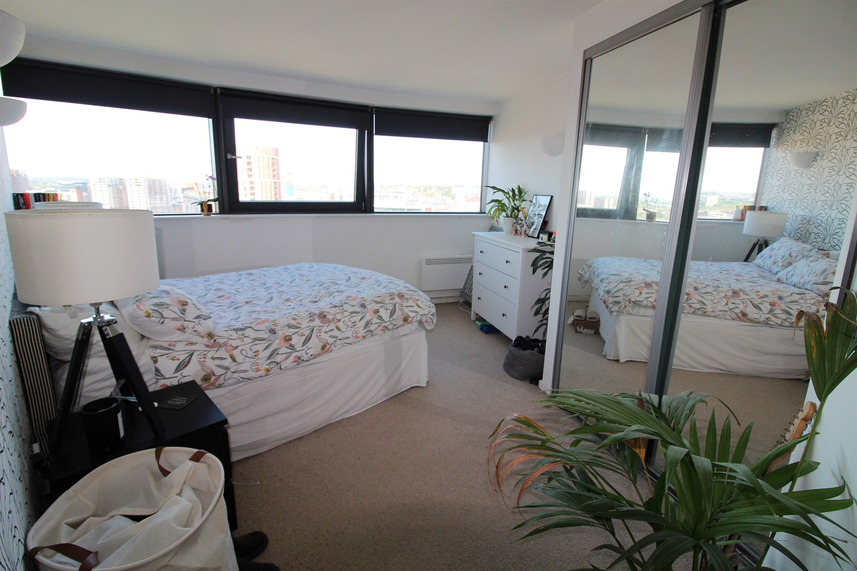

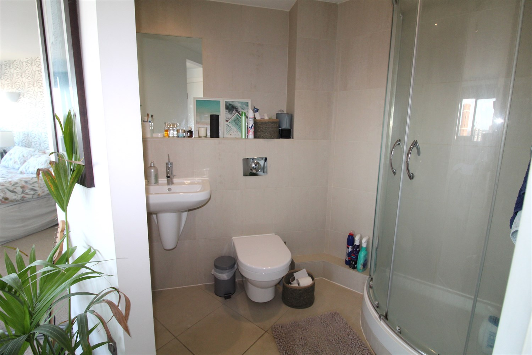

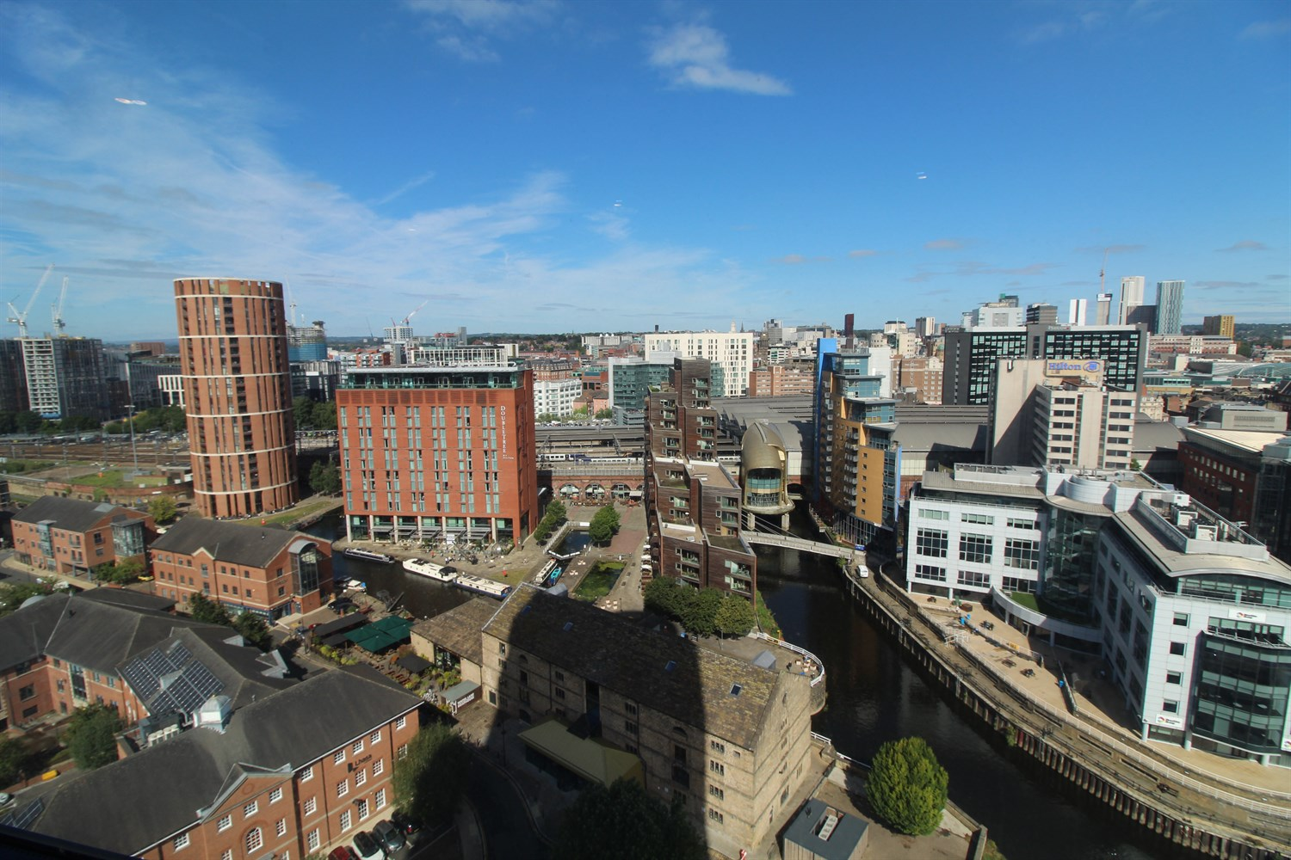

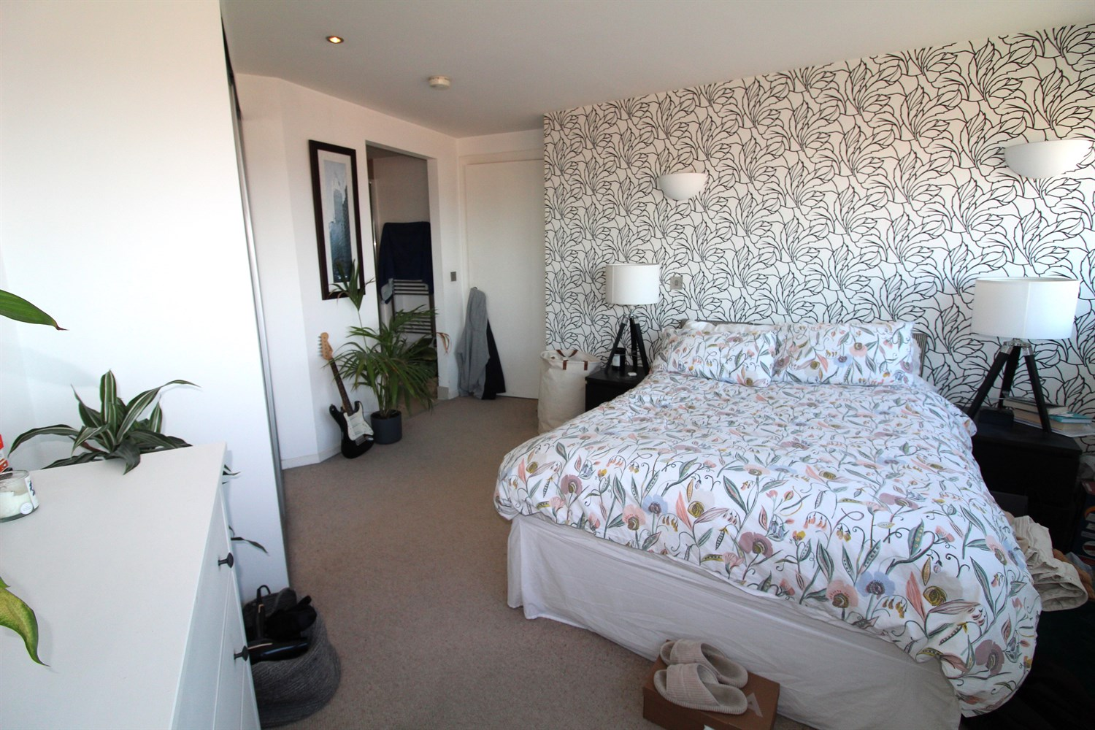

|  |
| --- |
| **Communal Entrance**  Stairs and lift to all floors. |
| **Hallway**  Via front entrance door. Secure entry phone system. Wall mounted electric radiator. Store cupboard plumbed for washing machine. Additional storage cupboard. |
| **Open Plan Living Room/Dining Room/Kitchen 2.5m (8'2) x 7.8m (25'7)**  Light and airy living area with double glazed windows offering panoramic views over the city below and beyond, to the north / west. Inset ceiling spotlights. Two wall mounted electric radiators. |
| **Kitchen**  Opening up from the living area. Fitted with a range of white gloss wall, base and drawer units with worktops over. Integrated oven with hob and extractor hood over. Integrated fridge and slim line dishwasher. |
| **Bedroom 1 3.8m (12'6) x 4.37m (14'4)**  Double bedroom with double glazed windows offering panoramic views over the city. Built in wardrobes. Wall mounted electric radiator. |
| **En-Suite Shower Room**  Fitted with a three piece suite comprising; shower cubicle, WC and wash hand basin. Tiled walls and tiled floor. Wall mounted heated towel rail. |
| **Bedroom 2 2.76m (9'1) x 2.32m (7'7)**  Second double bedroom with double glazed window. Built in wardrobes. Access to Jack and Jill Bathroom. |
| **Bathroom**  Fitted with a four piece bathroom suite comprising; shower cubicle, bath, WC and wash hand basin. Tiled walls and floor. |
| **Parking**  Allocated Parking |
| **Tenure**  The ground rent for the year ended 31 December 2024 is £370.03. The lease ends on 22/01/2257. |
| **Service Charge**  The current service charge for the flat is £1,290.73 per quarter and for the parking space is £81.36 per quarter. |
| **Garage** |

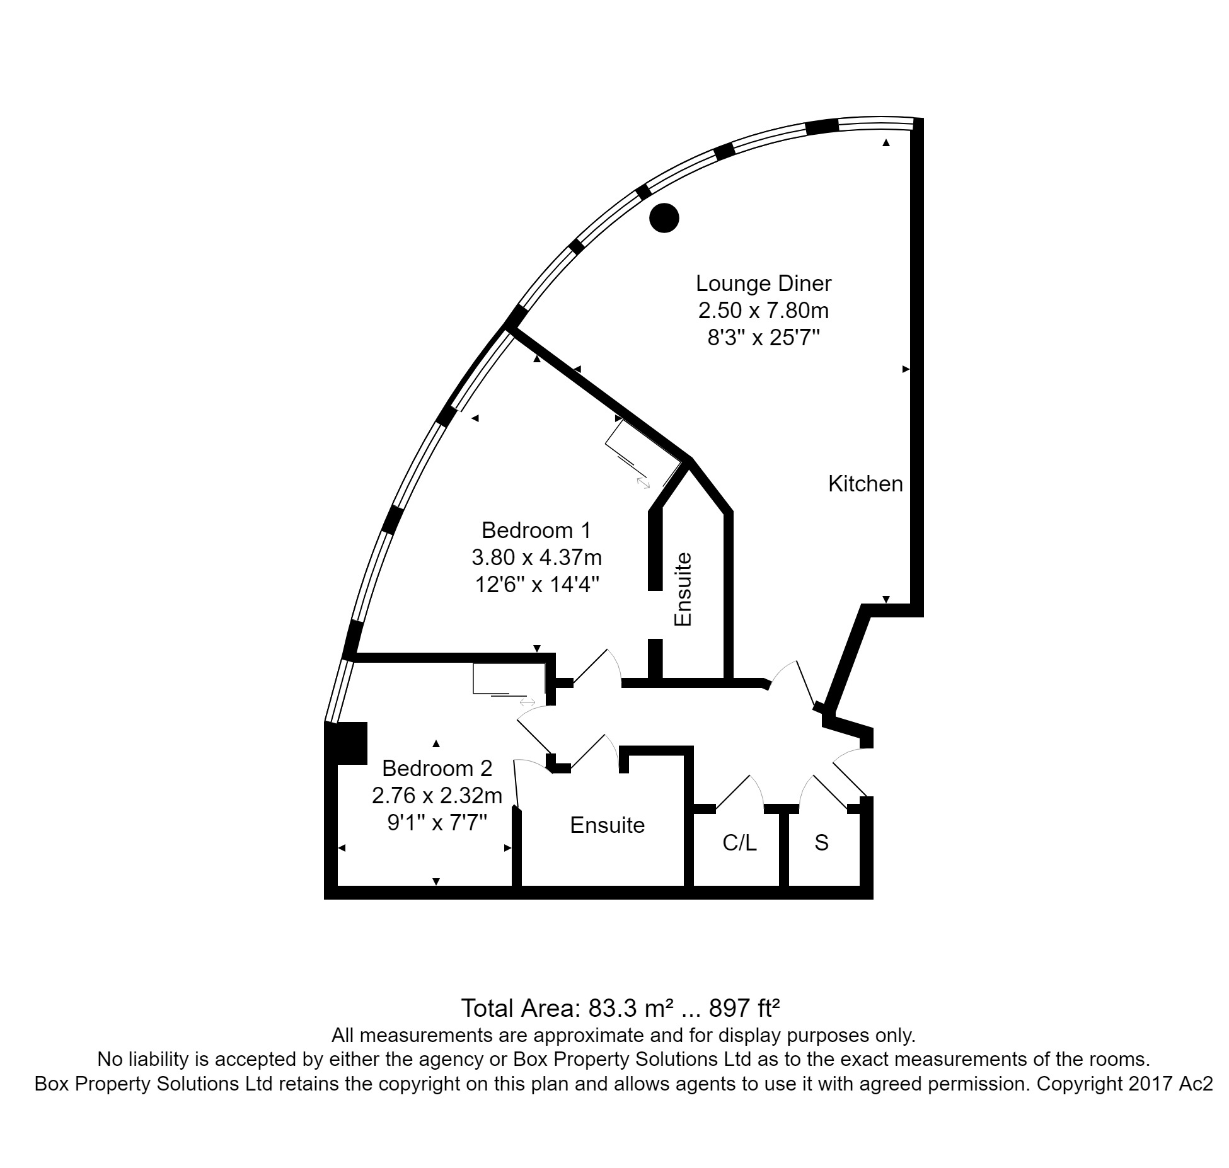

|  |  |
| --- | --- |
| These particulars are intended to give a fair description of the property, but their accuracy cannot be guaranteed, and they do not constitute an offer of contract. Intending purchasers must rely on their own inspection of the property. None of the above appliances/services have been tested by ourselves. We recommend purchasers arrange for a qualified person to check all appliances/services before legal commitment.  **Property Ref:** 3655  **For more information, please contact**  0113 258 1150 **|** [sales@adairpaxton.co.uk](mailto:sales@adairpaxton.co.uk) **|** www.adairpaxton.co.uk |  |