

10 Chaloner Grove, Wakefield
For Sale £315,000.00

**FOUR BEDROOM, TWO BATHROOM MID-TOWN HOUSE, SET OVER THREE FLOORS** Situated within Pinders Square in a popular residential development, this four-bedroom mid-town house offers spacious living accommodation over three floors. The property is within walking distance of Pinderfields hospital and is well placed for access to a range of amenities including local shops, schools, bus routes, two railway stations and easy access to the M1. The property briefly comprises; entrance hall, dining/sitting room, kitchen/diner and guest WC to the ground floor. To the first floor there is a spacious living area and a master bedroom with en-suite shower room. To the second floor there are two double bedrooms, a single bedroom and a house bathroom. Externally, the property benefits from having two parking spaces belonging to the property to the front and an enclosed garden to the rear. An internal viewing is highly recommended to appreciate the accommodation on offer.
0113 258 1150
0800 000 000
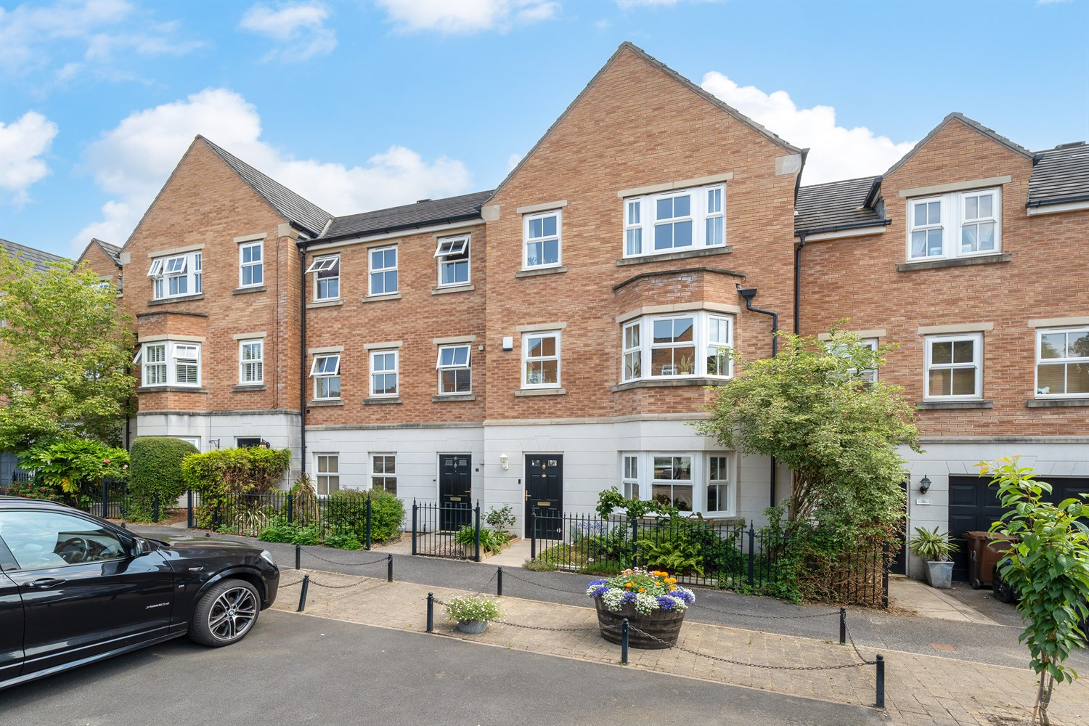
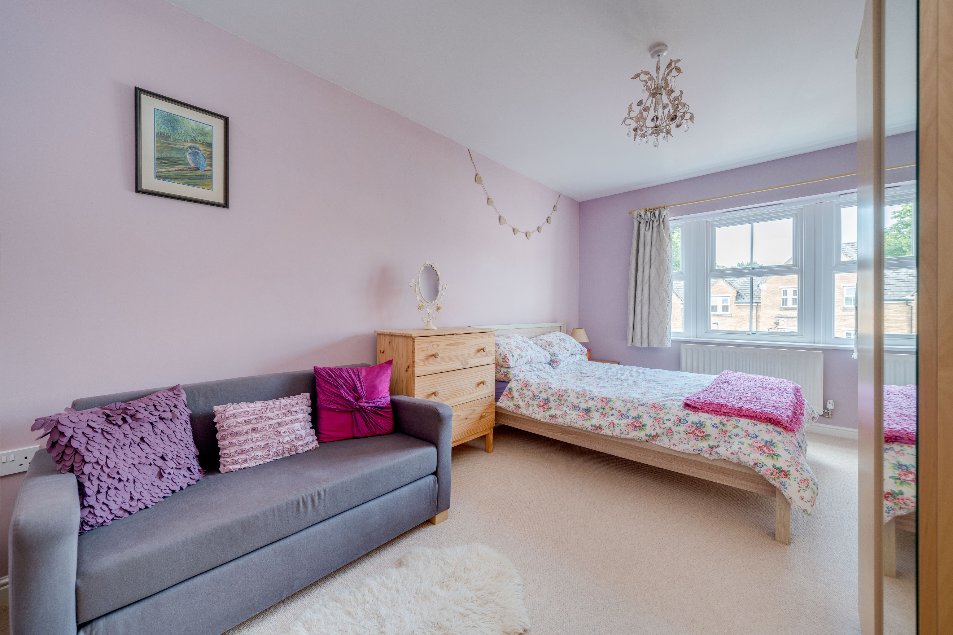
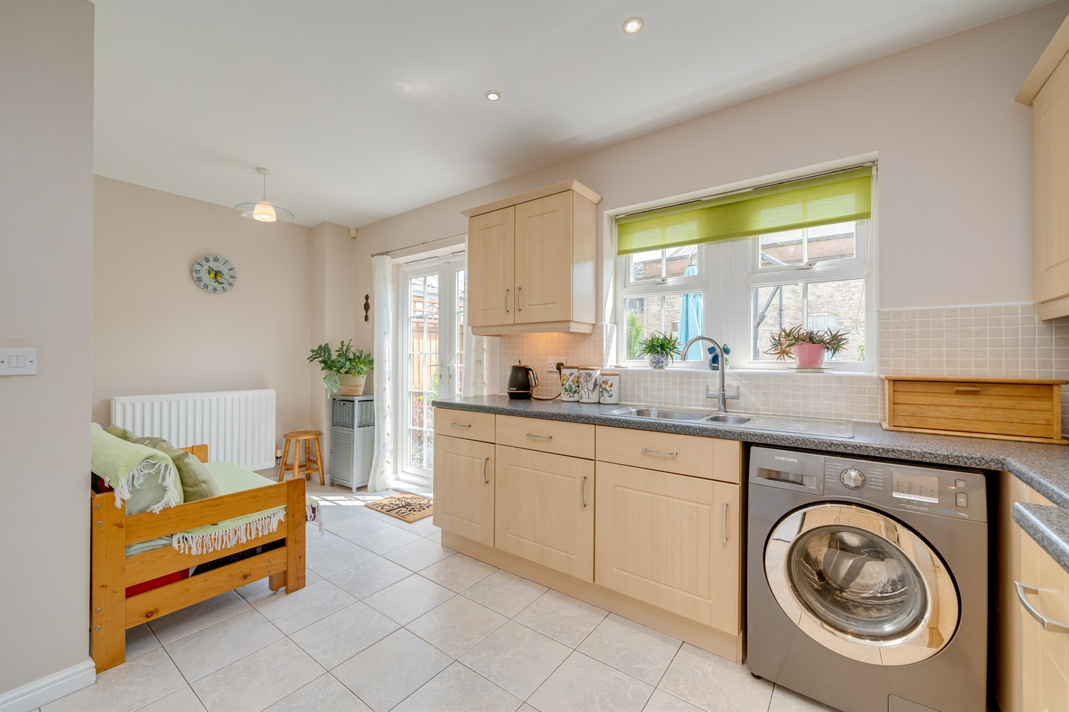
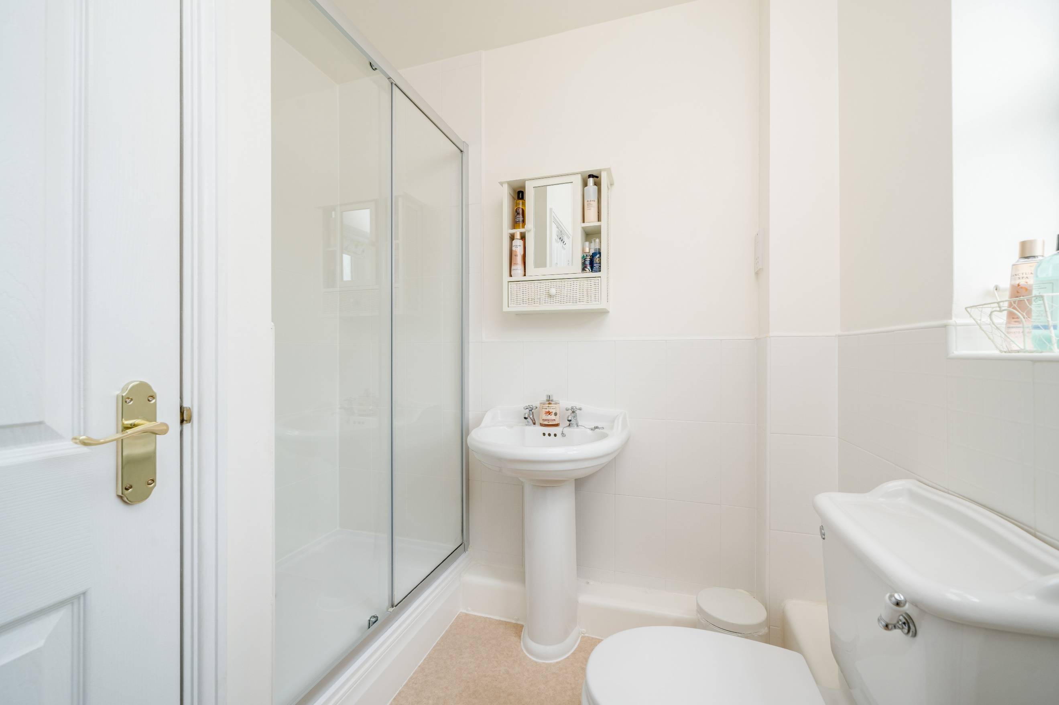
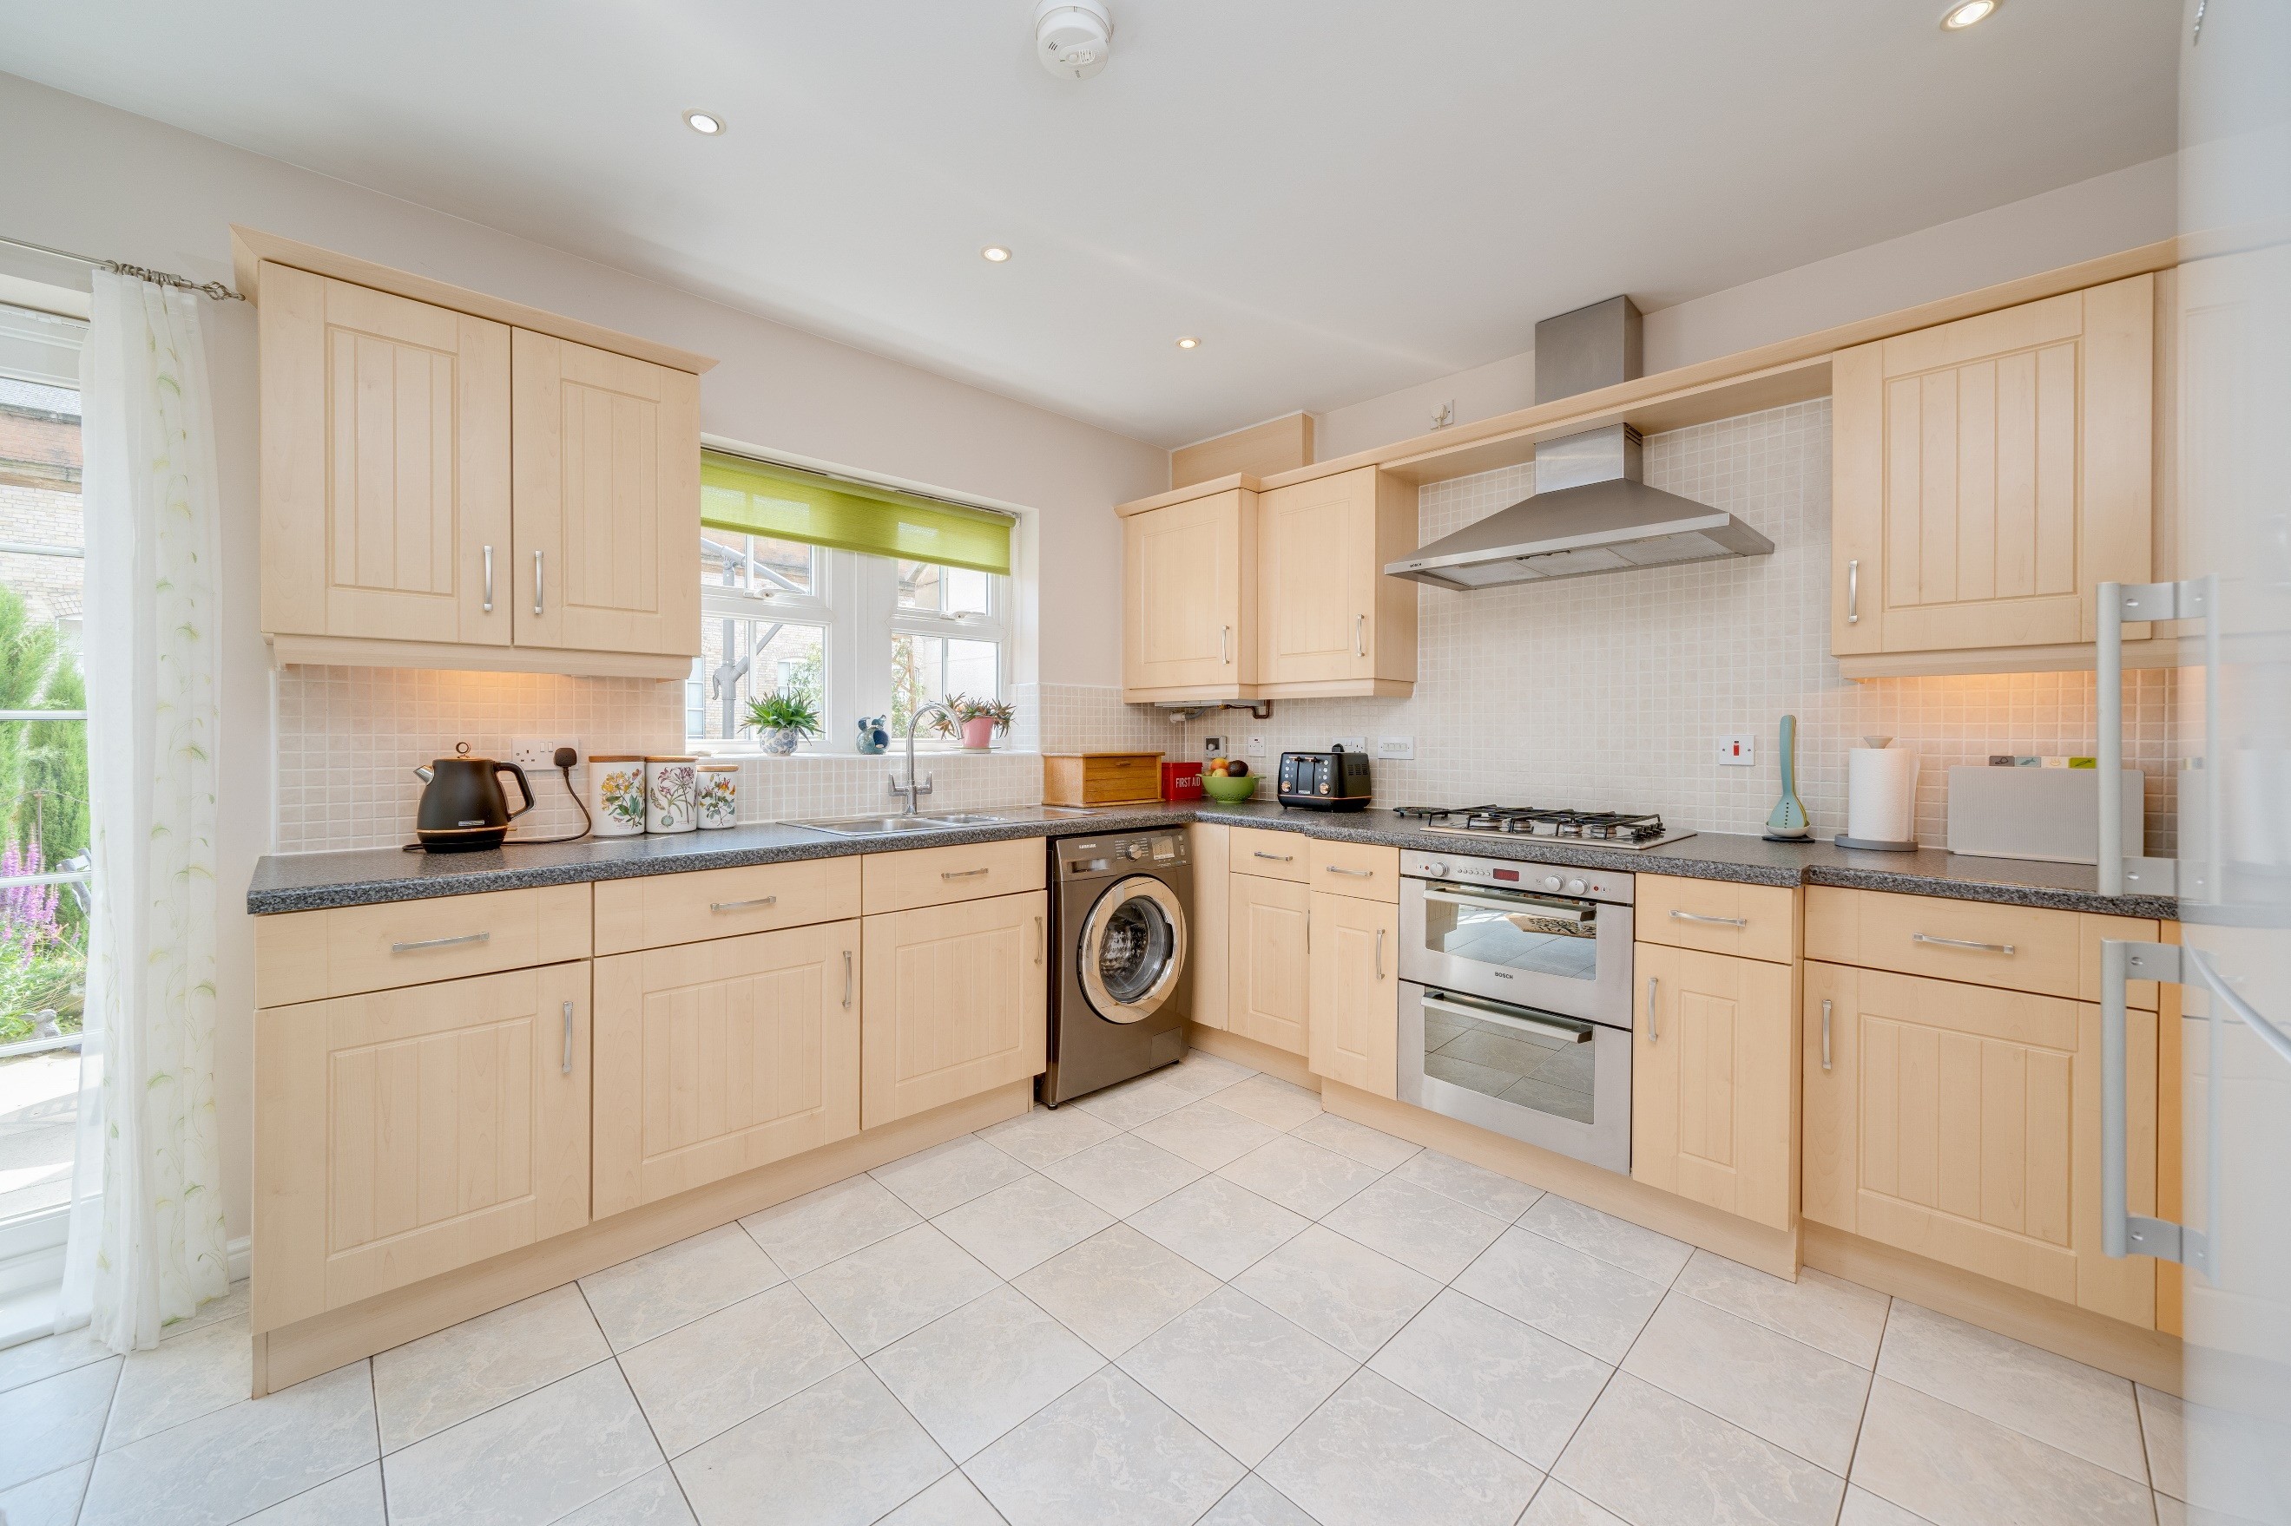
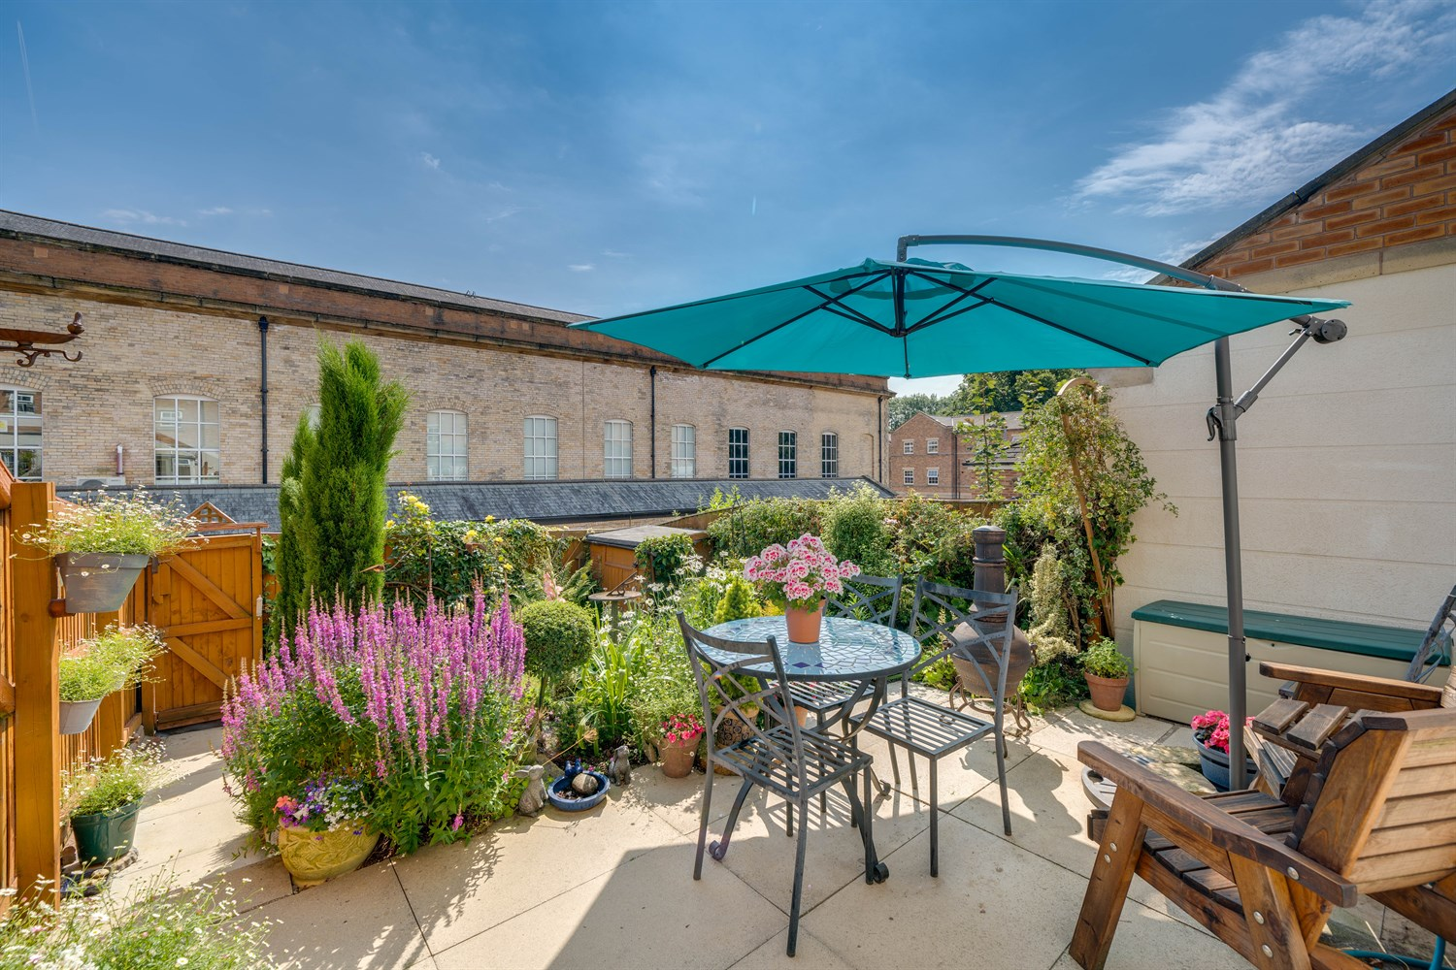
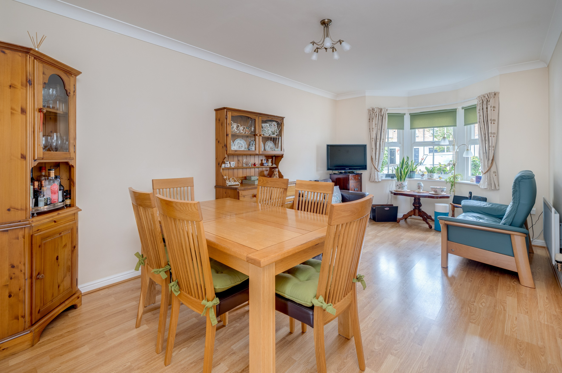
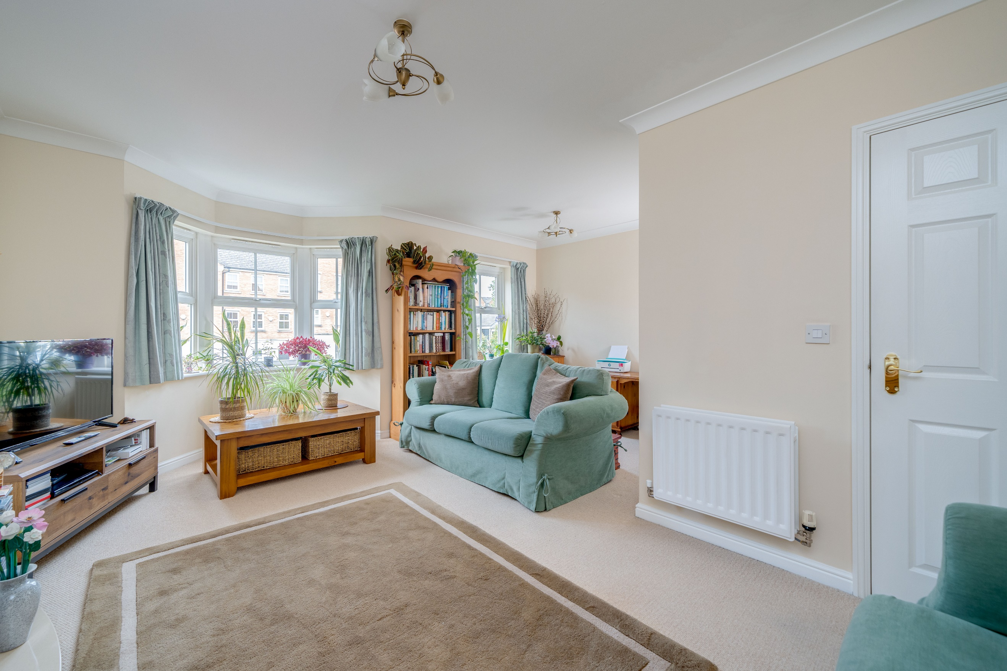
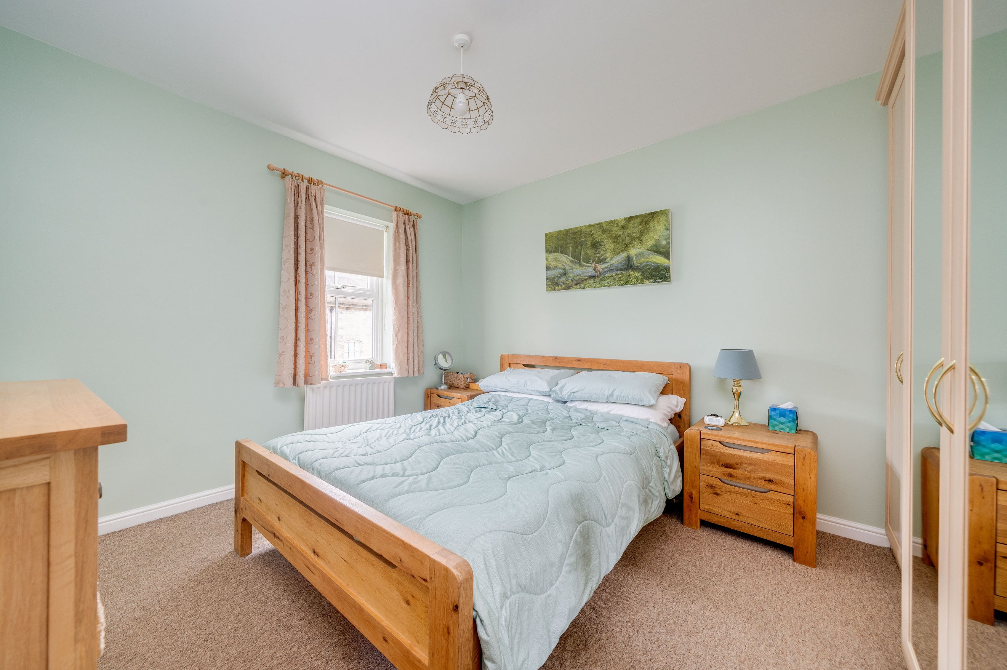

Entrance Hallway
Via front entrance door. Stairs to first floor.

Dining Room - 3.12m x 5.52m (max) (10'2" x 16'2")
Light and airy sitting room with uPVC double glazed bay window to front. Two gas central heating radiators. Laminate flooring throughout. Coving to ceiling.

Kitchen/Diner - 3.47m (max) x 5.14m (11’4” x 16’10”)
Fitted with wall, base and drawer units with worktops over. Space for washing machine and fridge/freezer. Integrated double oven with 4-ring gas hob and extractor hood over. 1.5 bowls stainless steel sink with mixer tap and drainer. Part tiled walls. uPVC double glazed window to rear. Inset ceiling spotlights. Opening up to the dining area with uPVC double glazed doors leading out to the rear garden. Gas central heating radiator.

Guest WC
Fitted with a two piece suite comprising; WC and wash hand basin. Gas central heating radiator. Part tiled walls. Access to under stairs storage cupboard.

First Floor
First Floor Landing

Living Room - 5.15m (max) x 4.70m (16’10” x 15’5”)
Spacious living area with uPVC double glazed bay window and second uPVC double glazed bay window to front. Two Gas central heating radiators. Electric fire inset to marble surround. Coving to the ceiling.

Bedroom 1 - 3.01m x 3.11m (9'10" x 10'2")
Double bedroom with uPVC double glazed window to rear. Gas central heating radiator. Built in wardrobes.

En-suite Shower Room
Fitted with a large walk in shower cubicle, WC and wash hand basin. Part tiled walls. uPVC double glazed window. Inset ceiling spotlights. Airing cupboard.

Second Floor
Second Floor Landing

Bedroom 2 - 2.85m x 4.85m (9’4” x 15’10”)
Great sized double bedroom with uPVC double glazed window to front. Gas central heating radiator. Access to boarded loft.

Bedroom 3 - 2.85m x 3.52m (9’4” x 11’6”)
Third double bedroom with uPVC double glazed window to rear. Gas central heating radiator.

Bedroom 4 - 3.82m (max) x 2.19m (12’6” x 7’2”)
Bedroom four with uPVC double glazed window to front. Built in storage cupboard over the bulkhead. Gas central heating radiator.

House Bathroom
Fitted with a three piece white suite comprising; bath with shower over, WC and wash hand basin. Part tiled walls. Gas central heating radiator. uPVC double glazed window.

Garden
To the front of the property are two off street parking spaces belonging to the property. There is a low maintenance garden with a path leading to the front door. To the rear, is an enclosed garden with a patio area ideal for entertaining, and a lawn with borders of plants and shrubs.

Gardening Charge for the Parklands Estate
There is a charge of £48.08 per quarter.

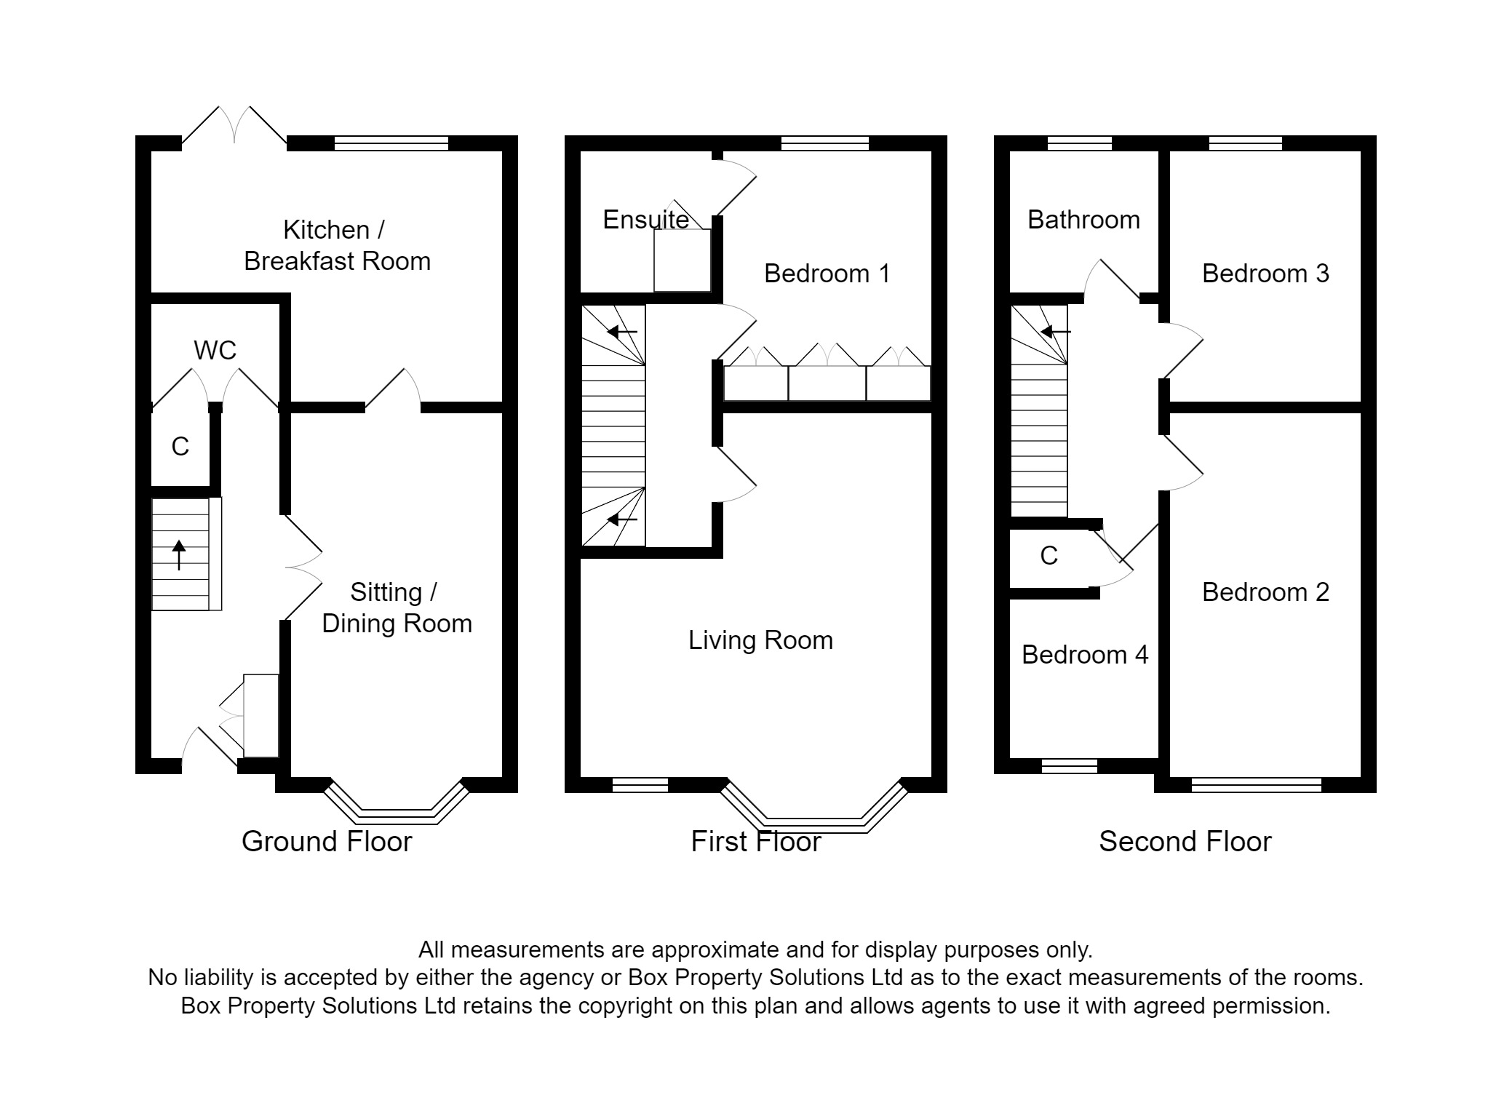

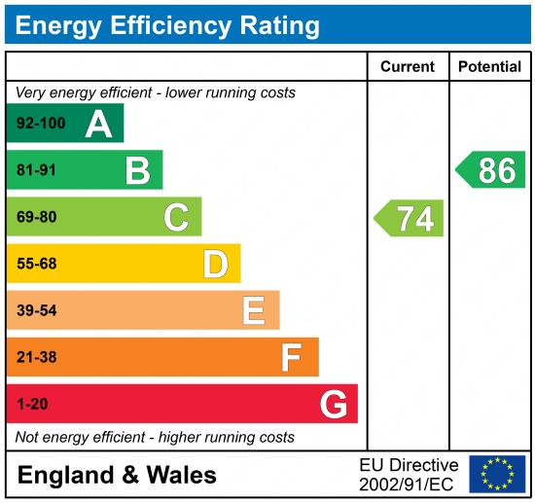

These particulars are intended to give a fair description of the property, but their accuracy cannot be guaranteed, and they do not constitute an offer of contract. Intending purchasers must rely on their own inspection of the property. None of the above appliances/services have been tested by ourselves. We recommend purchasers arrange for a qualified person to check all appliances/services before legal commitment.

Property Ref: 2830

For more information, please contact

0113 258 1150 | sales@adairpaxton.co.uk | www.adairpaxton.co.uk

