

Q54
Bridge Place, Horsforth
For Sale £249,950.00

**Beautifully Presented FULLY REFURBISHED two bedroom apartment with ALLOCATED PARKING** This upper floor apartment is READY TO MOVE INTO and must be viewed to be appreciated. Set in the desirable location, the apartment is ideally located for shops, bars and restaurants in Horsforth as well as it being located adjacent to Horsforth train station offering a 12 minute journey to Leeds and 20 minutes to Harrogate, plus useful transport links to both Leeds and Bradford. This apartment briefly comprises: Communal Entrance hall with lift and stair access, private entrance hall, contemporary lounge with dining area and open plan kitchen with access to a balcony, two good sized bedrooms, one with an en-suite and a house bathroom. Externally there is an allocated covered parking space. Offered for sale with NO ONWARD CHAIN, this property would suit many buyers from first time buyers to an investor or young family and as a quality down-sizer property in a superb location. Early internal inspection is highly recommended.
0113 258 1150
0800 000 000
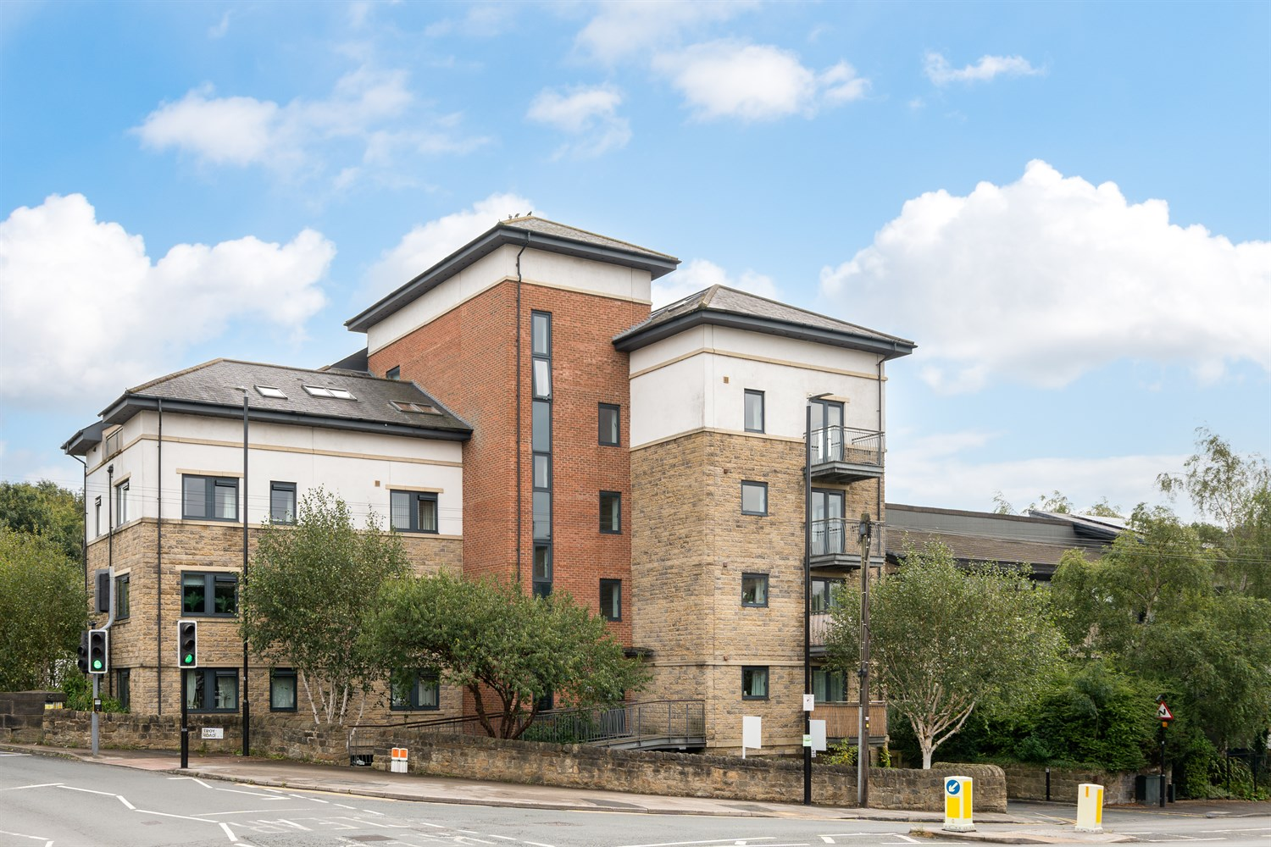
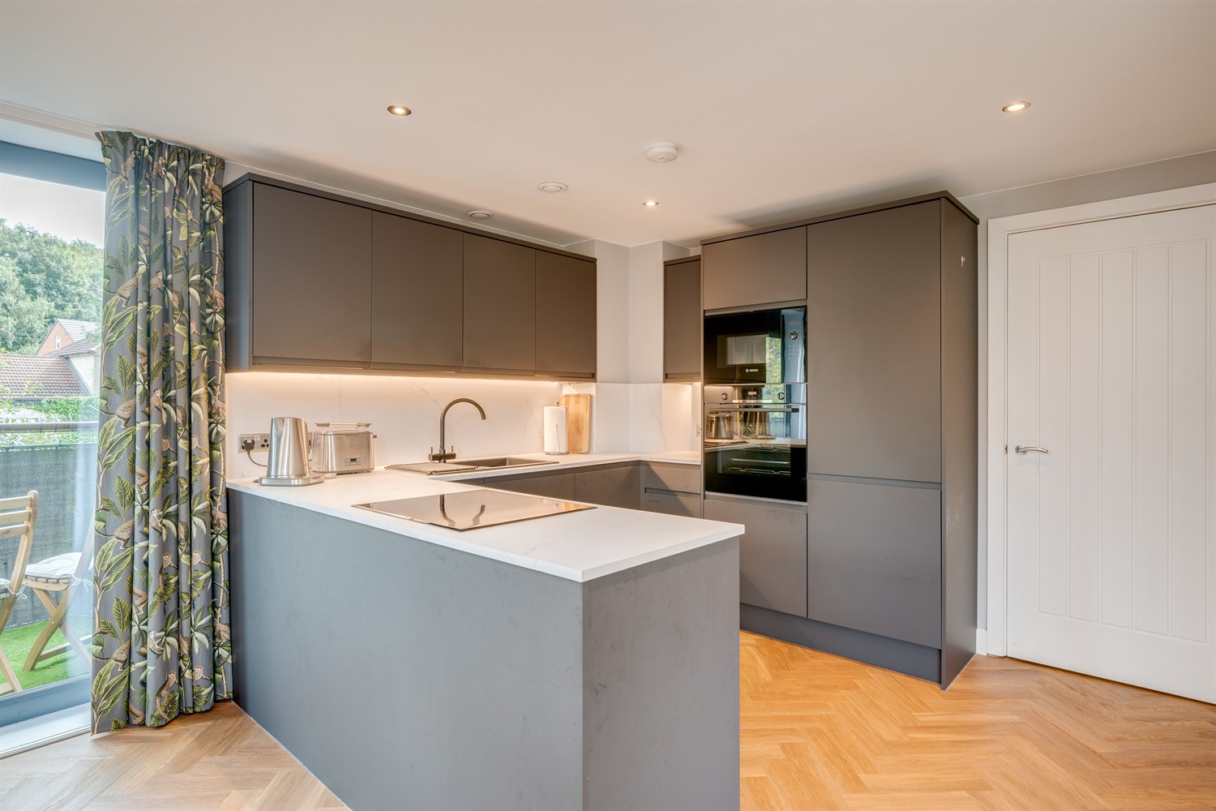
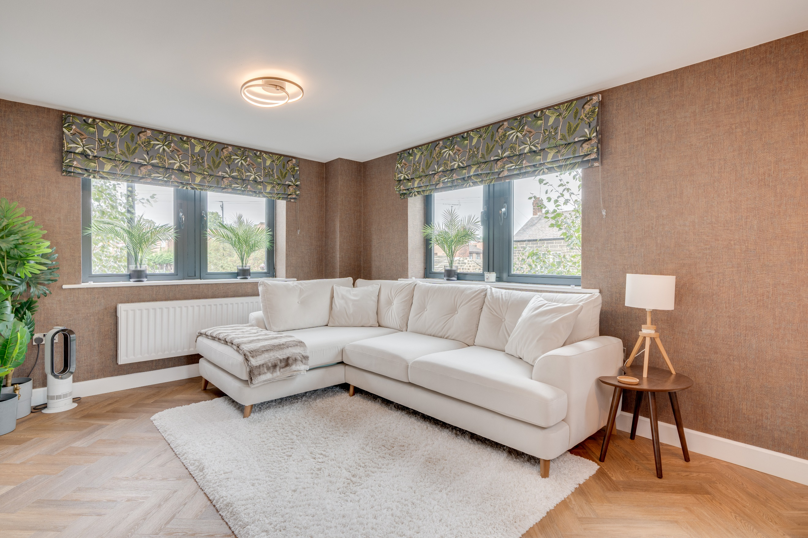
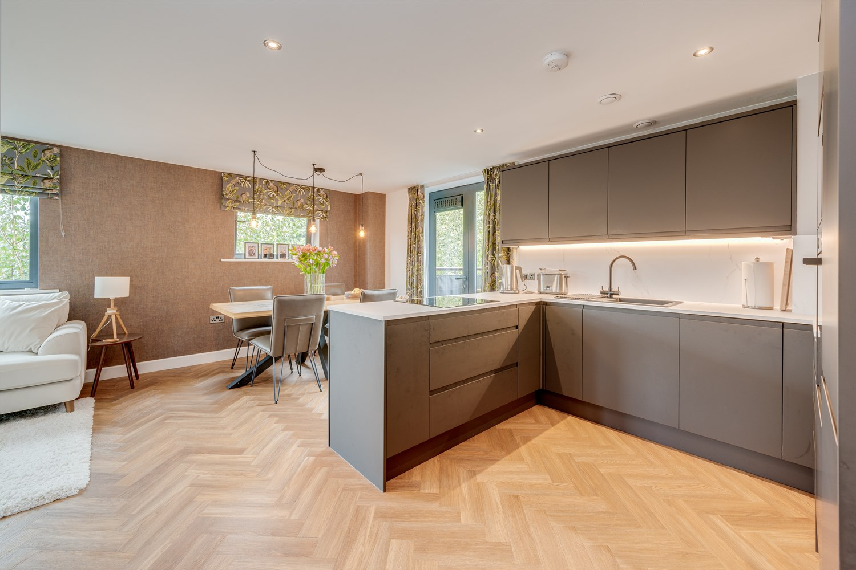
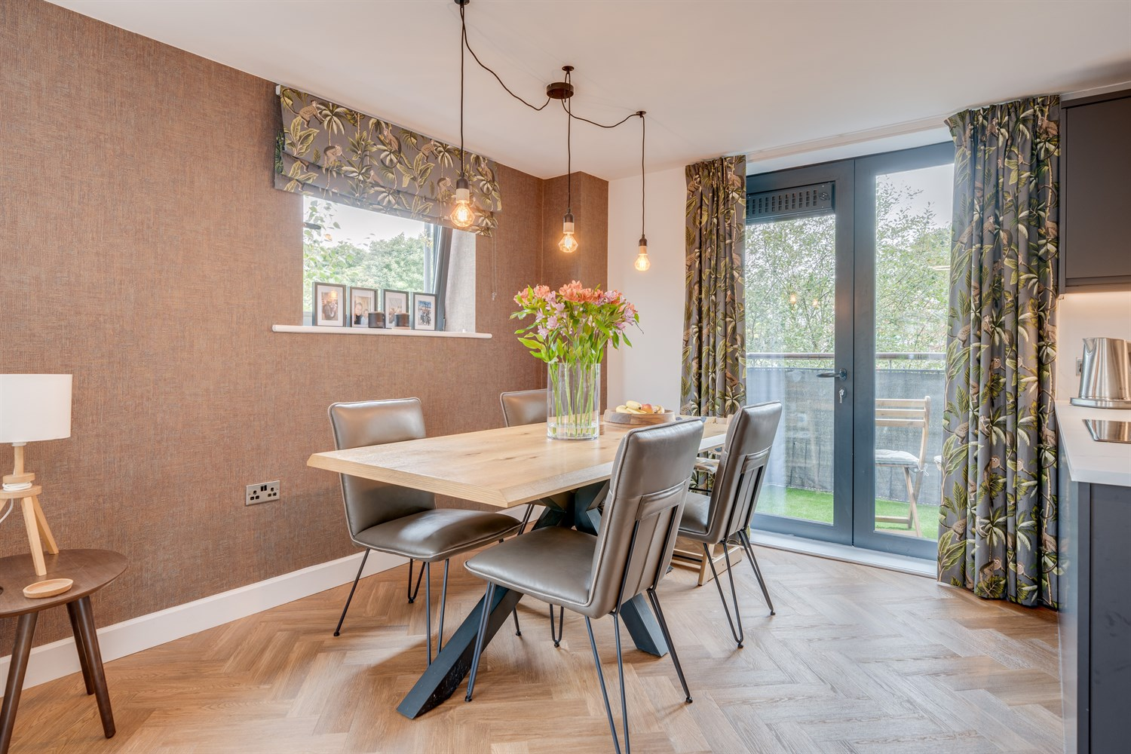
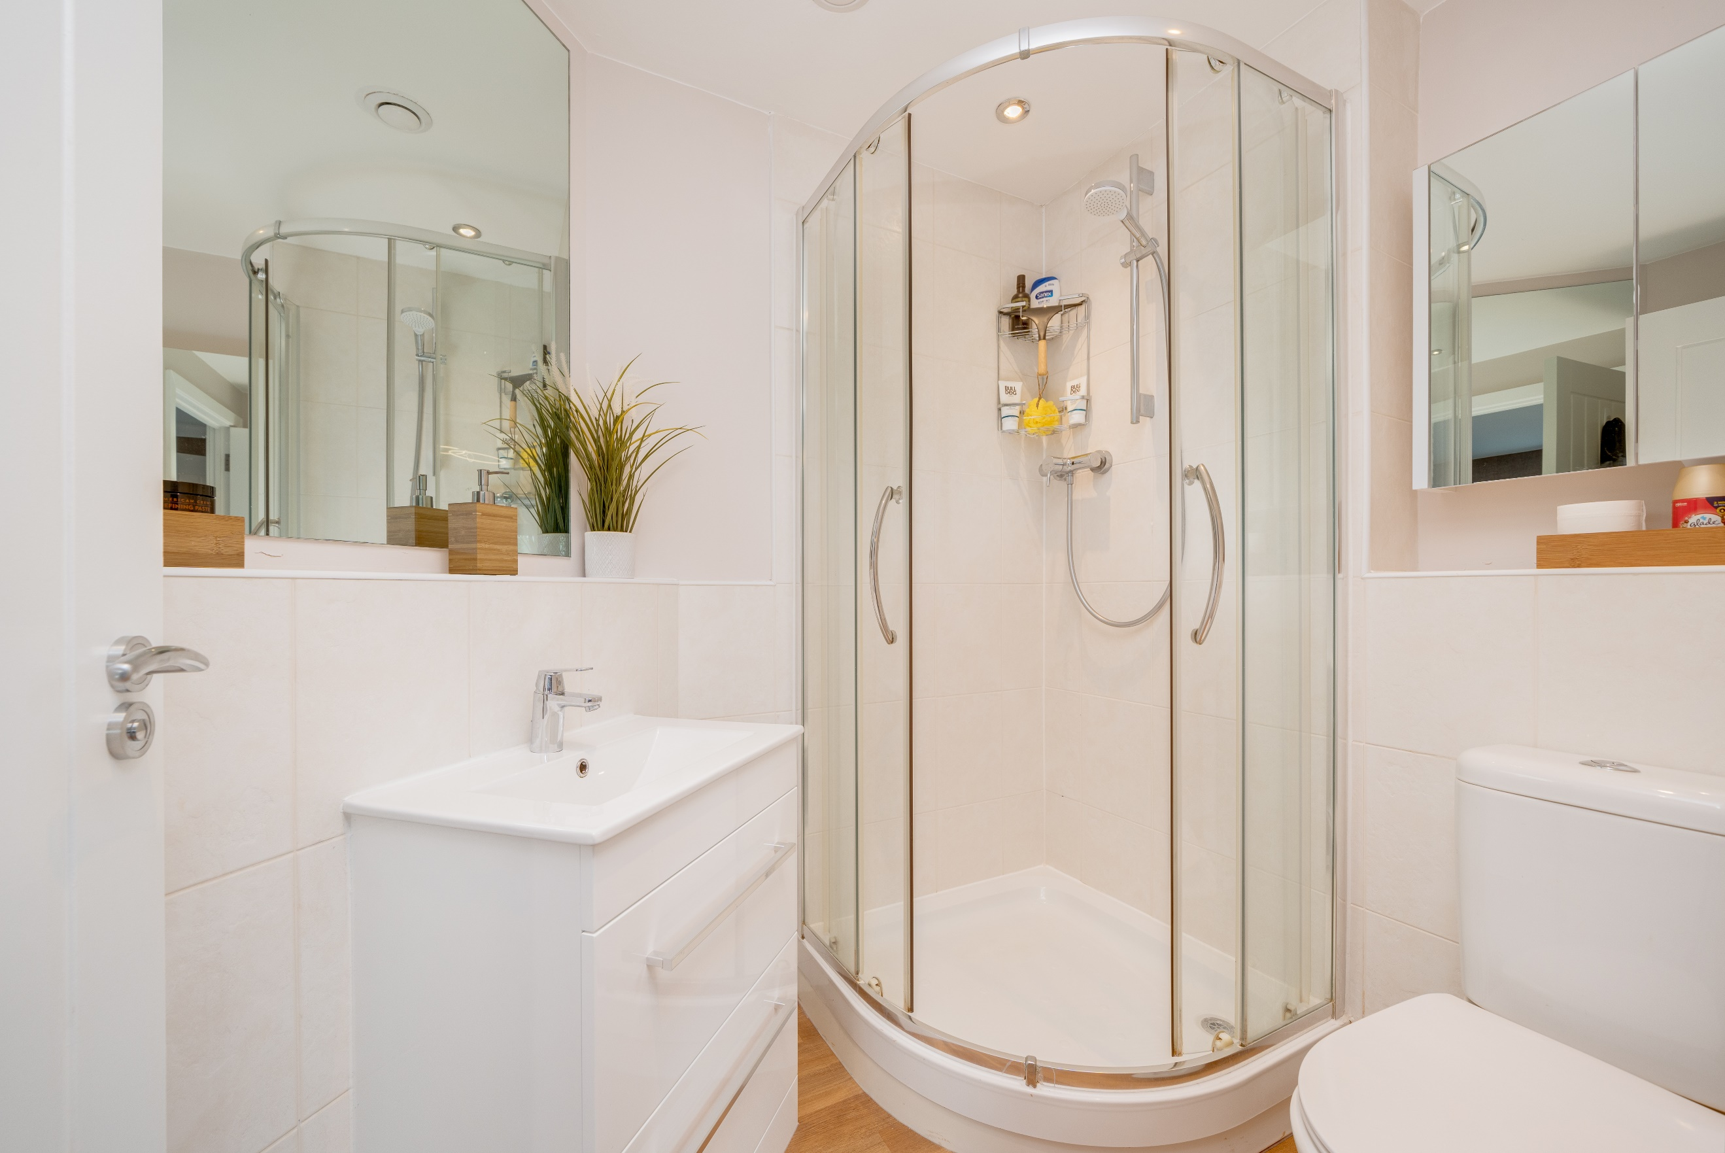
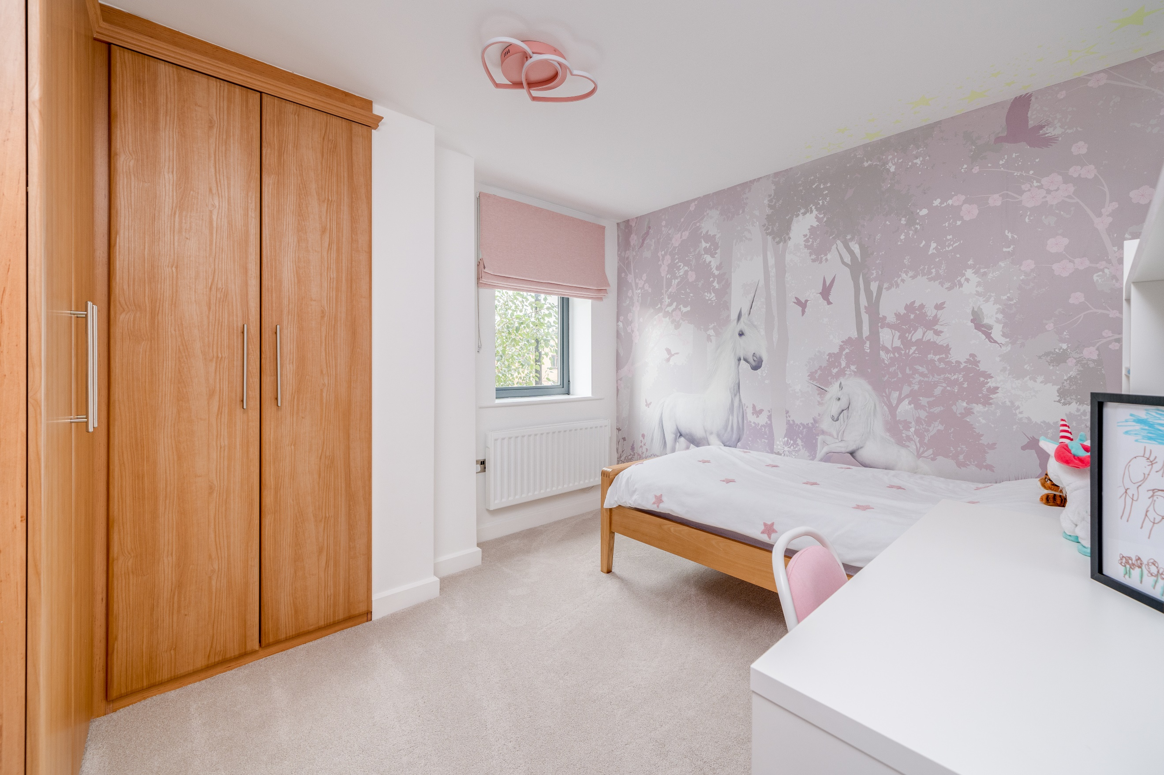
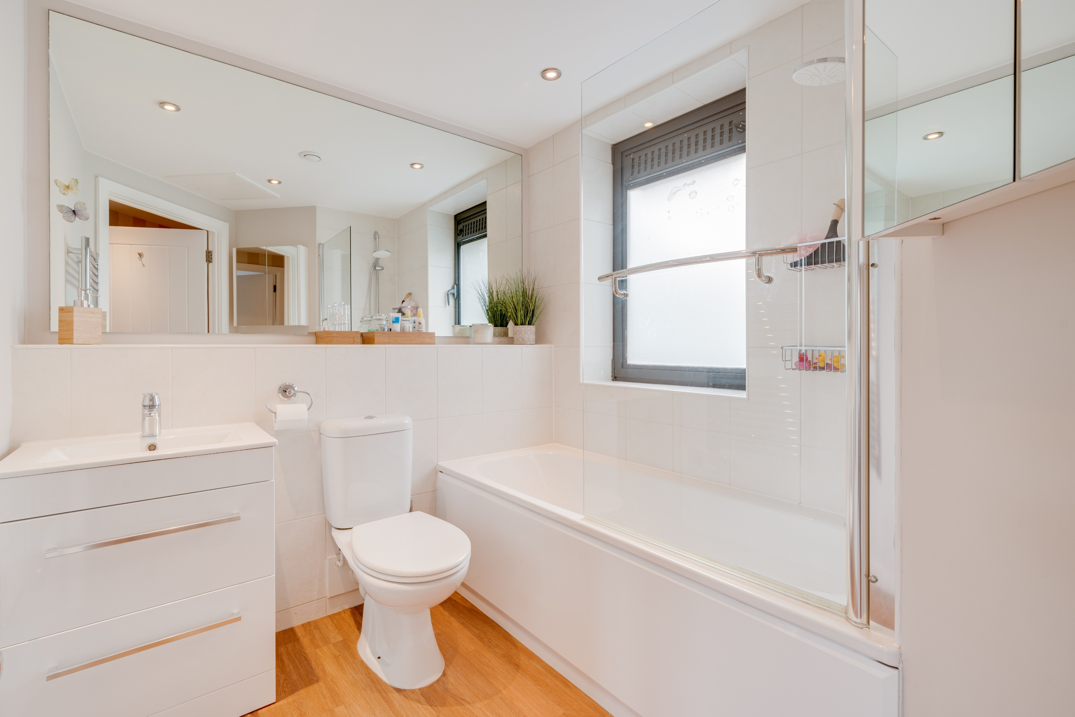
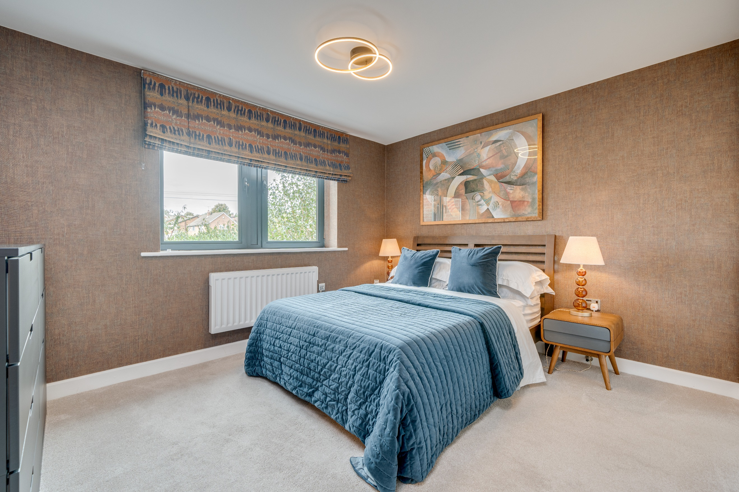

Communal entrance
Communal entrance with letter boxes, access to stairs and lift to all floors.

Hallway
Spacious hallway with large storage cupboard.

Open Plan Kitchen/Living room 3.2m (10'6) max x 6.45m (21'2)
A light and airy open plan living space with herringbone flooring throughout. Dining area with a door leading out onto the balcony with woodland and river views. Electric panel radiator that can be controlled with your phone and an updated secure entry phone system. The kitchen comprises a high spec range of wall, base and soft close drawer units with worktops over. Single drainer sink unit with mixer tap. Integrated oven with induction hob. Integrated microwave.

Bedroom 1 3.7m (12'2) x 3m (9'10)
Double bedroom with uPVC double glazed window to the front and a wall mounted electric radiator. The bedroom also leads into a dressing room with fitted wardrobes.

En-suite
A three piece white suite comprising a shower cubicle, WC and a wash hand basin with tiles walls.

Bedroom 2 3.46m (11'4) x 2.91m (9'7)
Second bedroom with uPVC double glazed window to the front, built in wardrobes and a wall mounted electric radiator.

Dressing Room 2.5m (8'2) x 2.09m (6'10)
Built in wardrobes.

Bathroom
A three piece white suite comprising bath with over head shower, WC and a wash hand basin with tiled walls.

Allocated Parking
Secure allocated parking.

Tenure
Leasehold – 105 years remaining.
Ground Rent of £250.00 is due 1 January each year.

Service Charge
The service charge is £1,441 per annum or £360.25 per quarter.

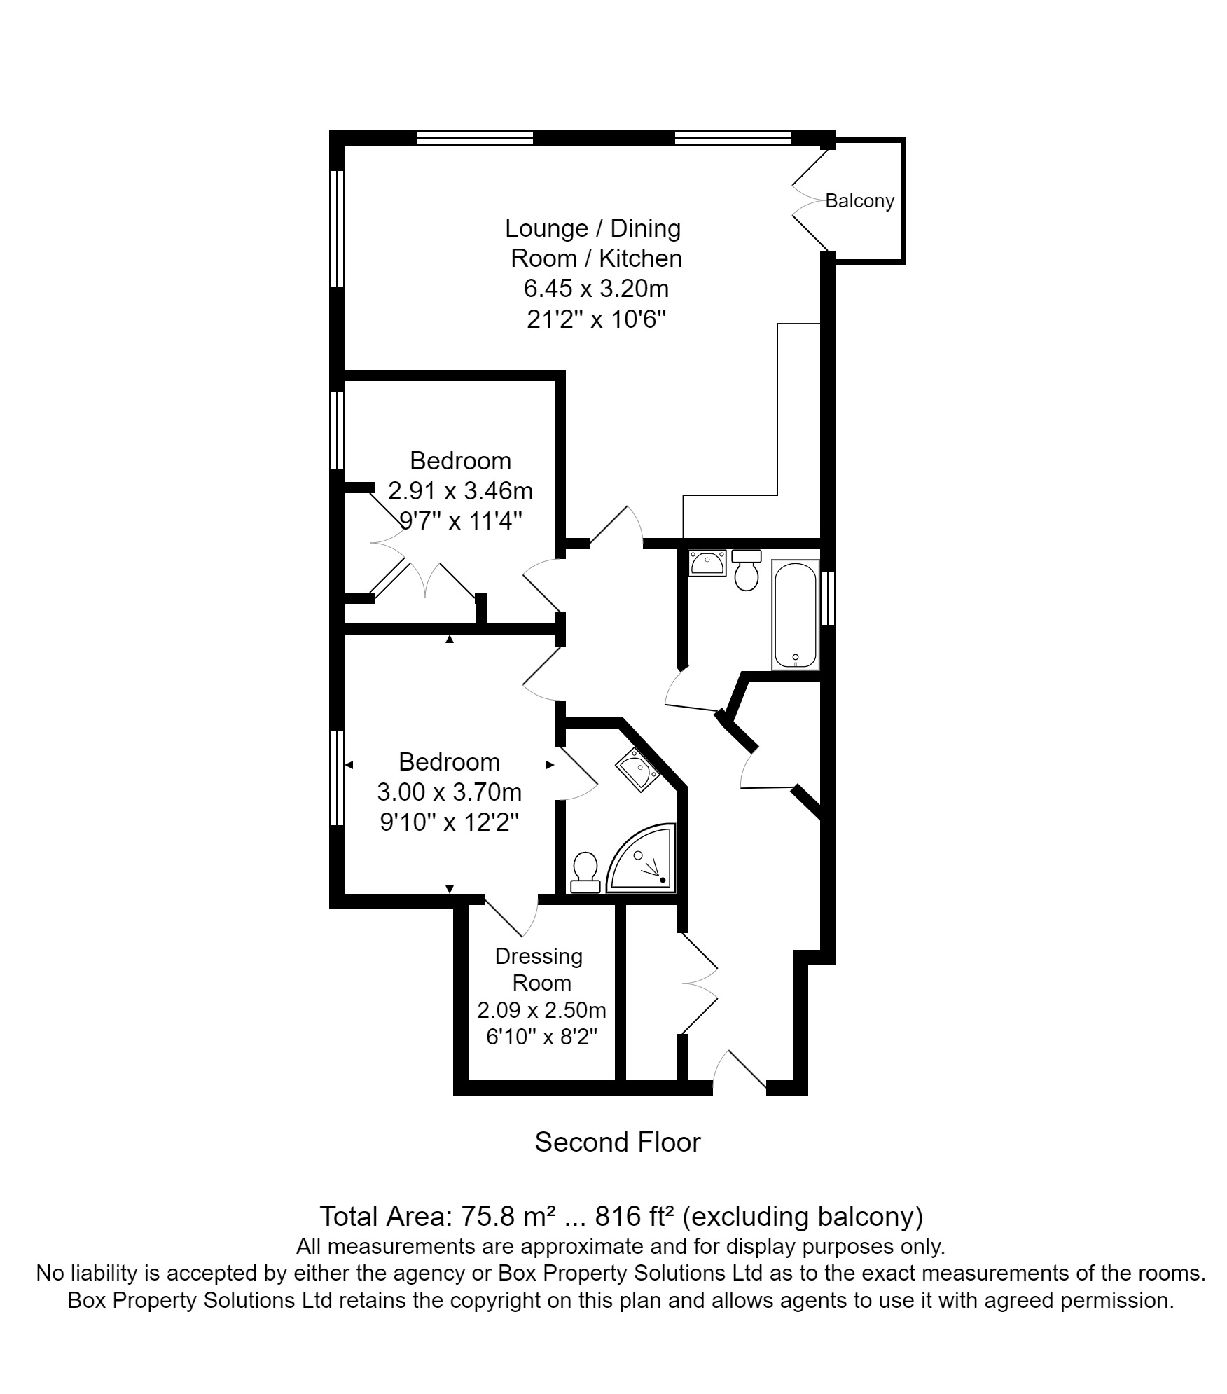

These particulars are intended to give a fair description of the property, but their accuracy cannot be guaranteed, and they do not constitute an offer of contract. Intending purchasers must rely on their own inspection of the property. None of the above appliances/services have been tested by ourselves. We recommend purchasers arrange for a qualified person to check all appliances/services before legal commitment.

Property Ref: 3482

For more information, please contact

0113 258 1150 | sales@adairpaxton.co.uk | www.adairpaxton.co.uk

