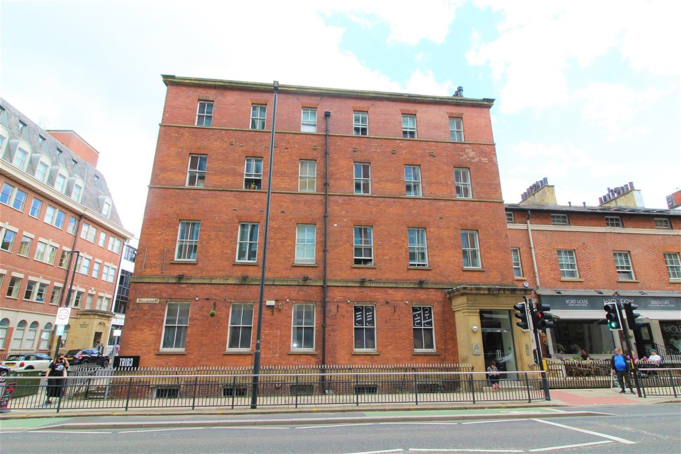



|  |  |
| --- | --- |
| **Atlantic Apartments, Leeds, LS1**  **£1,050.00pcm**  **Apartment** | |
|  |

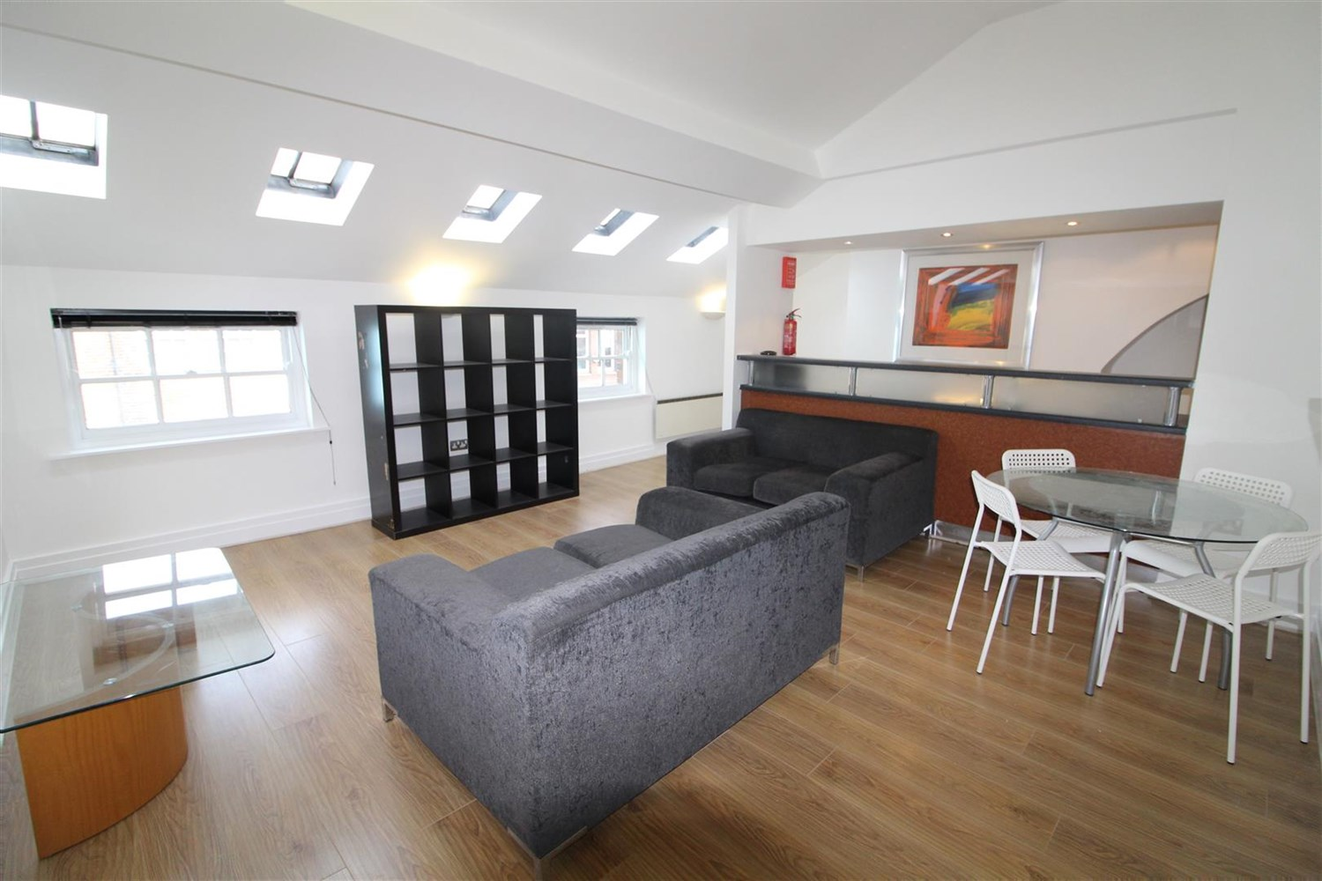

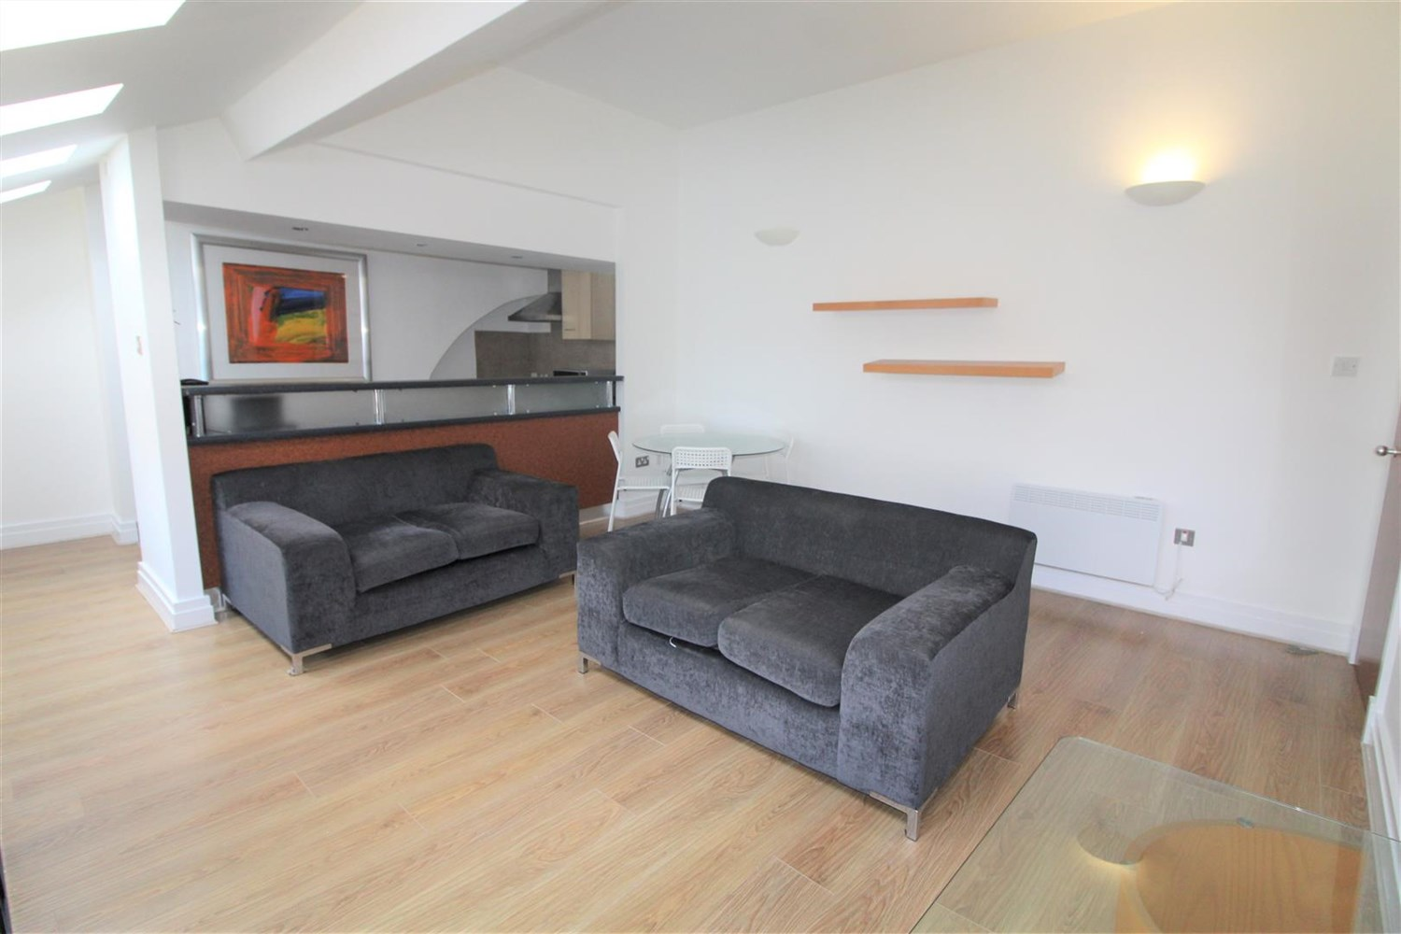

1 Bathroom(s)

1 Reception(s)

0 Bedroom(s)

00

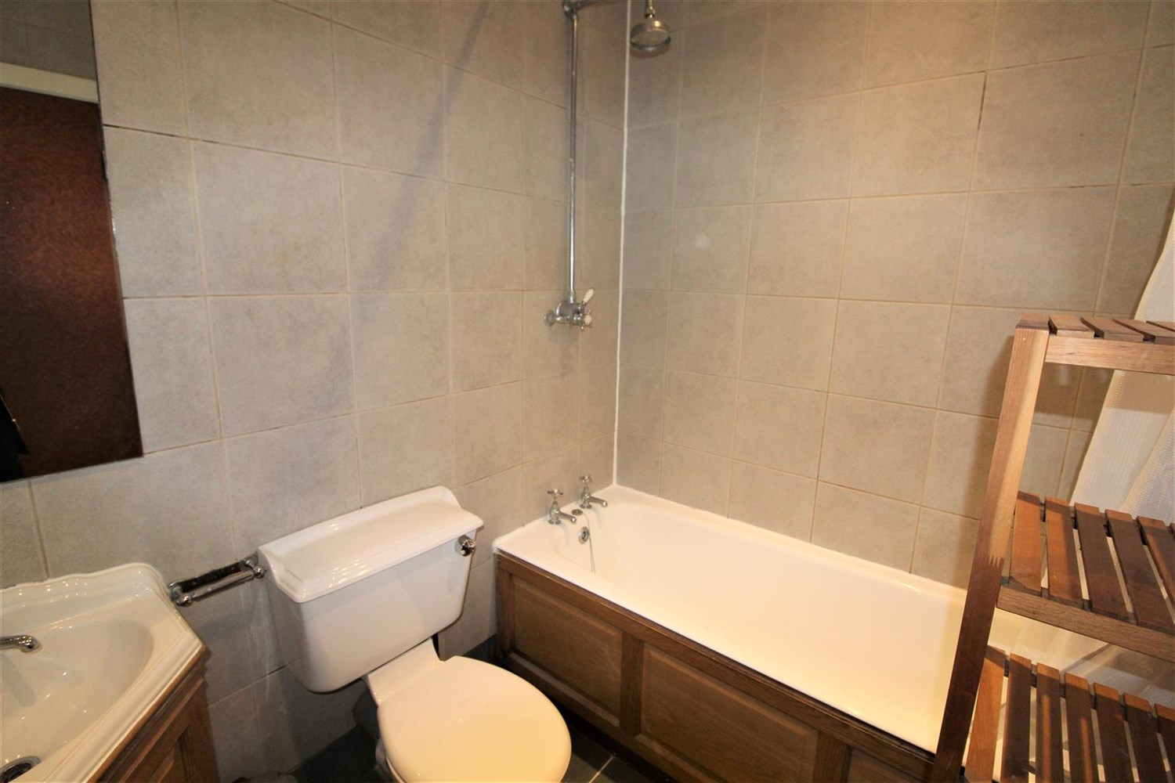

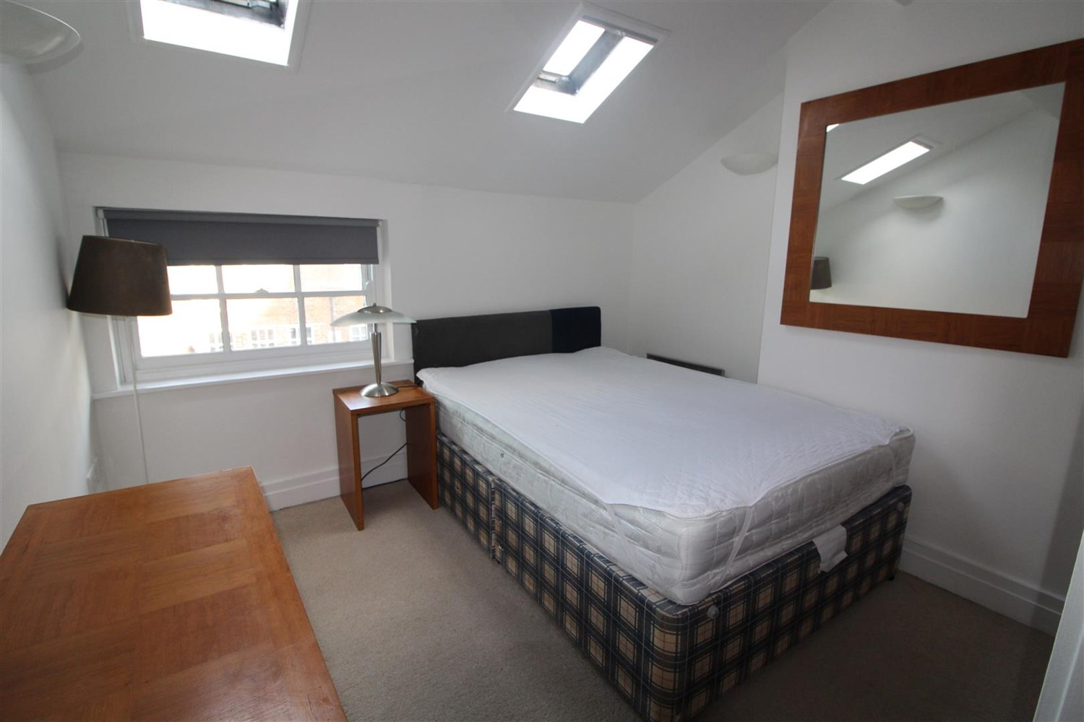

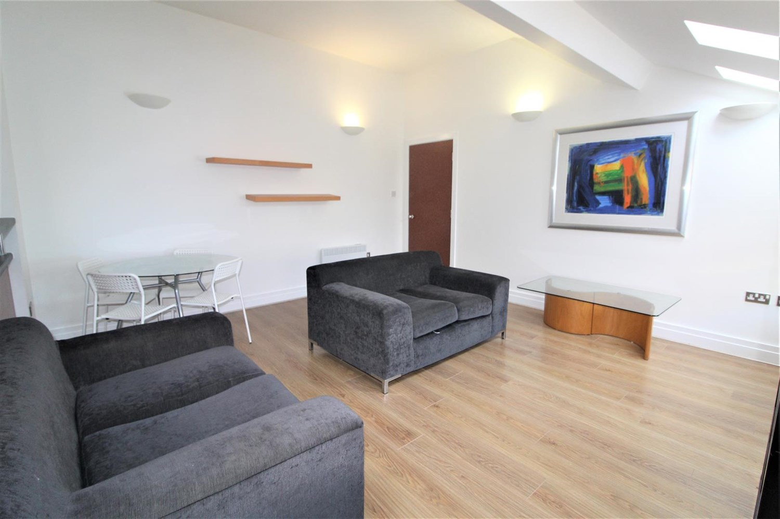

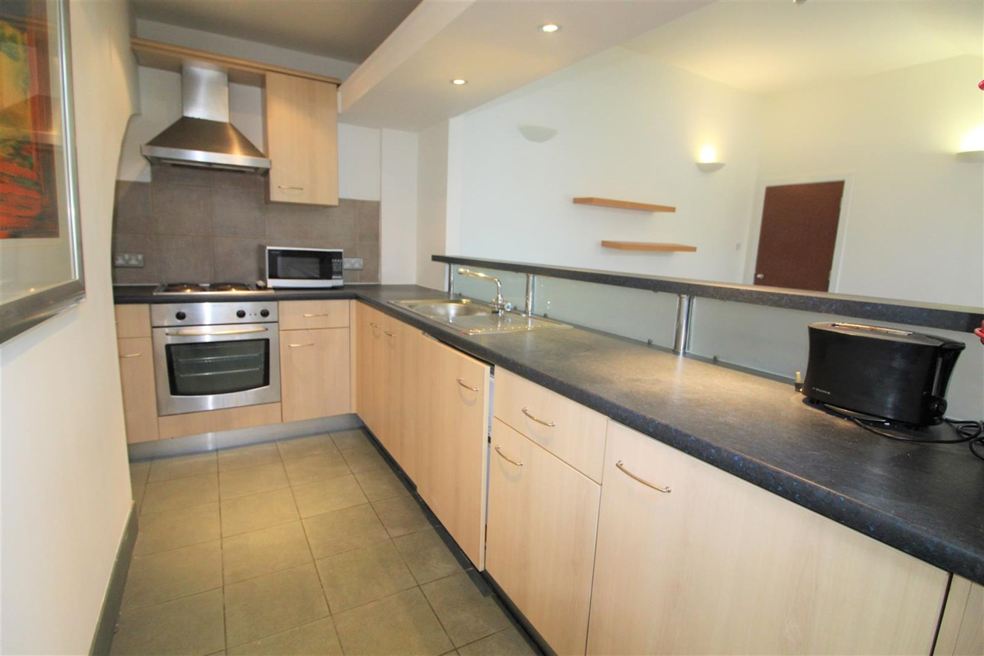

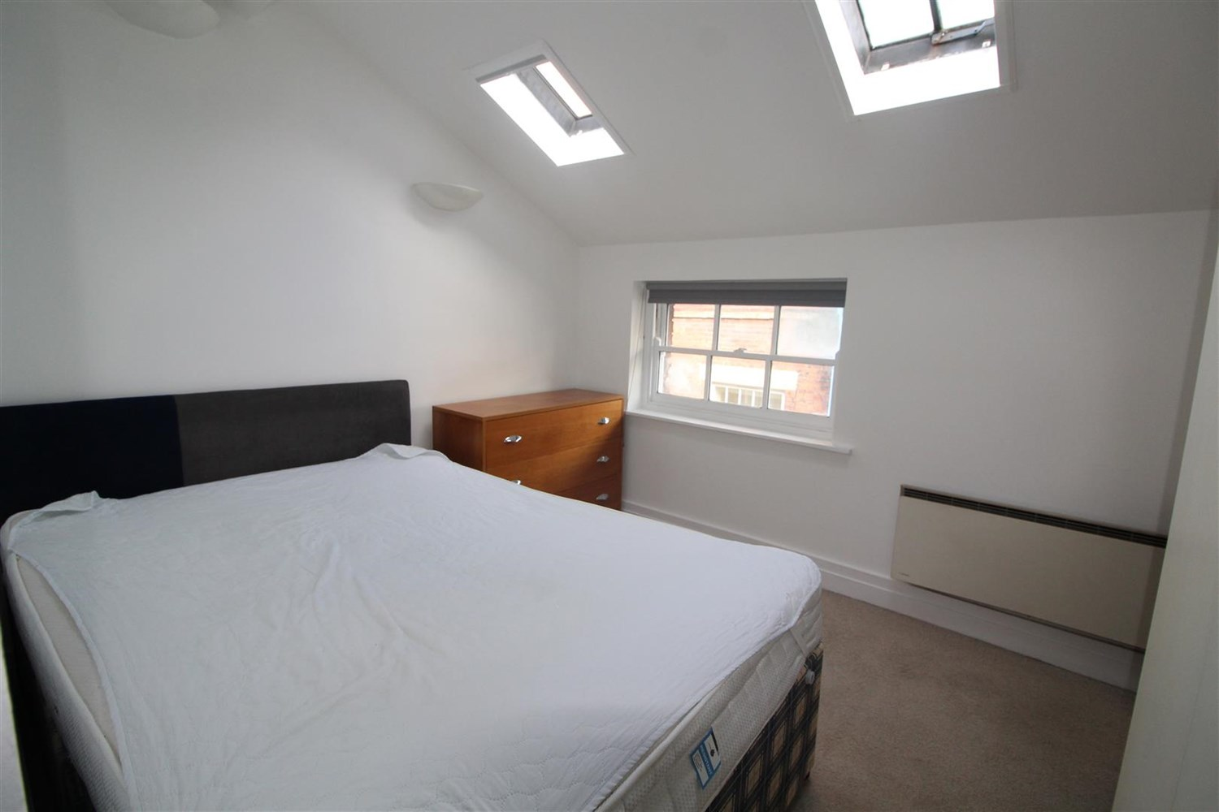

|  |  |
| --- | --- |
| These particulars are intended to give a fair description of the property, but their accuracy cannot be guaranteed, and they do not constitute an offer of contract. Intending purchasers must rely on their own inspection of the property. None of the above appliances/services have been tested by ourselves. We recommend purchasers arrange for a qualified person to check all appliances/services before legal commitment.  **Property Ref:** 915  **For more information, please contact**  0113 258 1150 **|** [lettings@adairpaxton.co.uk](mailto:lettings@adairpaxton.co.uk) **|** www.adairpaxton.co.uk |  |