

**0113 258 1150**

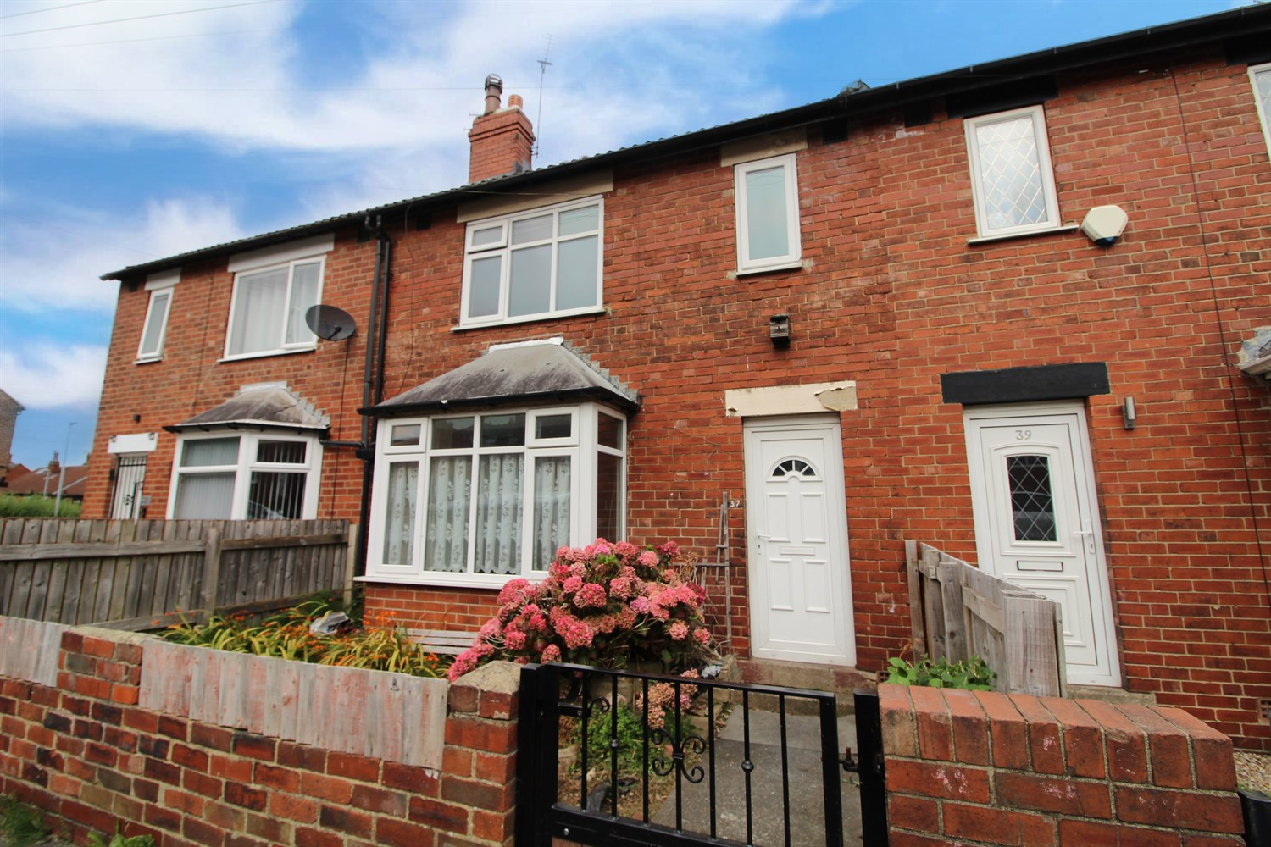



**For Sale £140,000.00**

**Aston Terrace, Bramley**

***THREE BEDROOM MID-TERRACE HOUSE - IN NEED OF A FULL RENOVATION*** Offered to the market with no onward chain, the property is situated within easy access of local amenities and transport links and would be ideally suited to a range of buyers. The property is now in need a full renovation and briefly comprises; hallway, lounge, dining room and kitchen to the ground floor. To the first floor there are three bedrooms and a house bathroom. Externally the property has a small enclosed garden to the front and an enclosed garden to the rear with steps leading to the rear door.

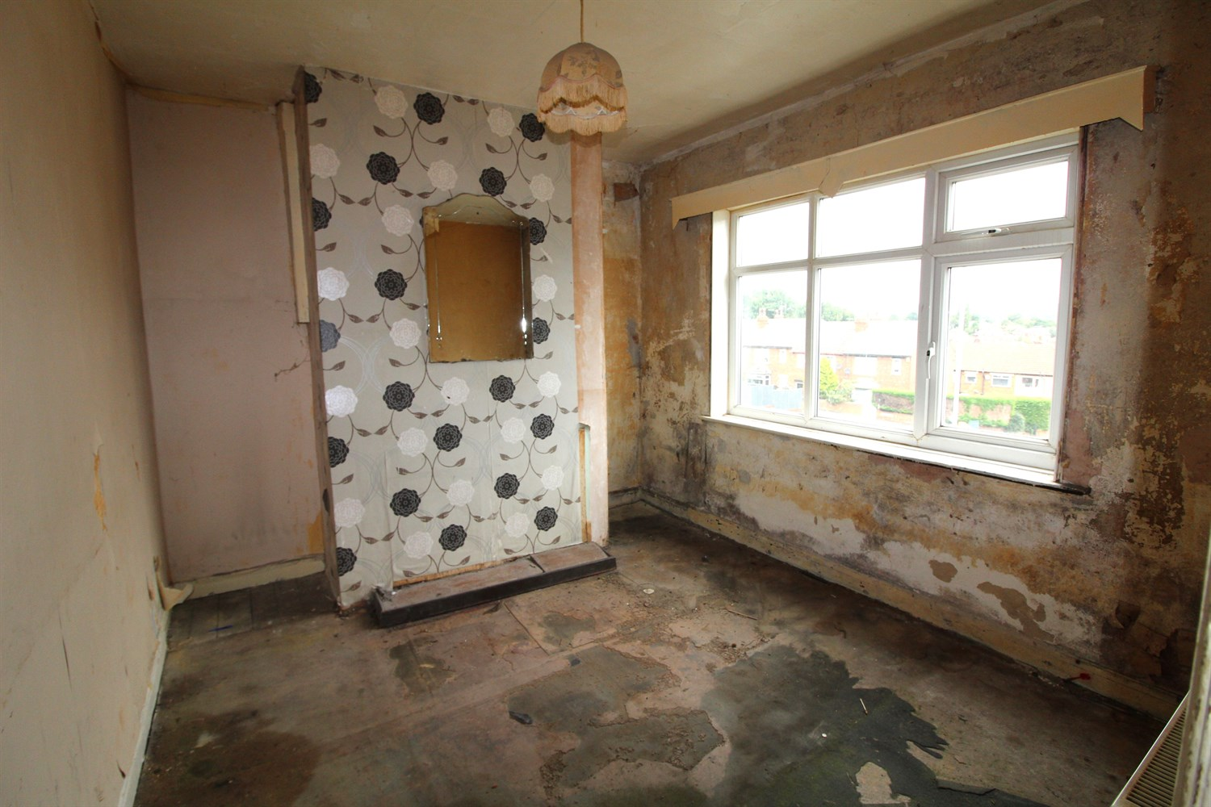

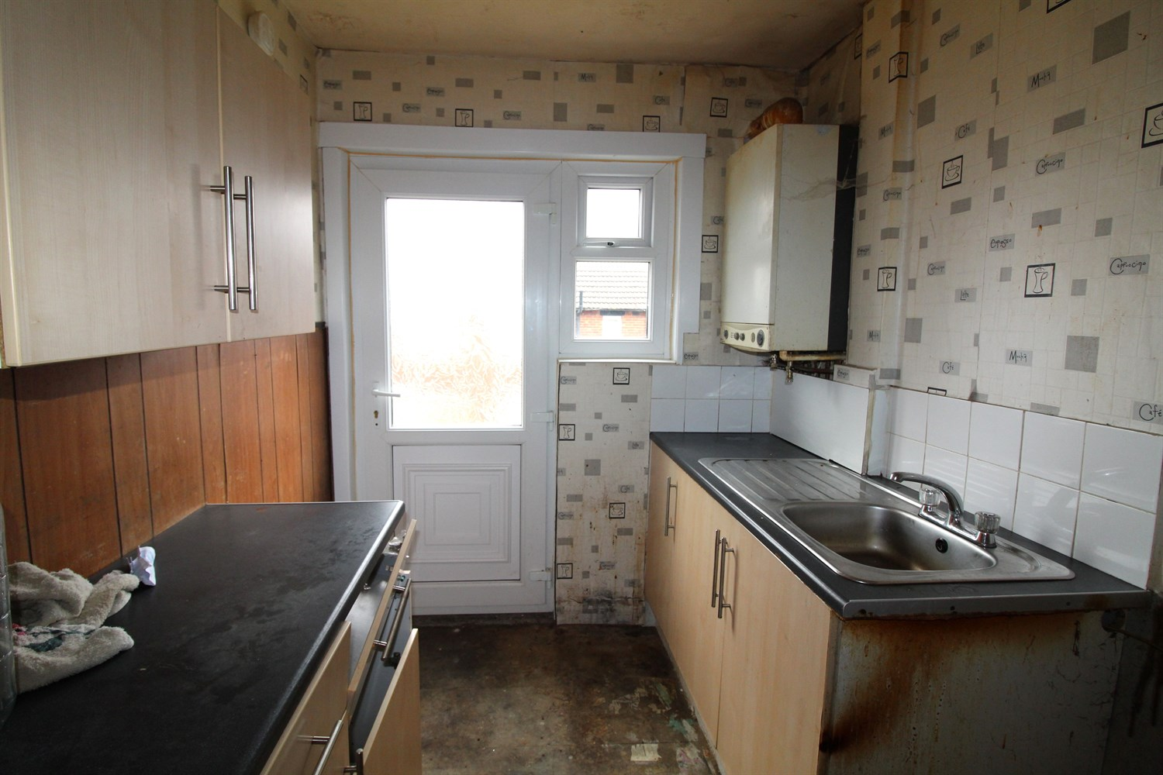

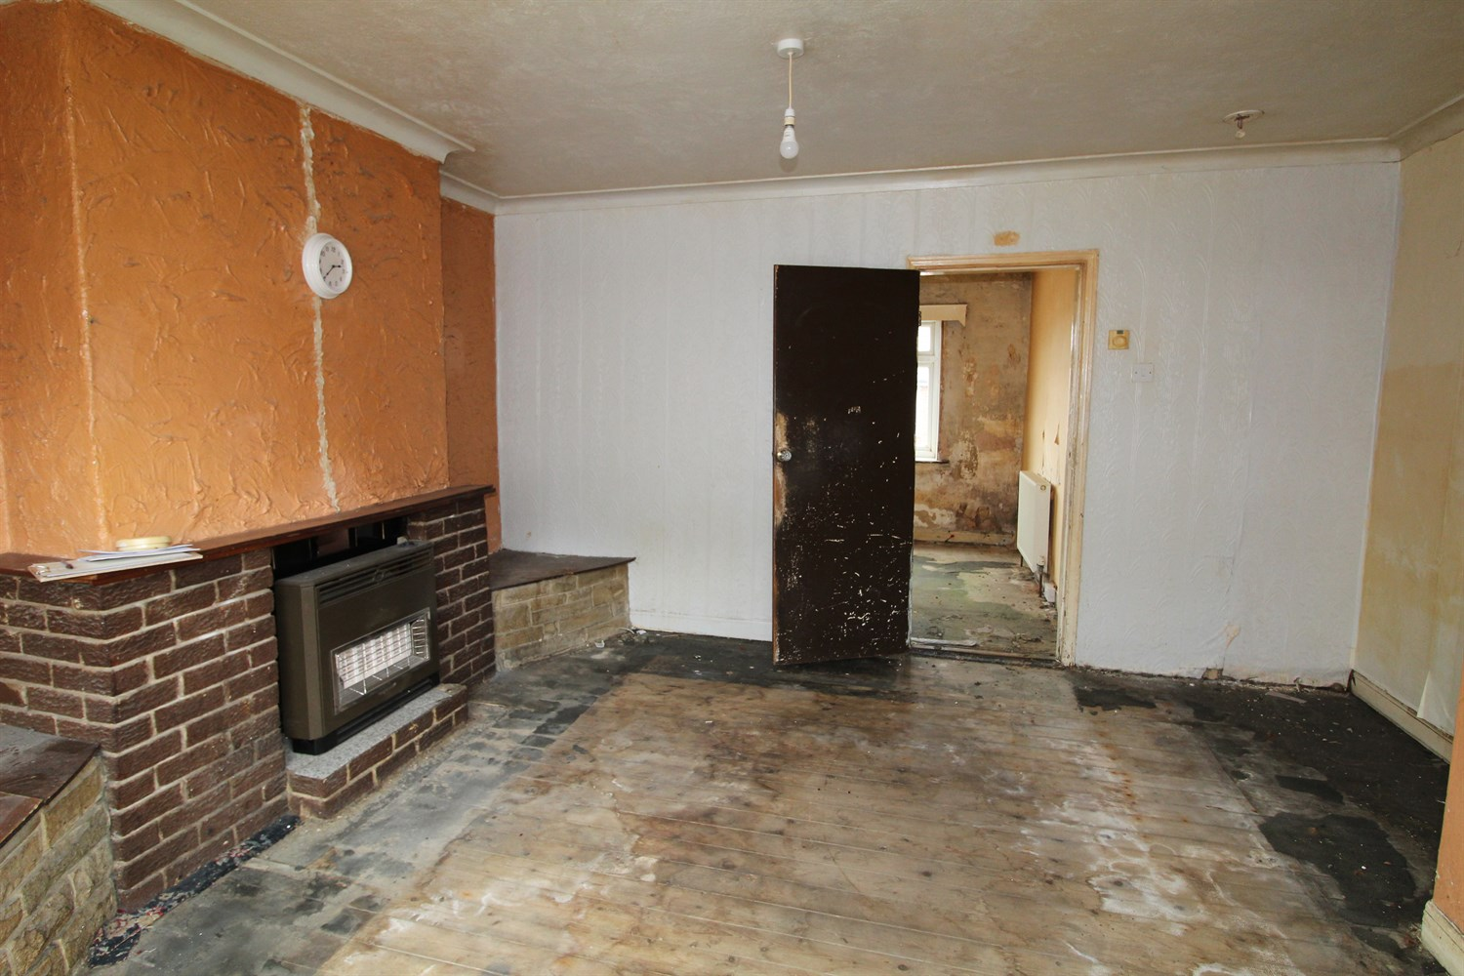

1 Bathroom(s)

2 Reception(s)

3 Bedroom(s)

00

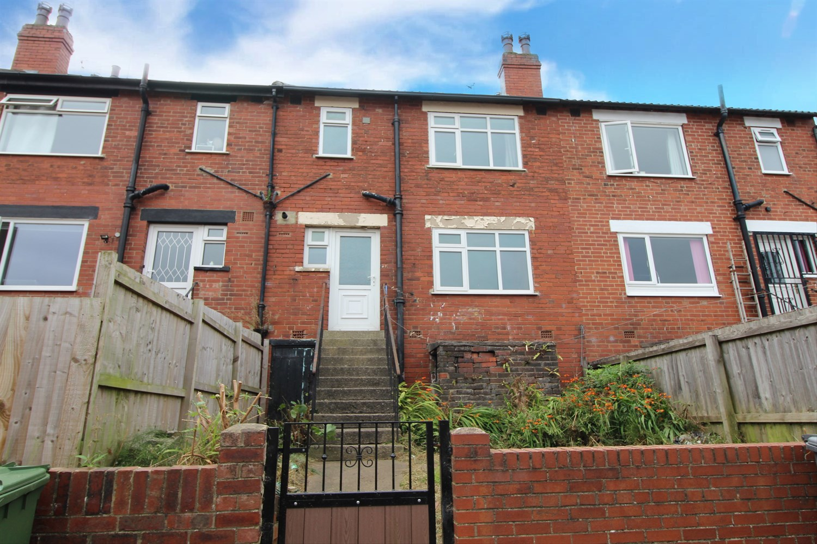

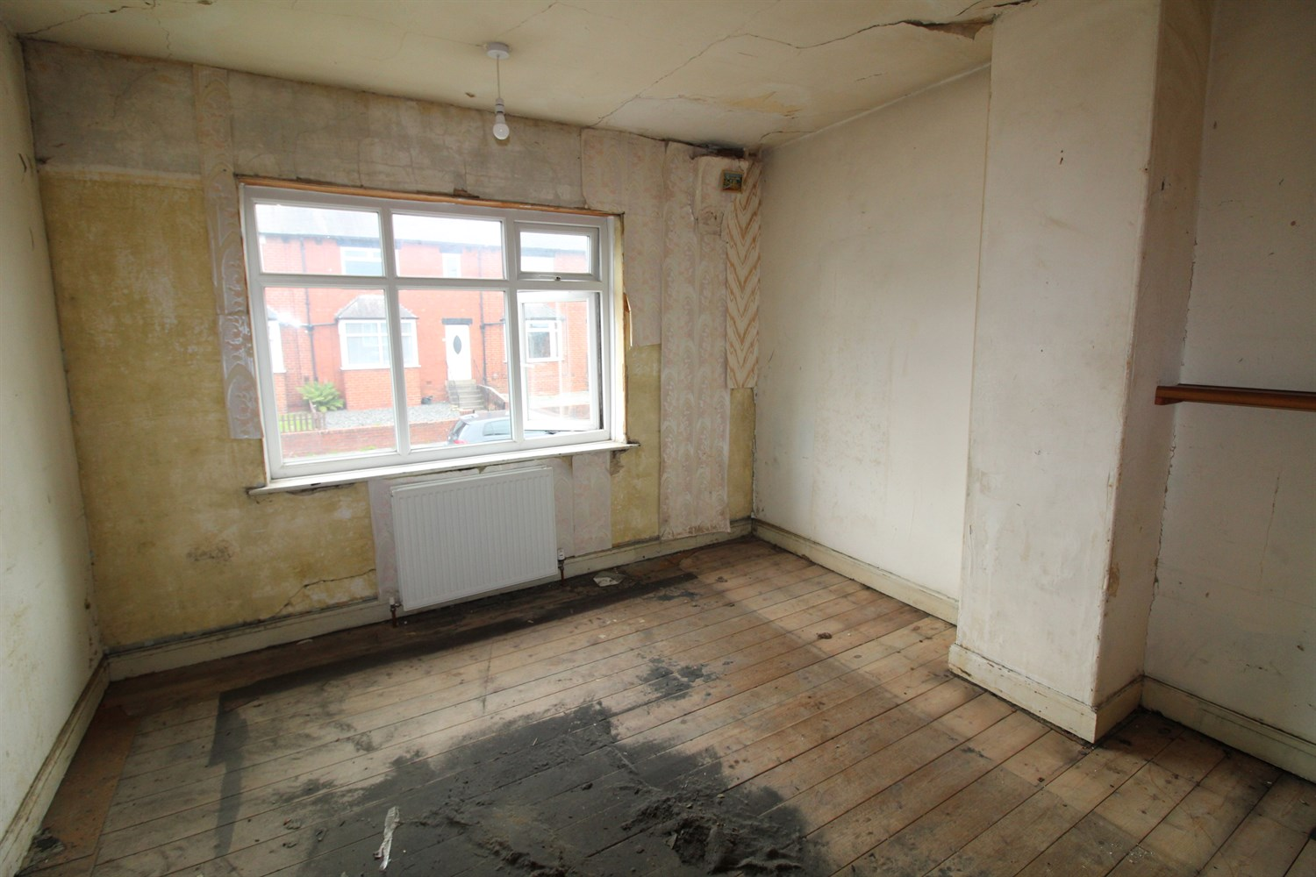

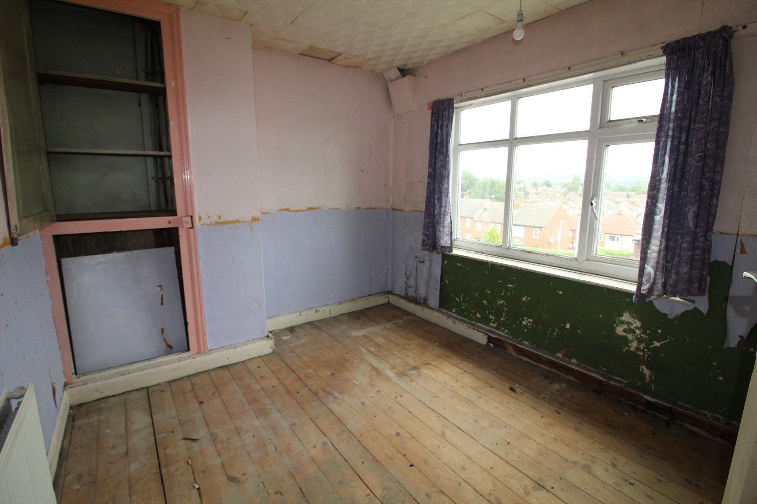

|  |
| --- |
| **Hall**  Via front entrance door. Stairs to first floor. |
| **Lounge 4.4m (14'5) x 4.32m (14'2)**  Spacious living room with double glazed bay window to front. Gas central heating radiator. |
| **Dining Room 3.26m (10'8) x 2.88m (9'5)**  Second reception room with double glazed window to rear. Gas central heating radiator. |
| **Kitchen 2.91m (9'7) x 1.95m (6'5)**  Fitted with a range of units with worktops over. Double glazed door and window to rear. |
| **Bedroom 1 3.48m (11'5) x 3.82m (12'6)**  Double bedroom with double glazed window to front. Gas central heating radiator. |
| **Bedroom 2 2.86m (9'5) x 3.27m (10'9) max**  Second double bedroom with double glazed window to rear. Gas central heating radiator. |
| **Bedroom 3 1.93m (6'4) x 2.15m (7'1)**  Third bedroom with double glazed window to front. |
| **Bathroom**  Fitted with a three piece suite comprising; bath, WC and wash hand basin. |
| **Outside**  To the front of the property is a small enclosed garden. To the rear is an enclosed garden with steps leading up to the rear door. |

|  |  |
| --- | --- |
| These particulars are intended to give a fair description of the property, but their accuracy cannot be guaranteed, and they do not constitute an offer of contract. Intending purchasers must rely on their own inspection of the property. None of the above appliances/services have been tested by ourselves. We recommend purchasers arrange for a qualified person to check all appliances/services before legal commitment.  **Property Ref:** 3575  **For more information, please contact**  0113 258 1150 **|** [sales@adairpaxton.co.uk](mailto:sales@adairpaxton.co.uk) **|** www.adairpaxton.co.uk |  |