

**Mount Pleasant Heights**

**For Sale £1,150,000.00**

The available opportunity comprises a purpose-built block of 12 apartments that have been constructed. These apartments consist of 8, two-bedroom apartments and 4 one-bedroom apartments. A number of which benefit from being a `duplex'.  
  
The block has been constructed by stone walls under a pitched, slate roof. The apartments all benefit from electric heating and double glazing. Within the grounds, there is ample private parking of which all apartments have access to allocated car parking.

**0113 258 1150**

**0800 000 000**

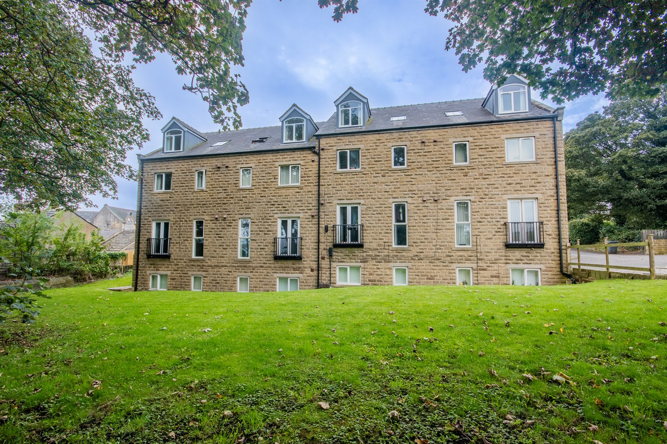



0 Reception(s)

0 Bathroom(s)

0 Bedroom(s)

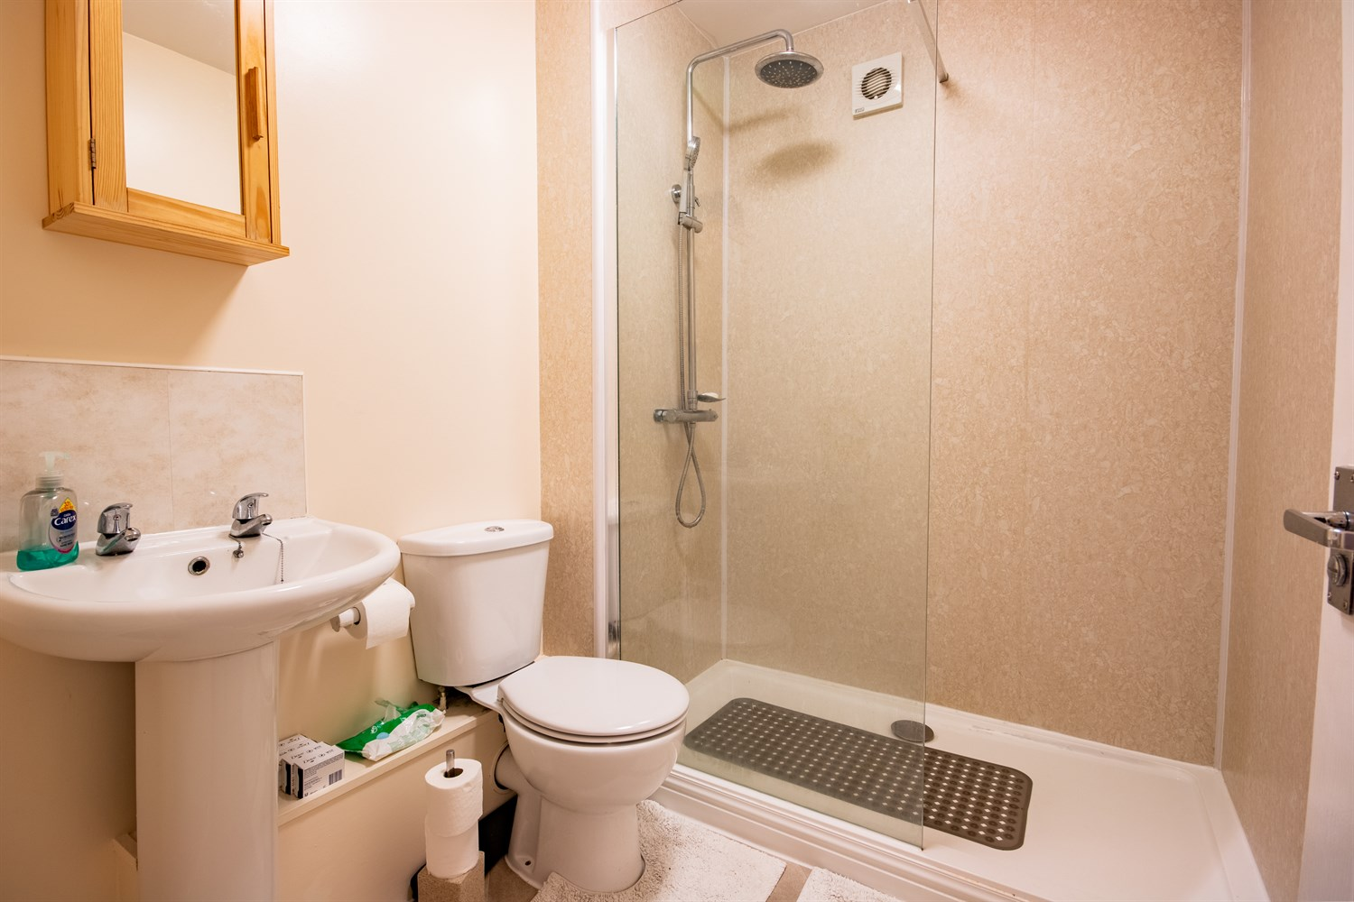

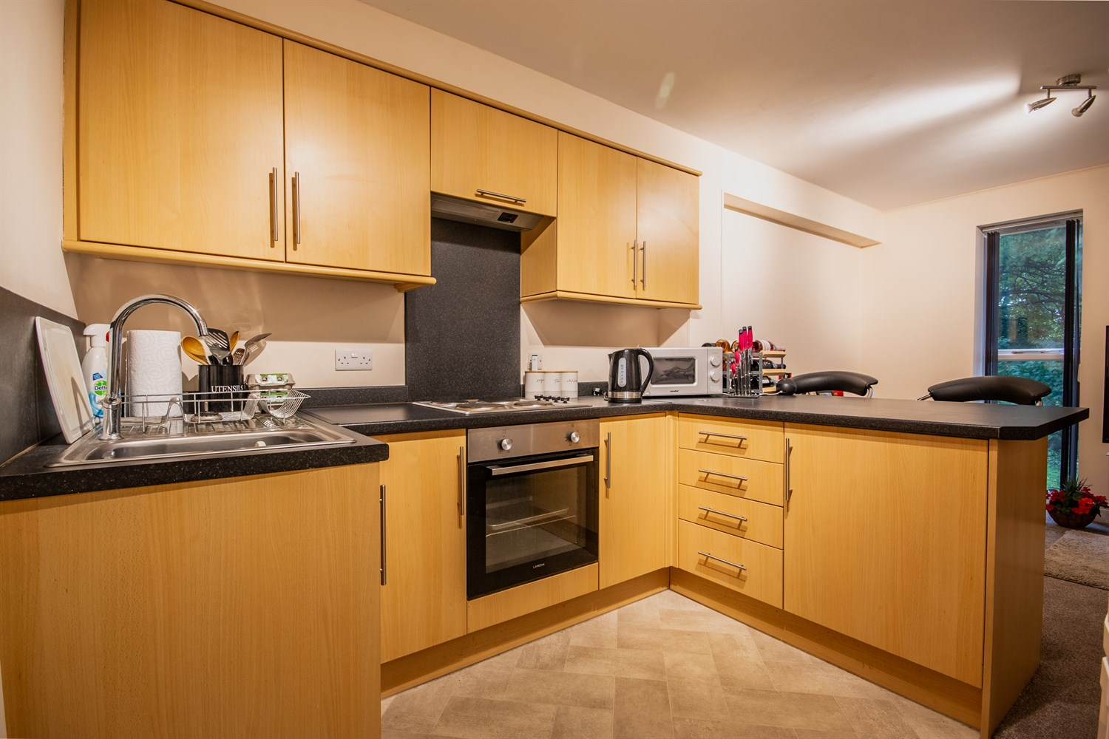

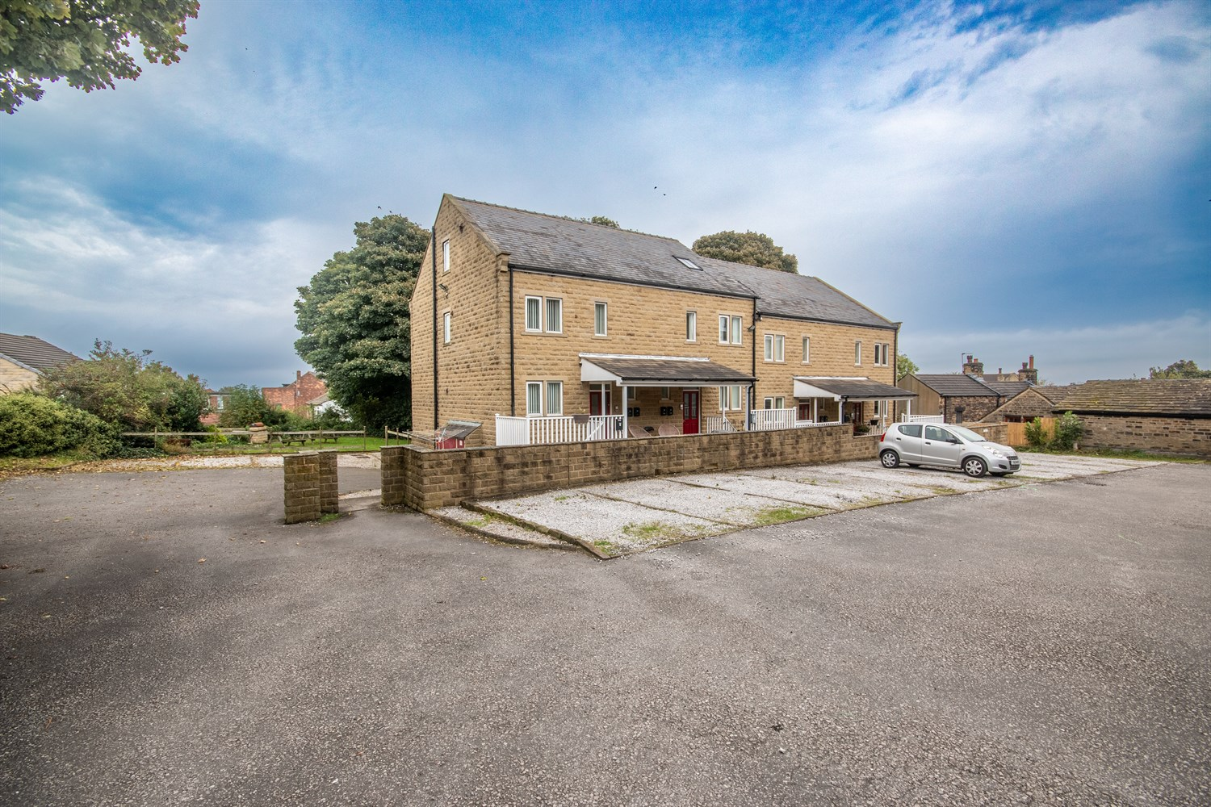

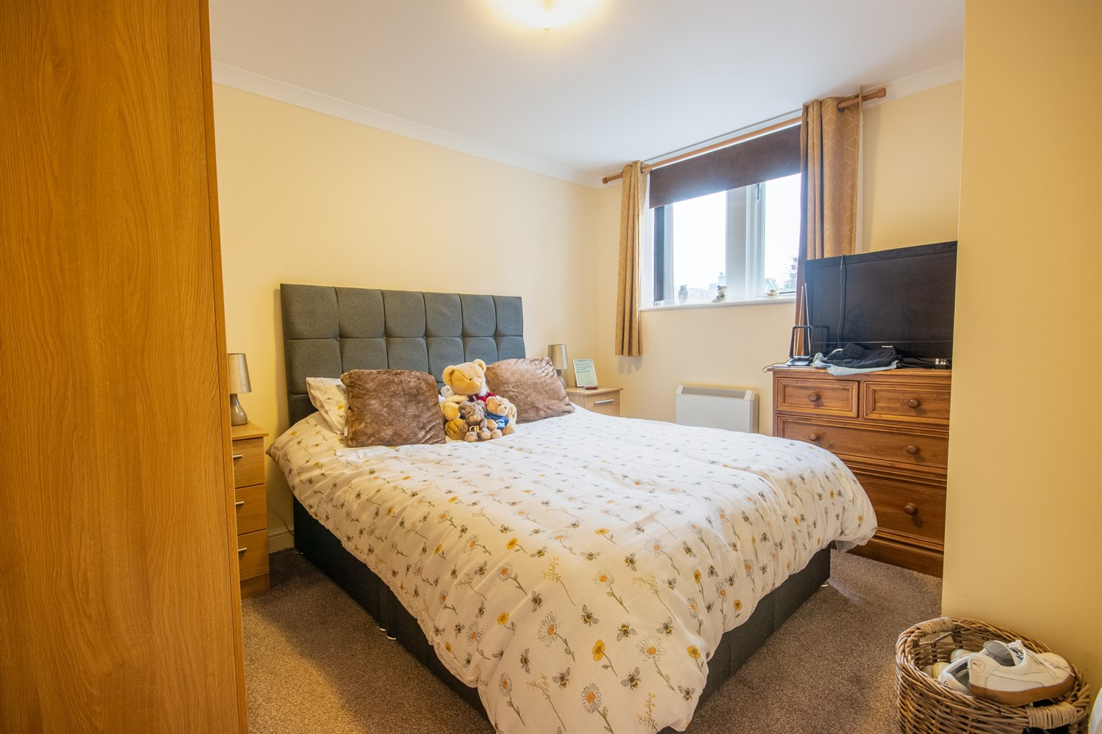

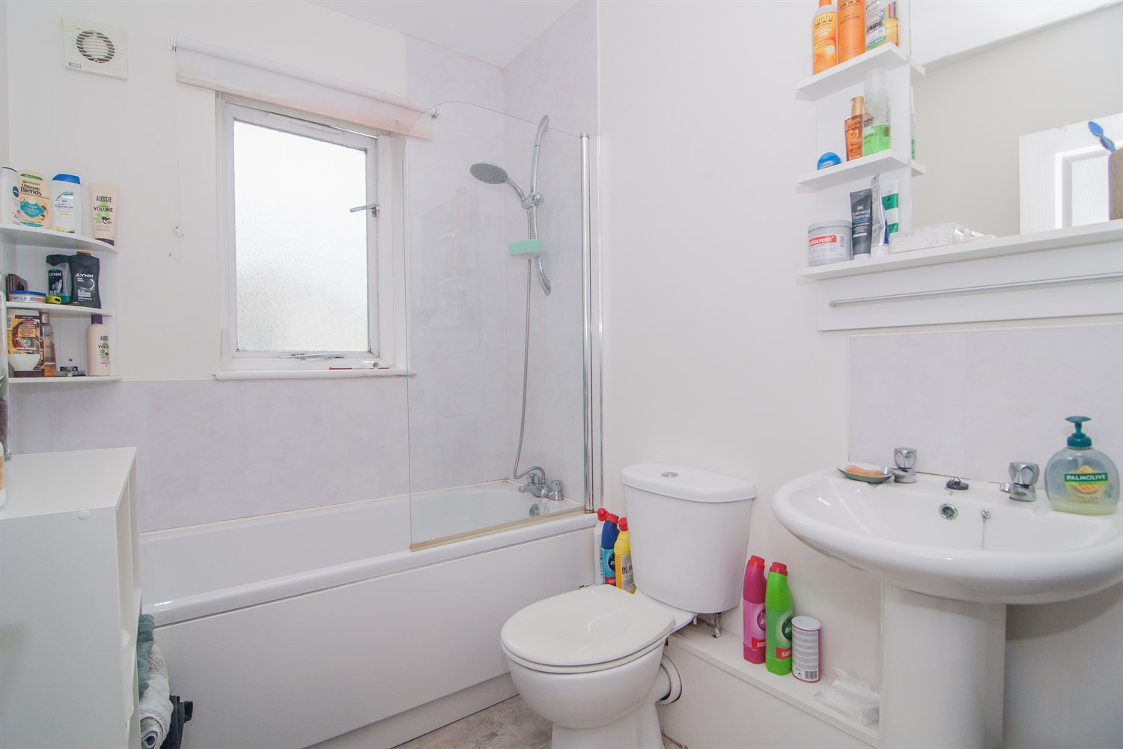

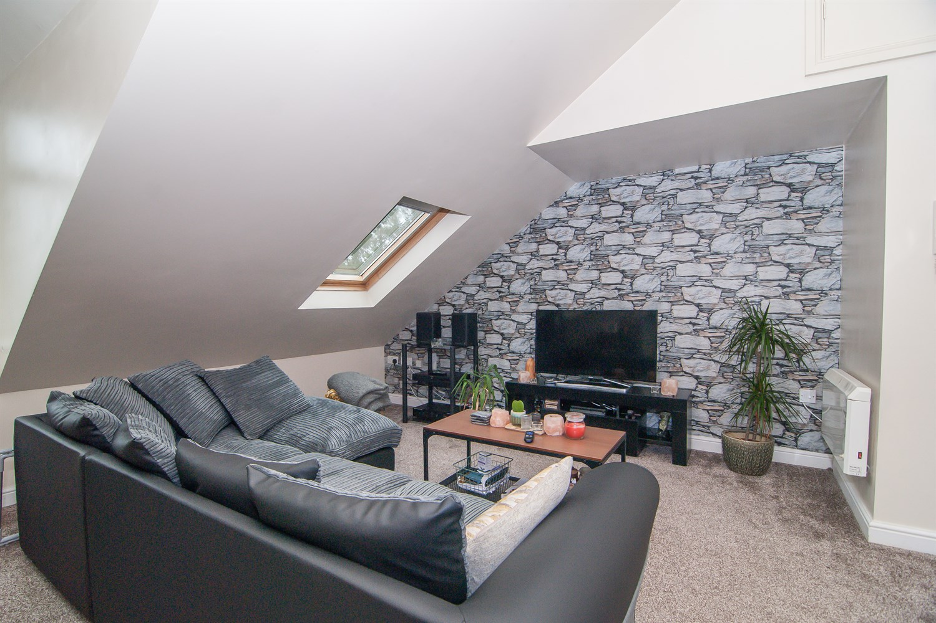

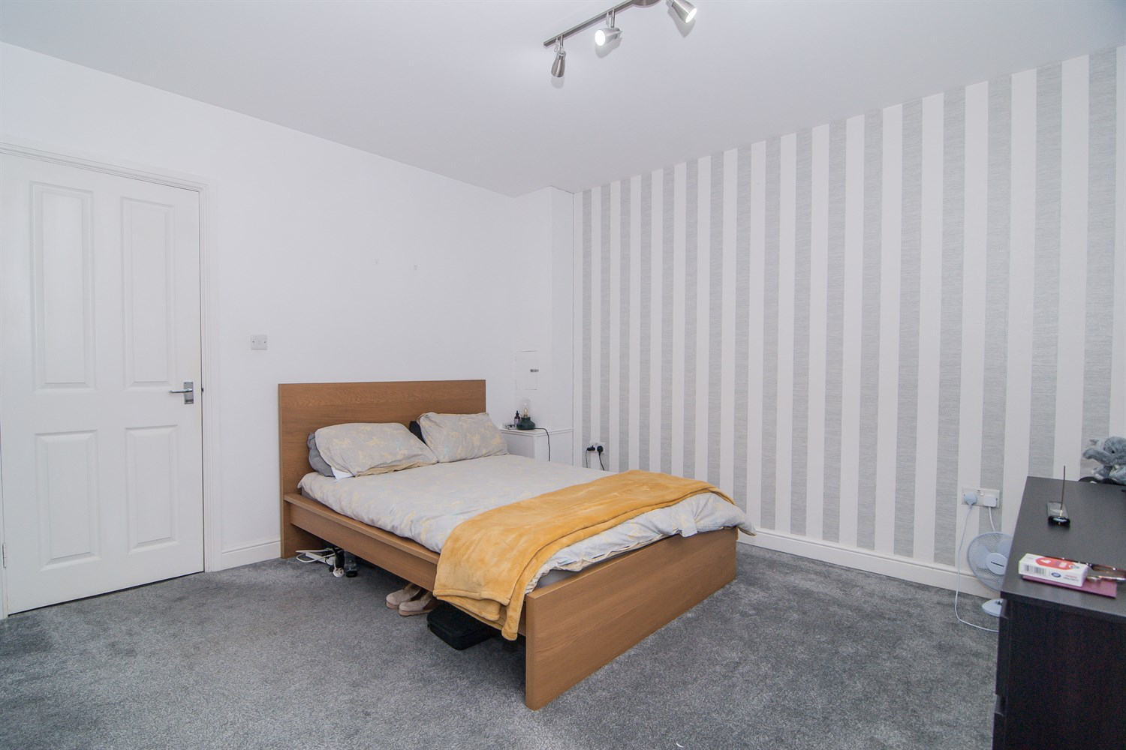

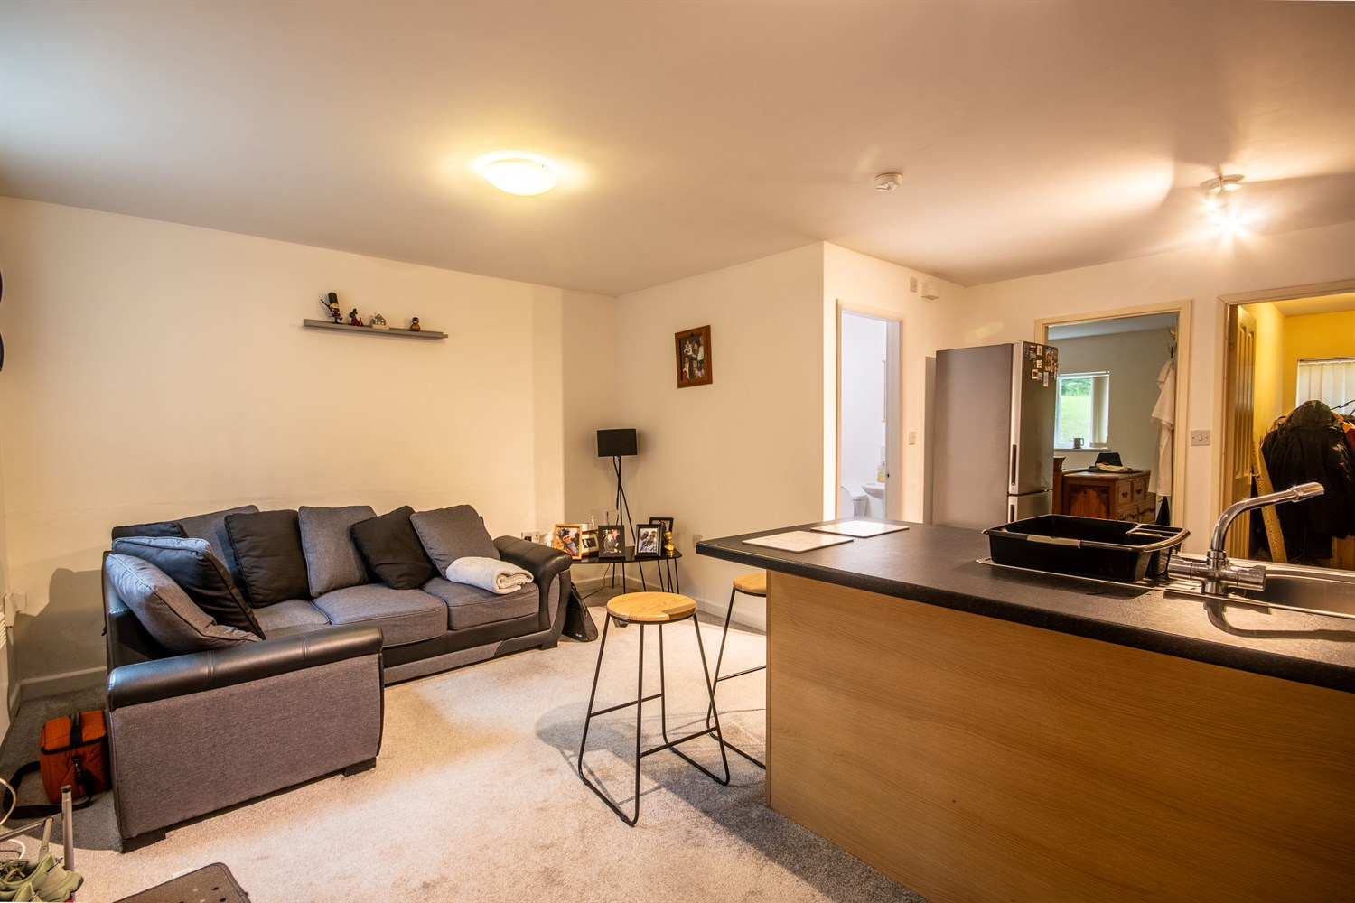

|  |
| --- |
| **LOCATION**  The property is located off Mount Pleasant Road in Pudsey Town Centre. This location is within easy reach of all town centre amenities by foot and a short distance by car or public transport to the Owlcotes Shopping Centre. |
| **DESCRIPTION**  The available opportunity comprises a purpose-built block of 12 apartments that have been constructed. These apartments consist of 8, two-bedroom apartments and 4 one-bedroom apartments. A number of which benefit from being a `duplex'.  The block has been constructed by stone walls under a pitched, slate roof. The apartments all benefit from electric heating and double glazing. Within the grounds, there is ample private parking of which all apartments have access to allocated car parking. |
| **TERMS**  The property is offered for sale on a freehold basis, subject to existing tenancies at offers in excess of £1,150,000. It is understood that VAT is not applicable on this property. |
| **COUNCIL TAX**  Leeds City Council show that apartments 1, 2, 3, 4, 5, 7, 9 and fall under Council Tax Band A. Flats 6, 8, 10 and 12 fall under Council Tax Band B. |
| **VIEWING/FURTHER INFORMATION**  For further information or to arrange a viewing, please contact Will Tomlin on 0113 239 5776 (will.tomlin@adairpaxton.co.uk) or Alfie Stevens-Neale on 0113 239 5778 (alfie@adairpaxton.co.uk). |

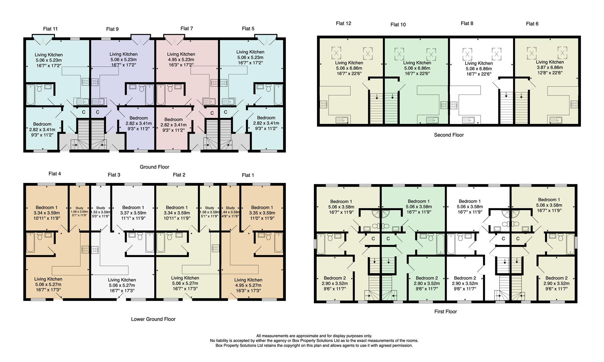

|  |
| --- |
|  |

These particulars are intended to give a fair description of the property, but their accuracy cannot be guaranteed, and they do not constitute an offer of contract. Intending purchasers must rely on their own inspection of the property. None of the above appliances/services have been tested by ourselves. We recommend purchasers arrange for a qualified person to check all appliances/services before legal commitment.

**Property Ref:** 3139

**For more information, please contact**

0113 258 1150 **|** [sales@adairpaxton.co.uk](mailto:sales@adairpaxton.co.uk) **|** www.adairpaxton.co.uk