

**0113 258 1150**

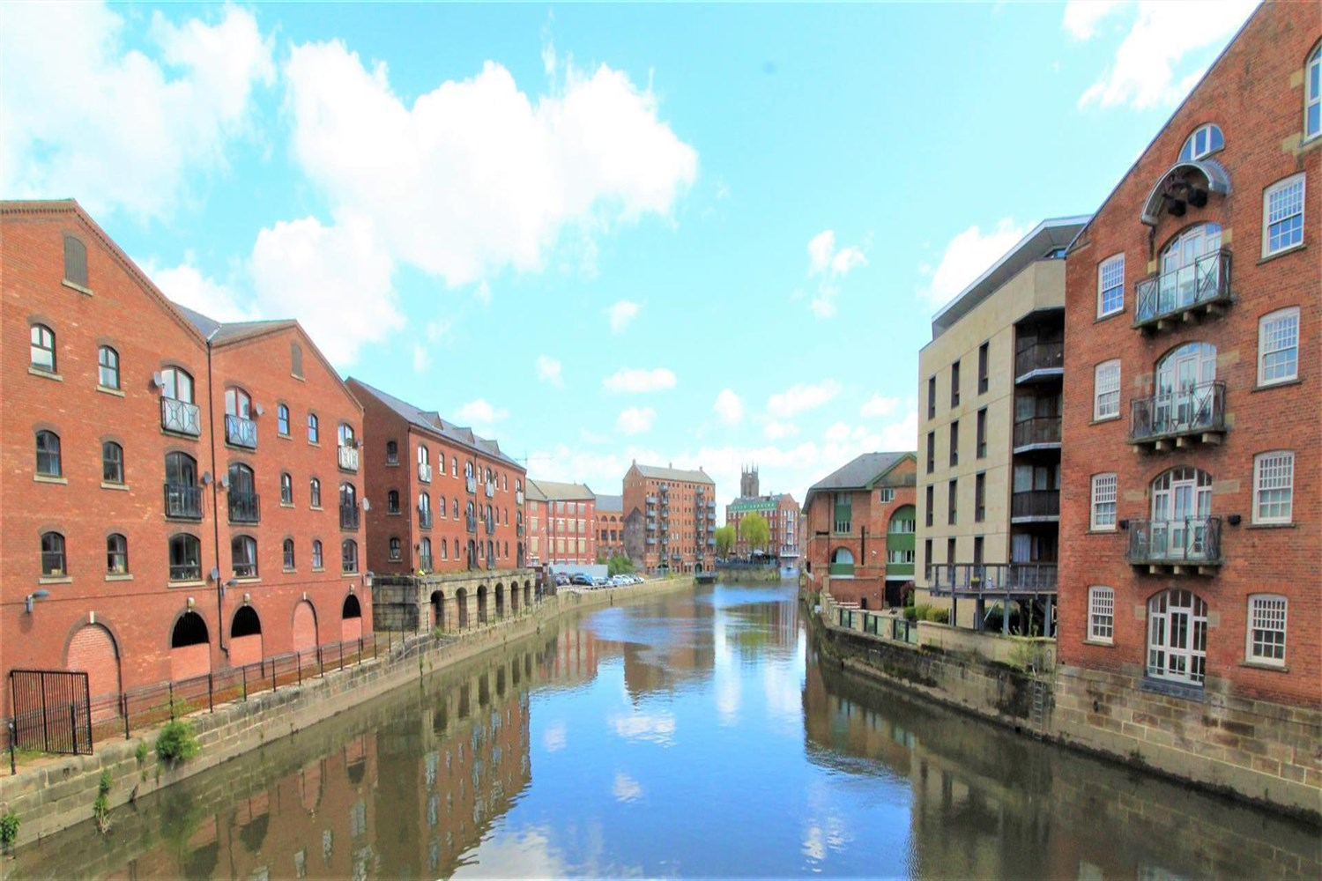



**For Sale £187,500.00**

**Riverside Court, Leeds**

***TWO BEDROOM APARTMENT IN THE HEART OF LEEDS CITY CENTRE WITH ALLOCATED PARKING*** Situated in an excellent RIVERSIDE location! This top floor apartment briefly comprises: communal entrance hall with stairs to all floors, private entrance lobby leading to entrance hall, spacious lounge with arched French doors leading to a Juliette balcony with side views over the river. A fitted kitchen, two double bedrooms and a house bathroom. Externally there is an allocated parking space. Offered for sale with NO ONWARD CHAIN. An internal viewing is highly recommended.

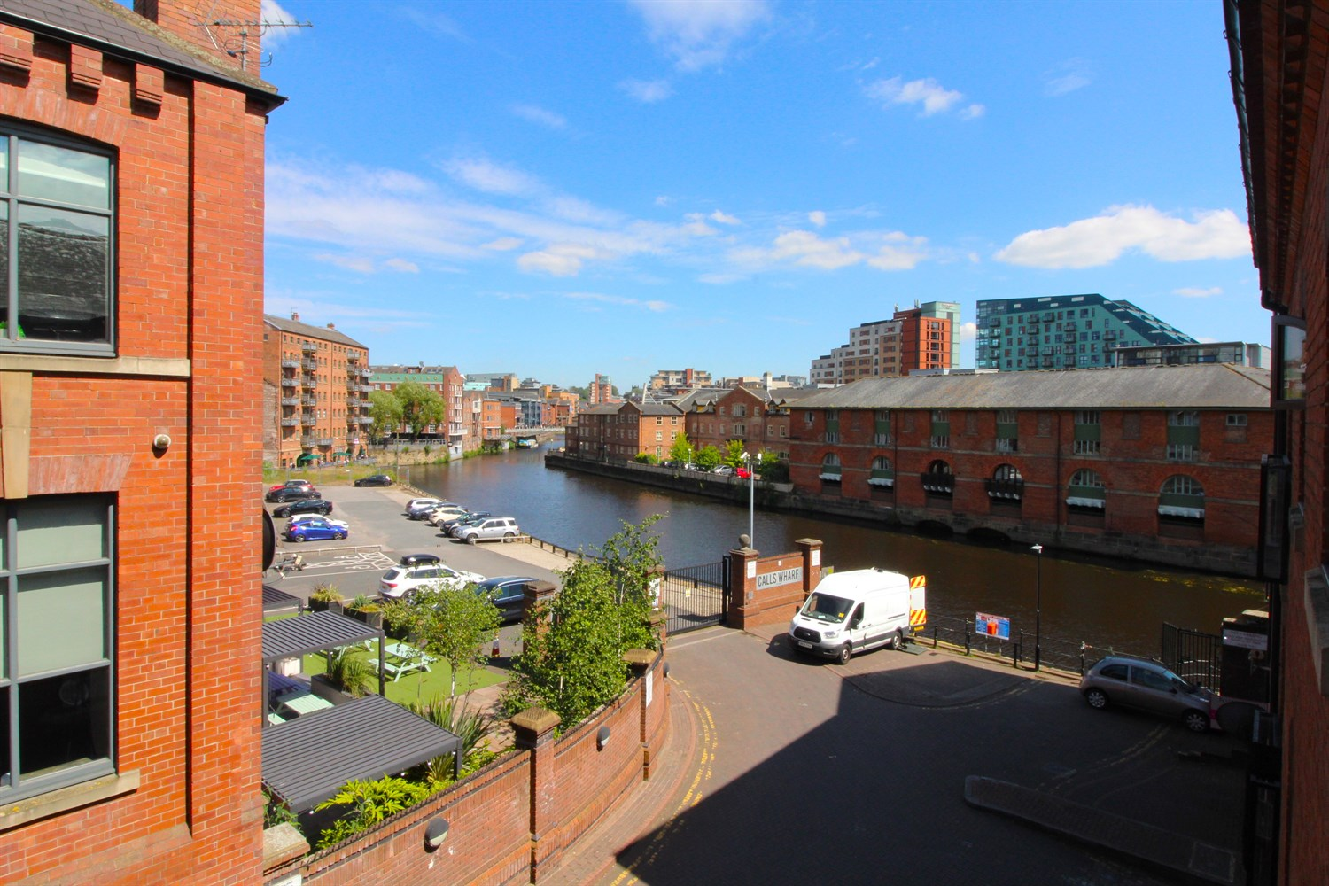

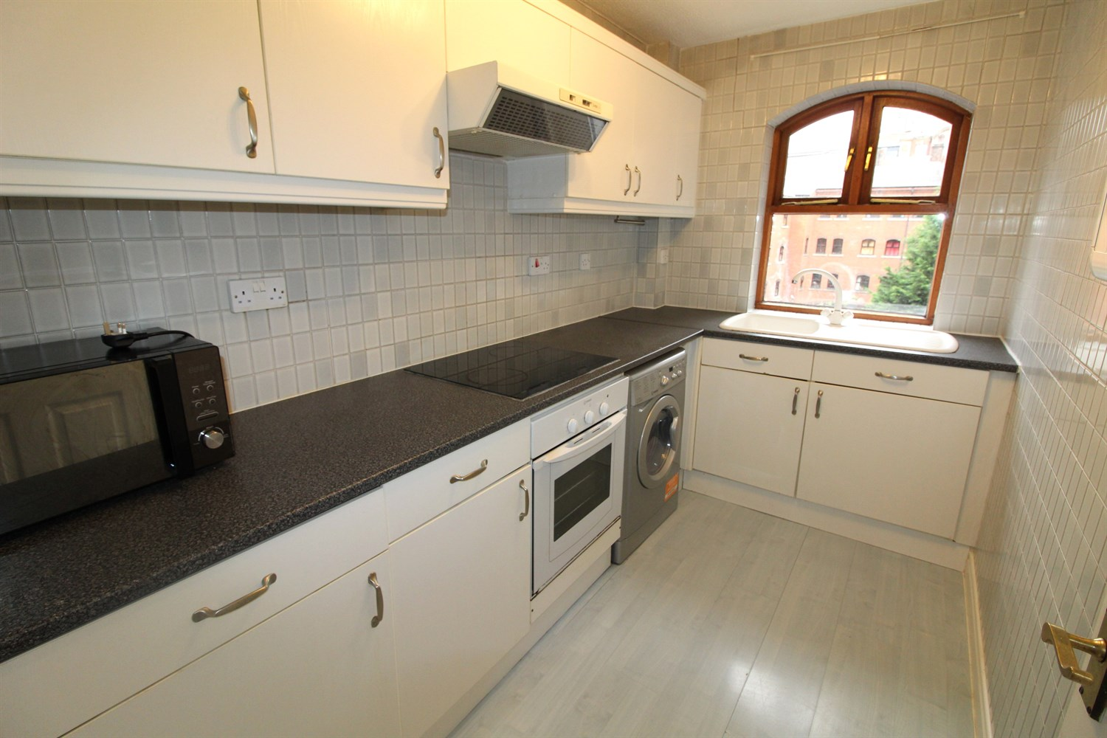

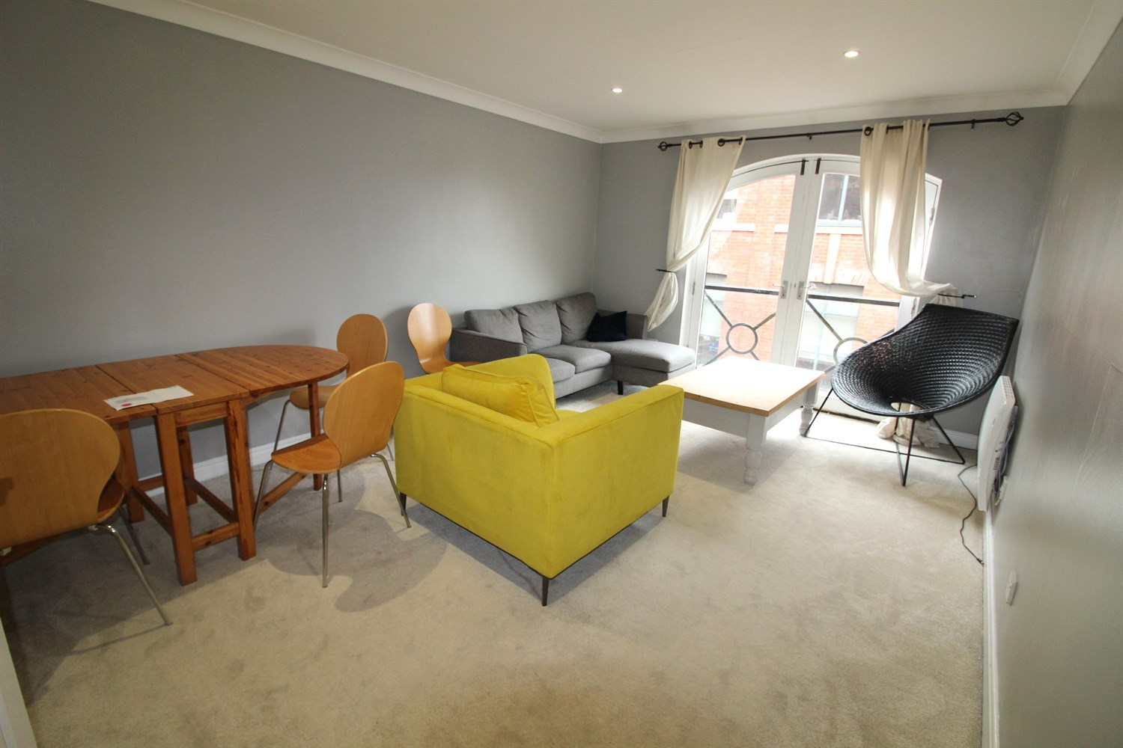

1 Bathroom(s)

1 Reception(s)

2 Bedroom(s)

00

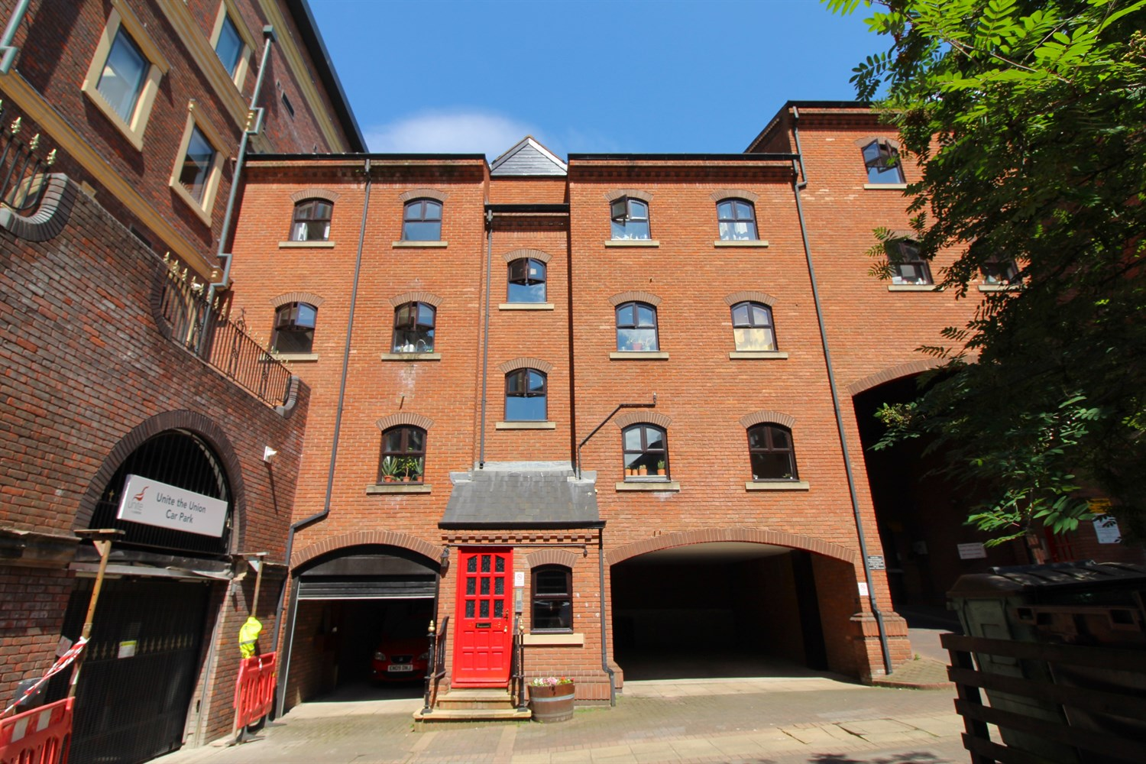

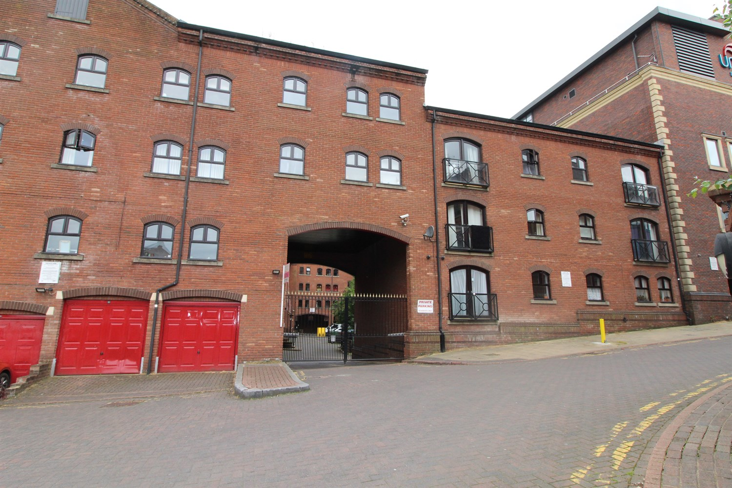

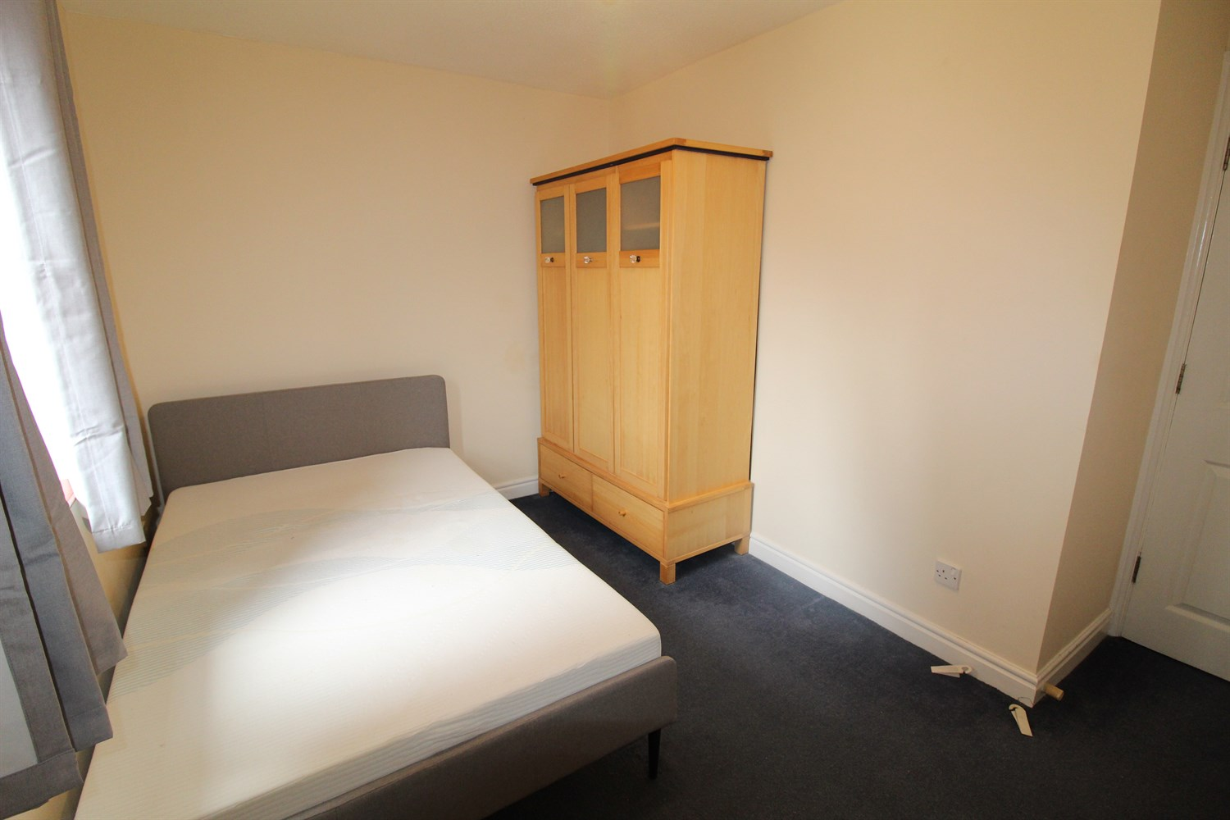

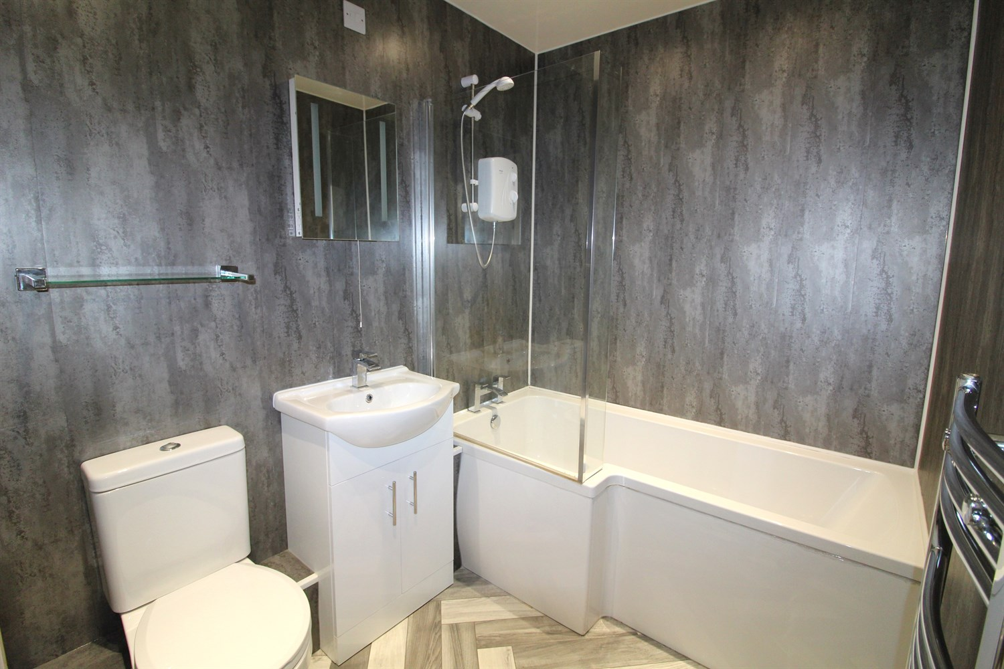

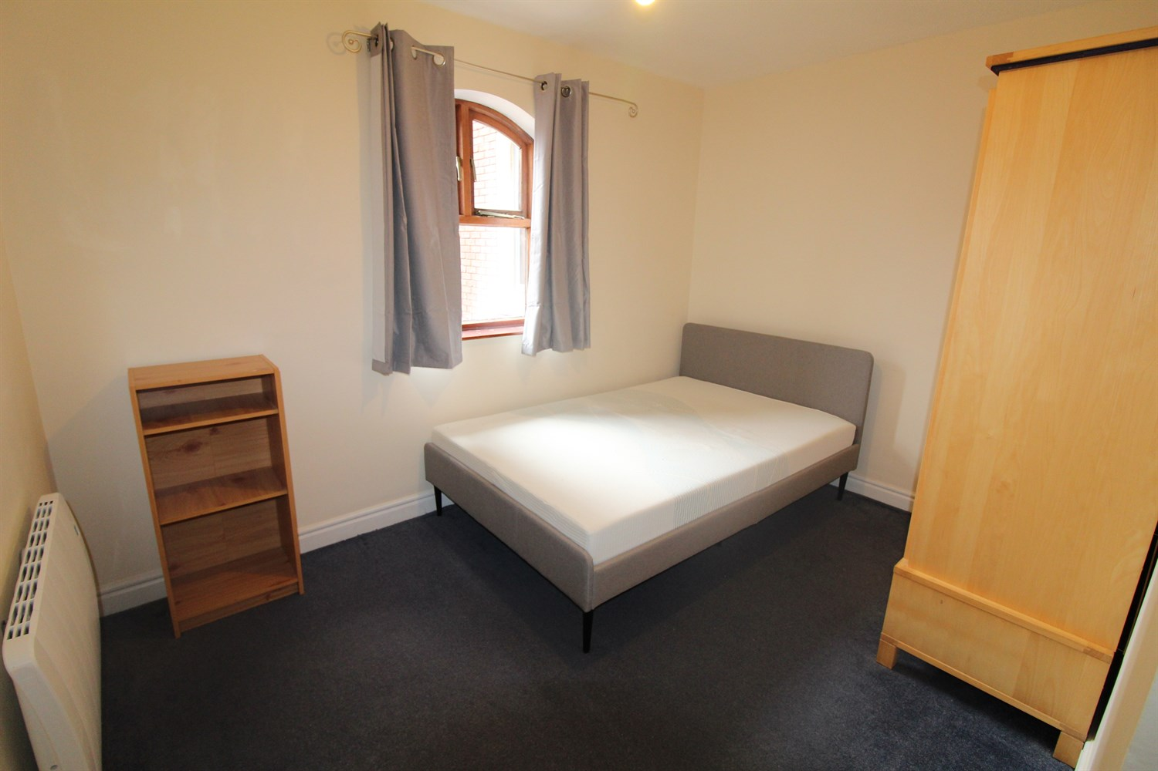

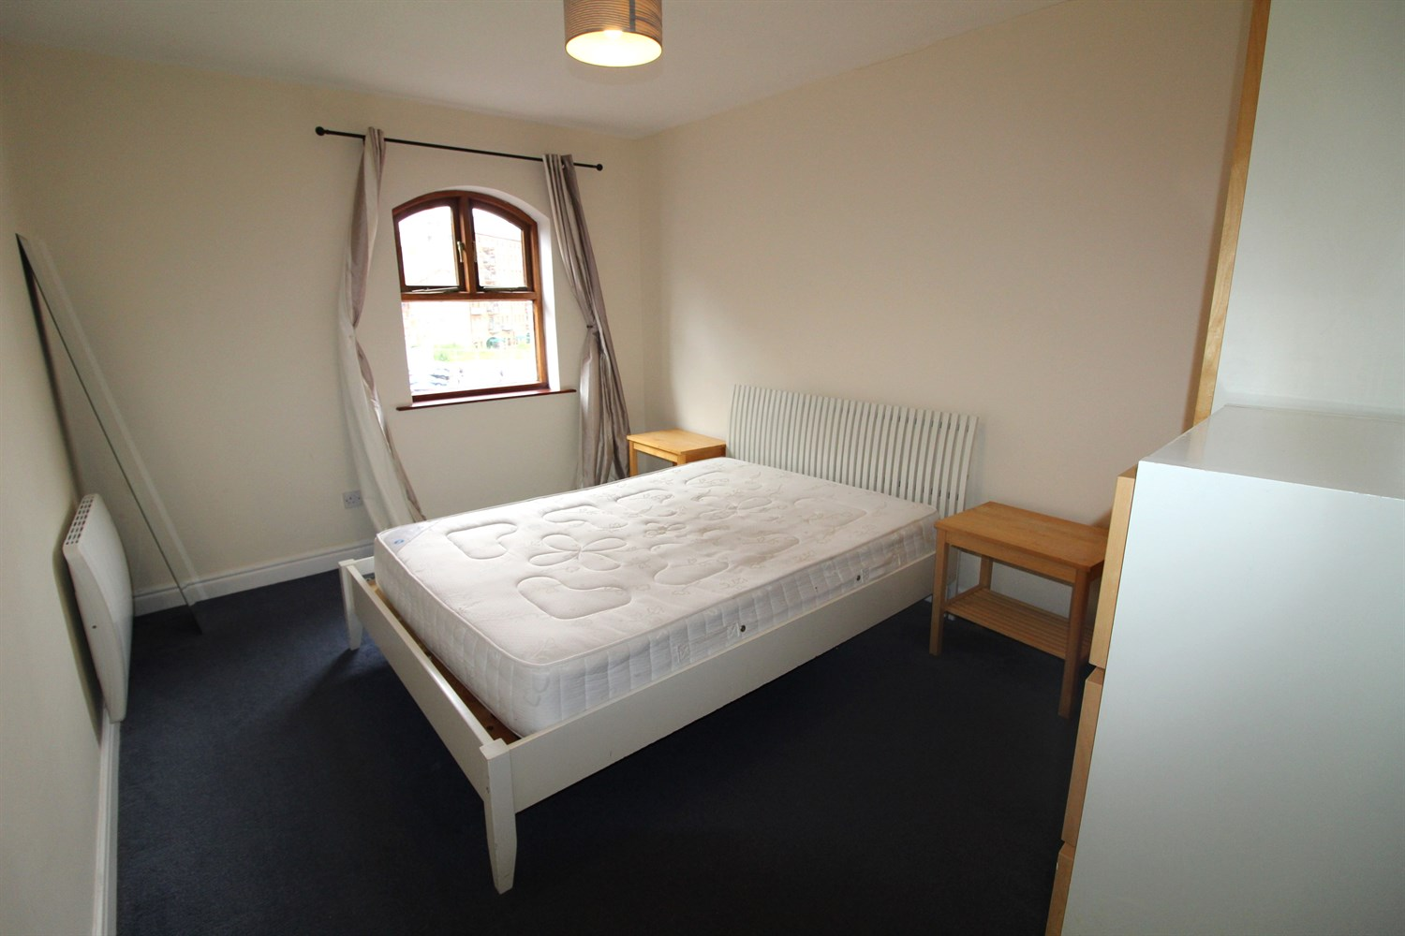

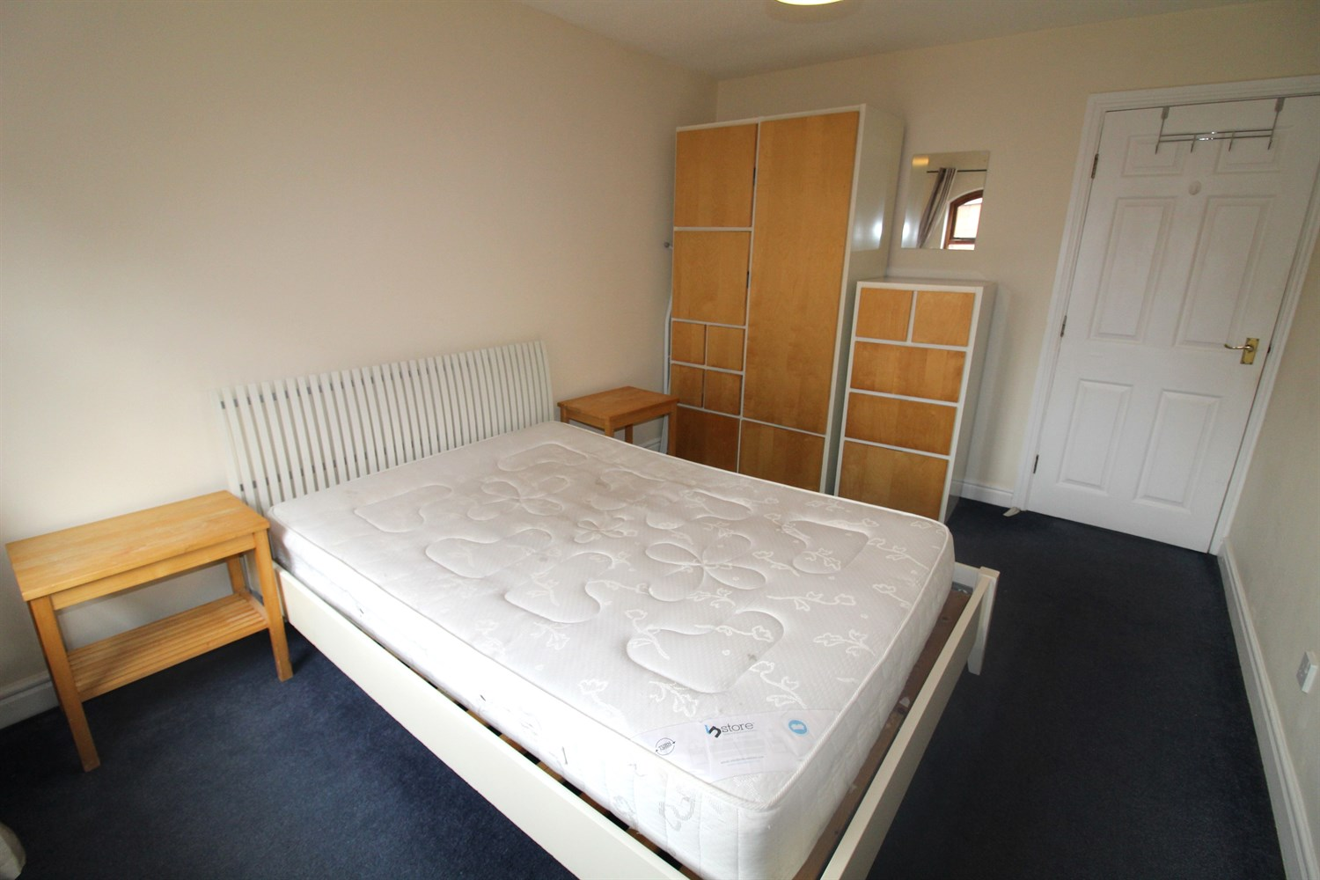

|  |
| --- |
| **Entrance Hallway**  Secure entry phone system. Storage cupboard. |
| **Lounge/Diner**  An attractive lounge with double French doors to a Juliette balcony with side river views. Electric heated Radiator. |
| **Kitchen**  Fitted kitchen with a range of base and wall units with work surfaces over. Part tiled walls. Stainless steel sink with side drainer. Integrated oven with electric hob and extractor hood. Space for washing machine, fridge/freezer and dishwasher. Feature window overlooking the courtyard. |
| **Bedroom 1**  A double bedroom with window to rear. Electric radiator. |
| **Bedroom 2**  A second double room with window to rear. Electric radiator. |
| **Bathroom**  White three piece suite comprising: WC, wash hand basin and bath with shower over. Heated towel rail. Part tiled walls. |
| **Tenure**  Leasehold - 165 years remaining. |
| **Service Charge**  The service charges are £175.00 per month. |
| **Parking** |

|  |  |
| --- | --- |
| These particulars are intended to give a fair description of the property, but their accuracy cannot be guaranteed, and they do not constitute an offer of contract. Intending purchasers must rely on their own inspection of the property. None of the above appliances/services have been tested by ourselves. We recommend purchasers arrange for a qualified person to check all appliances/services before legal commitment.  **Property Ref:** 2679  **For more information, please contact**  0113 258 1150 **|** [sales@adairpaxton.co.uk](mailto:sales@adairpaxton.co.uk) **|** www.adairpaxton.co.uk |  |