

Keldregate, Huddersfield
For Sale £225,000.00

**BEAUTIFULLY PRESENTED THREE BEDROOM EXTENDED BUNGALOW** Offering superb accommodation, and a luxury finish throughout, bungalows of this caliber are rare to the market in such a sought after location. Situated in the well established residential area of Deighton, conveniently placed for schools, local amenities, public transport routes as well as being close to the M62 networks with access to neighbouring Leeds and Manchester. The property briefly comprises; entrance hall, sitting room opening to dining area/sunroom, kitchen, two bedrooms and a shower room to the ground floor. To the first floor there is a master bedroom with an en-suite bathroom. Externally the property has off street parking to the front of the property and an enclosed garden to the rear. Boasting a modern finish throughout and NO ONWARD CHAIN, early internal viewing is highly recommended.
0113 258 1150
0800 000 000
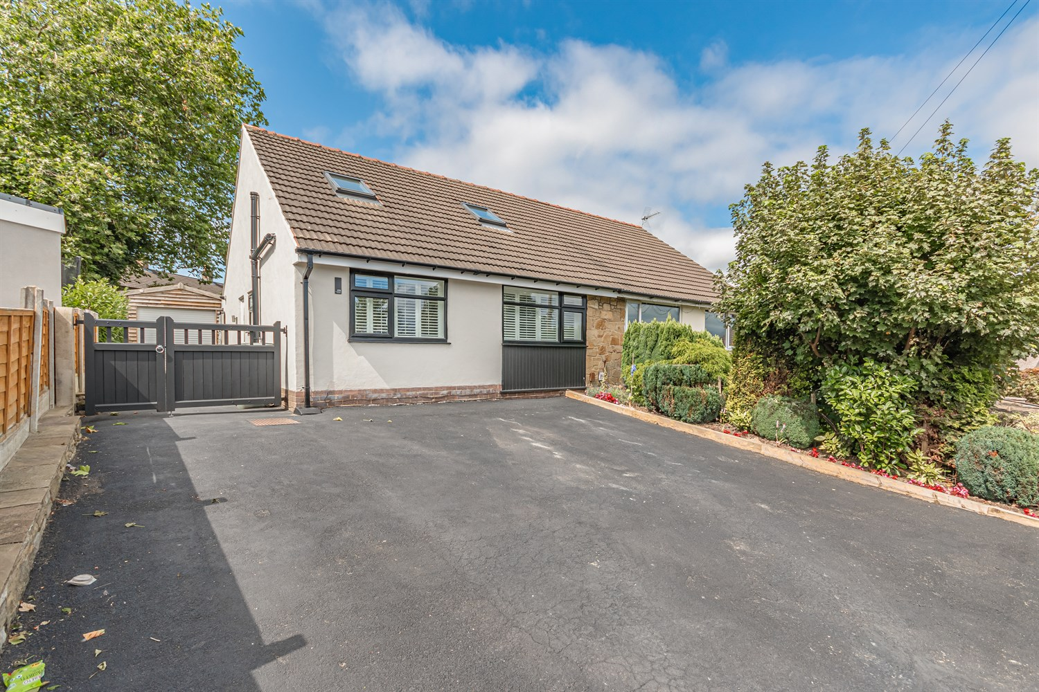
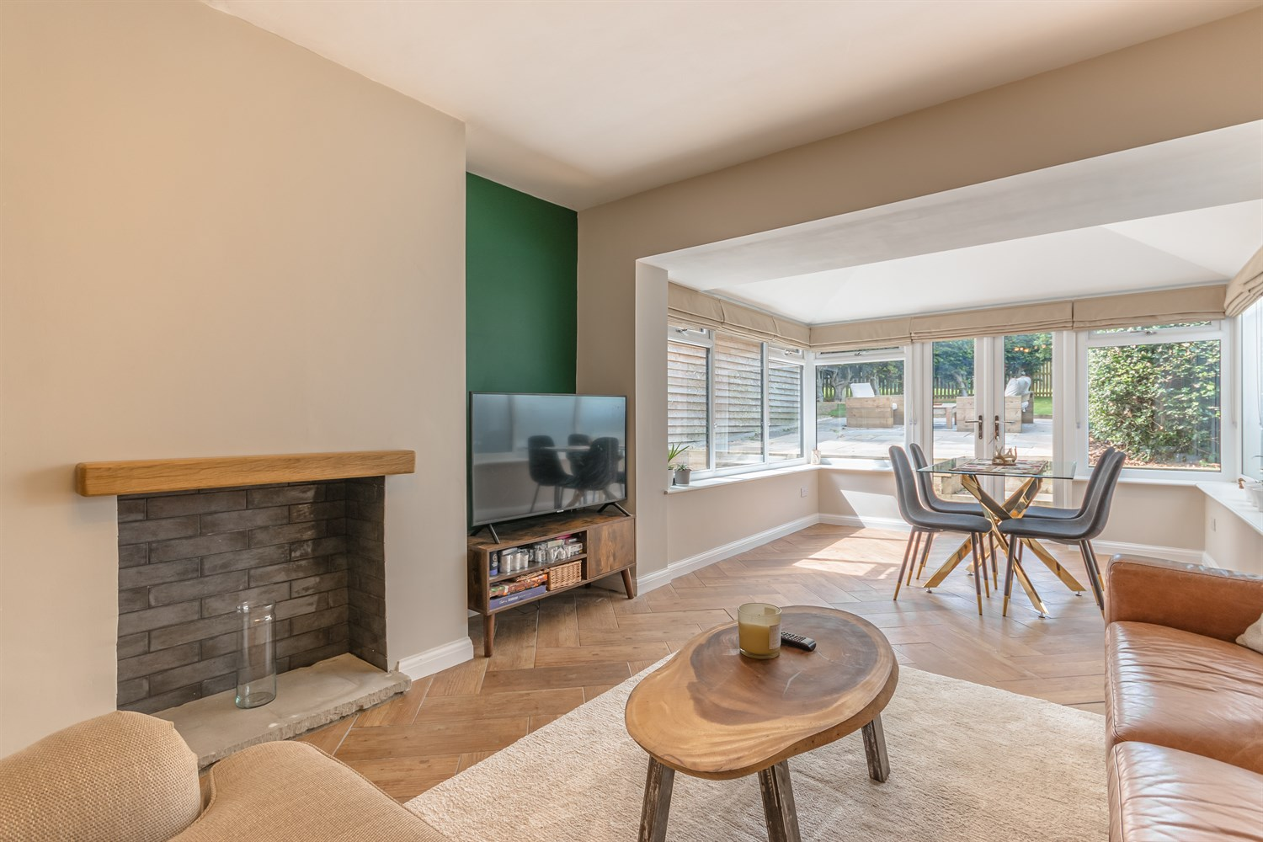
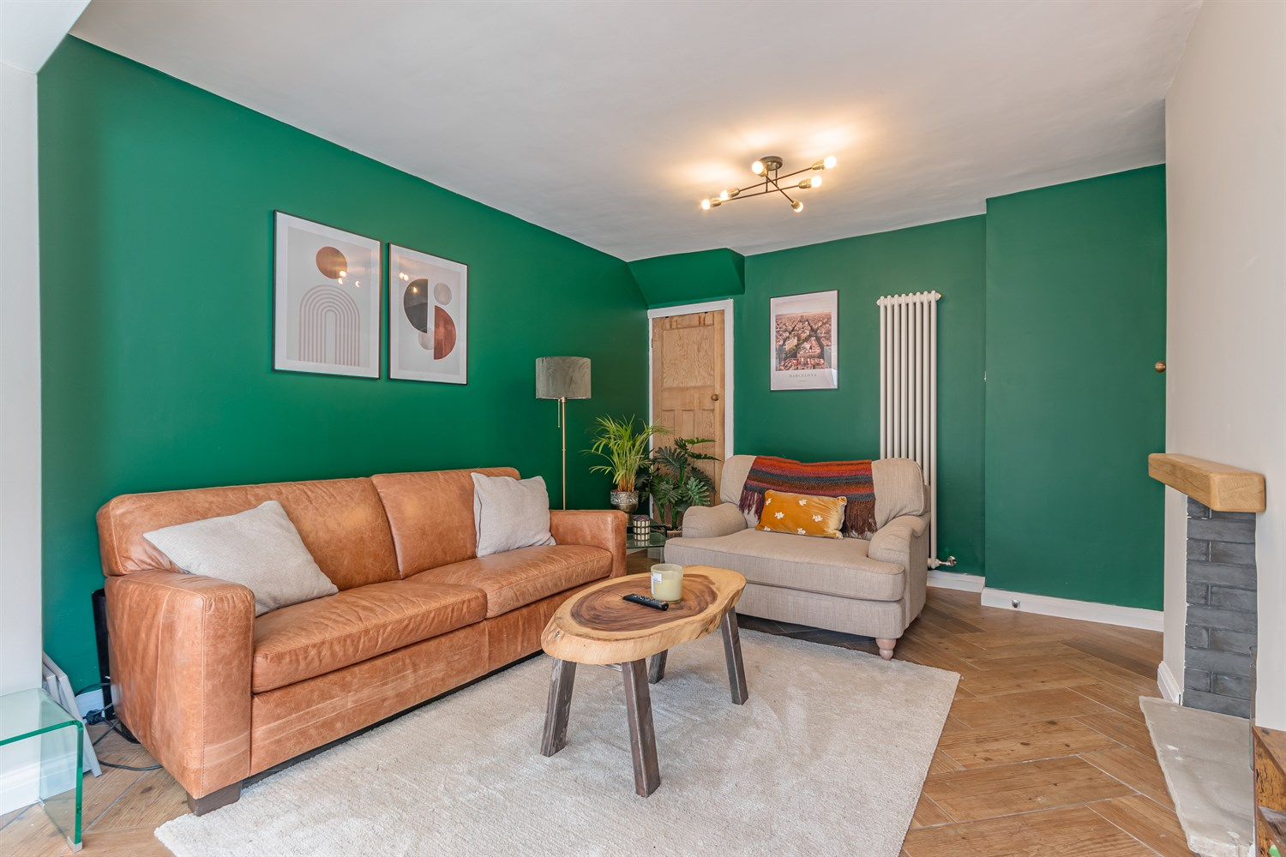
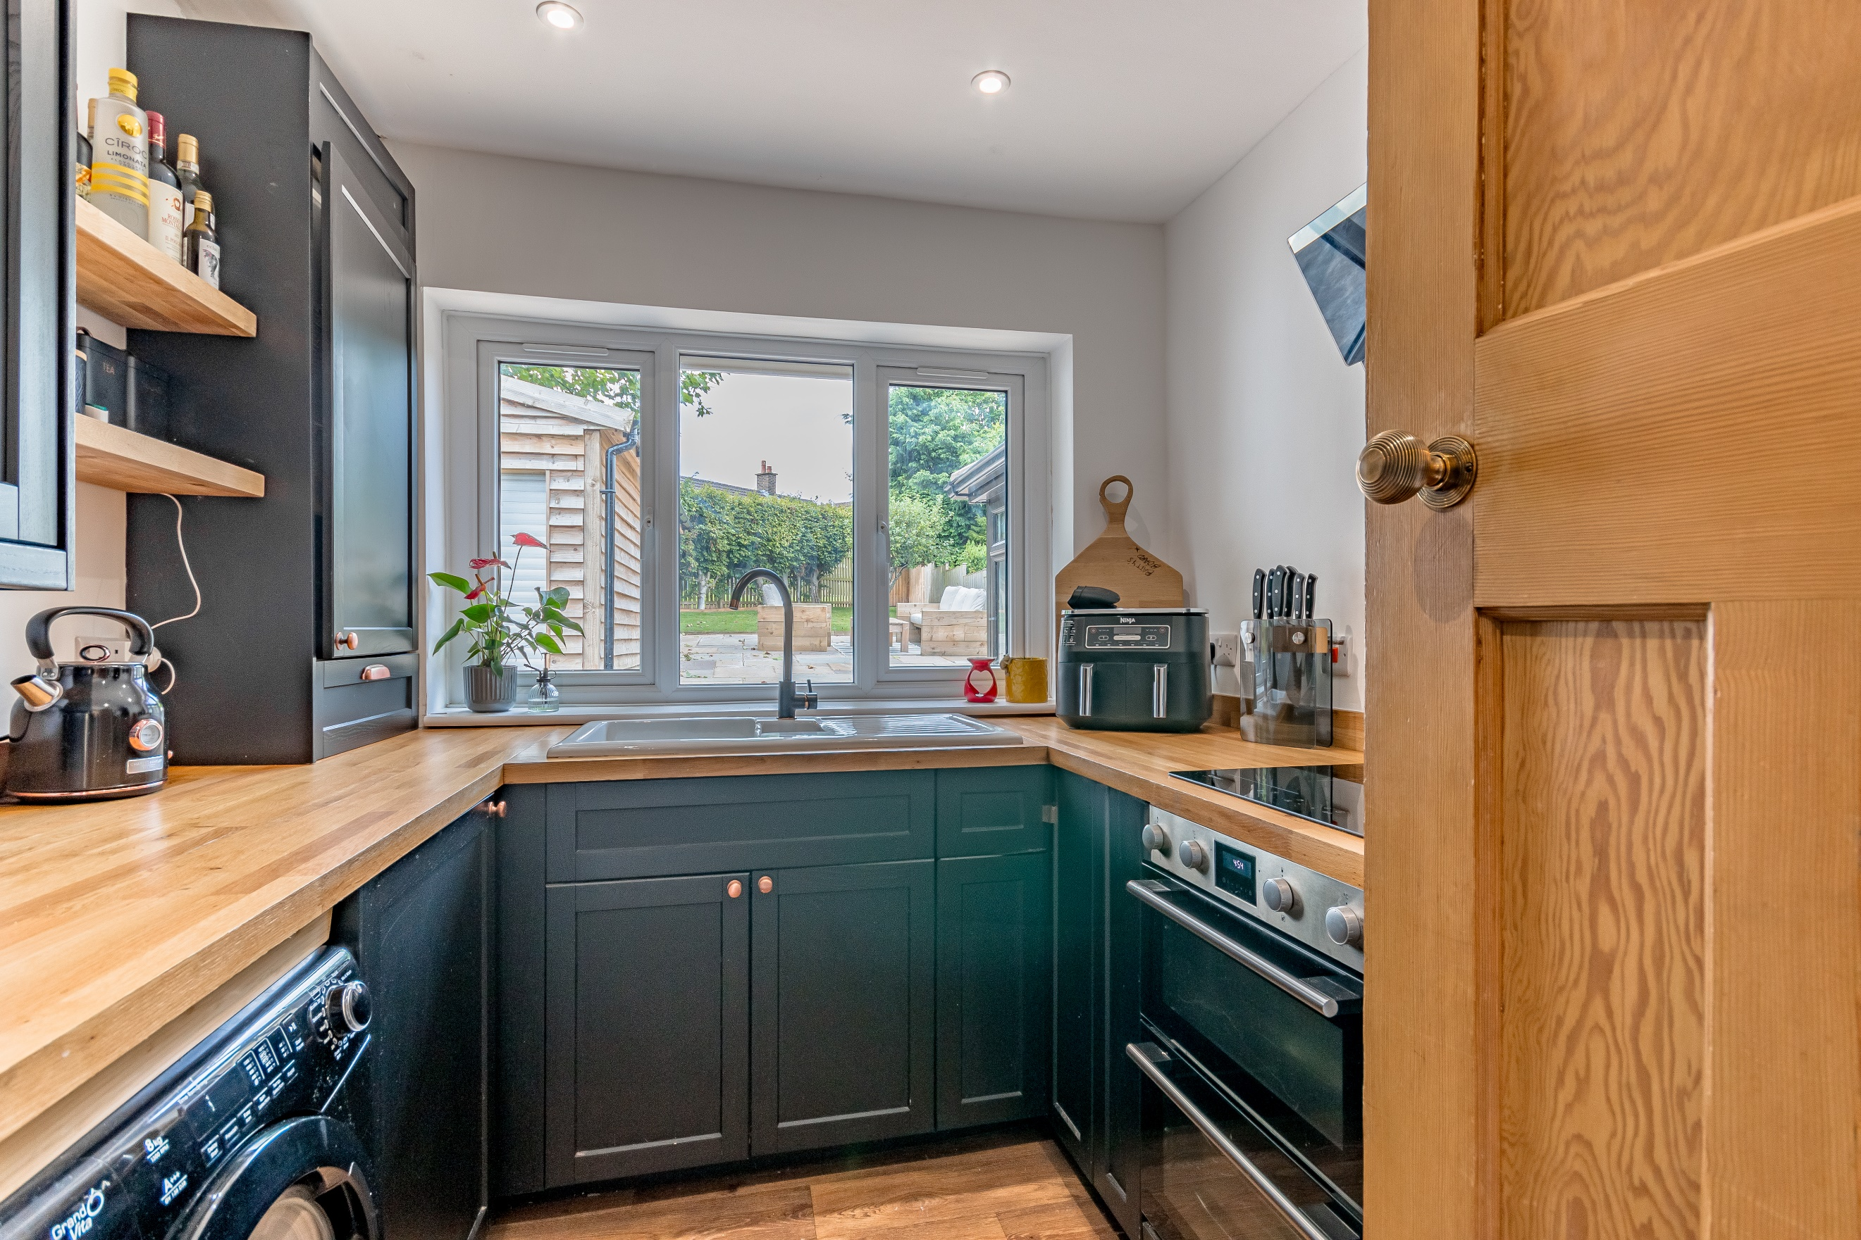
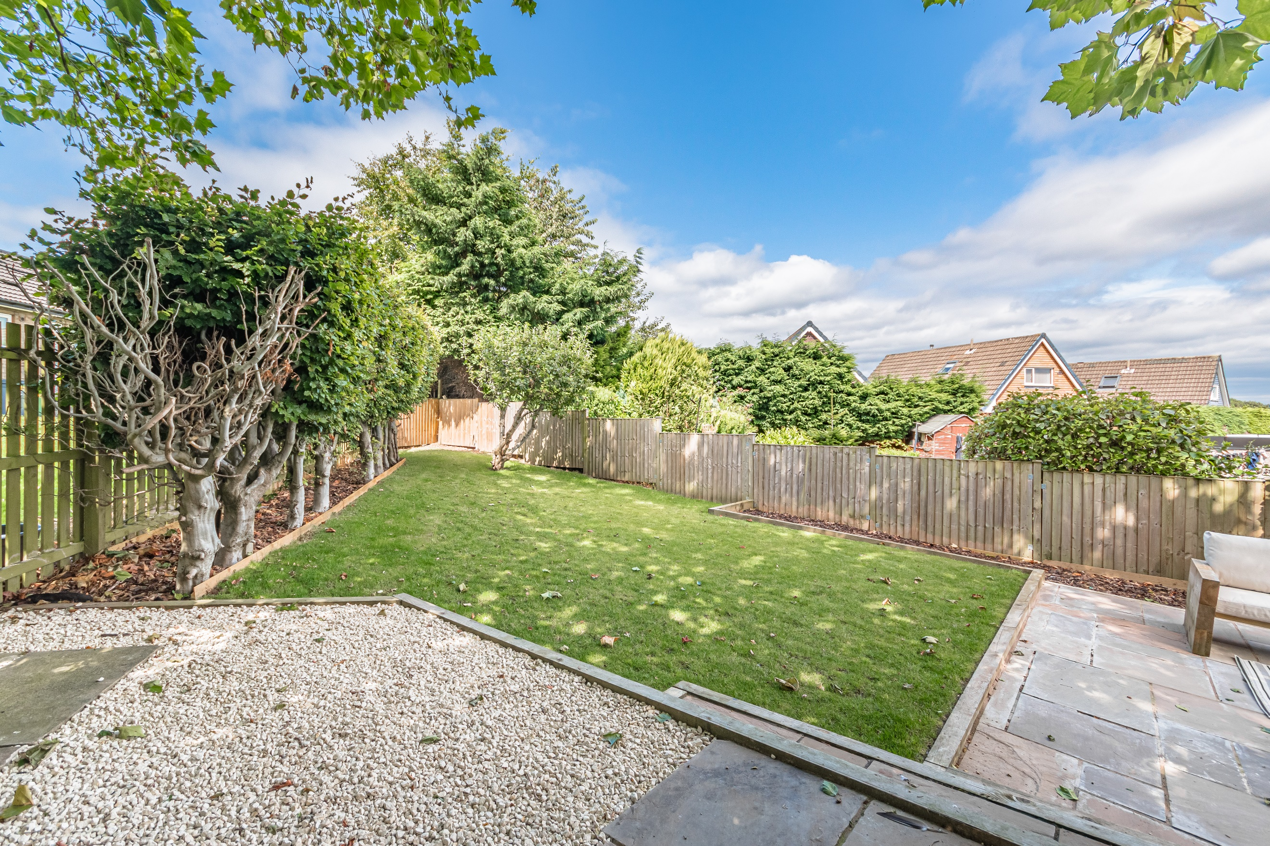
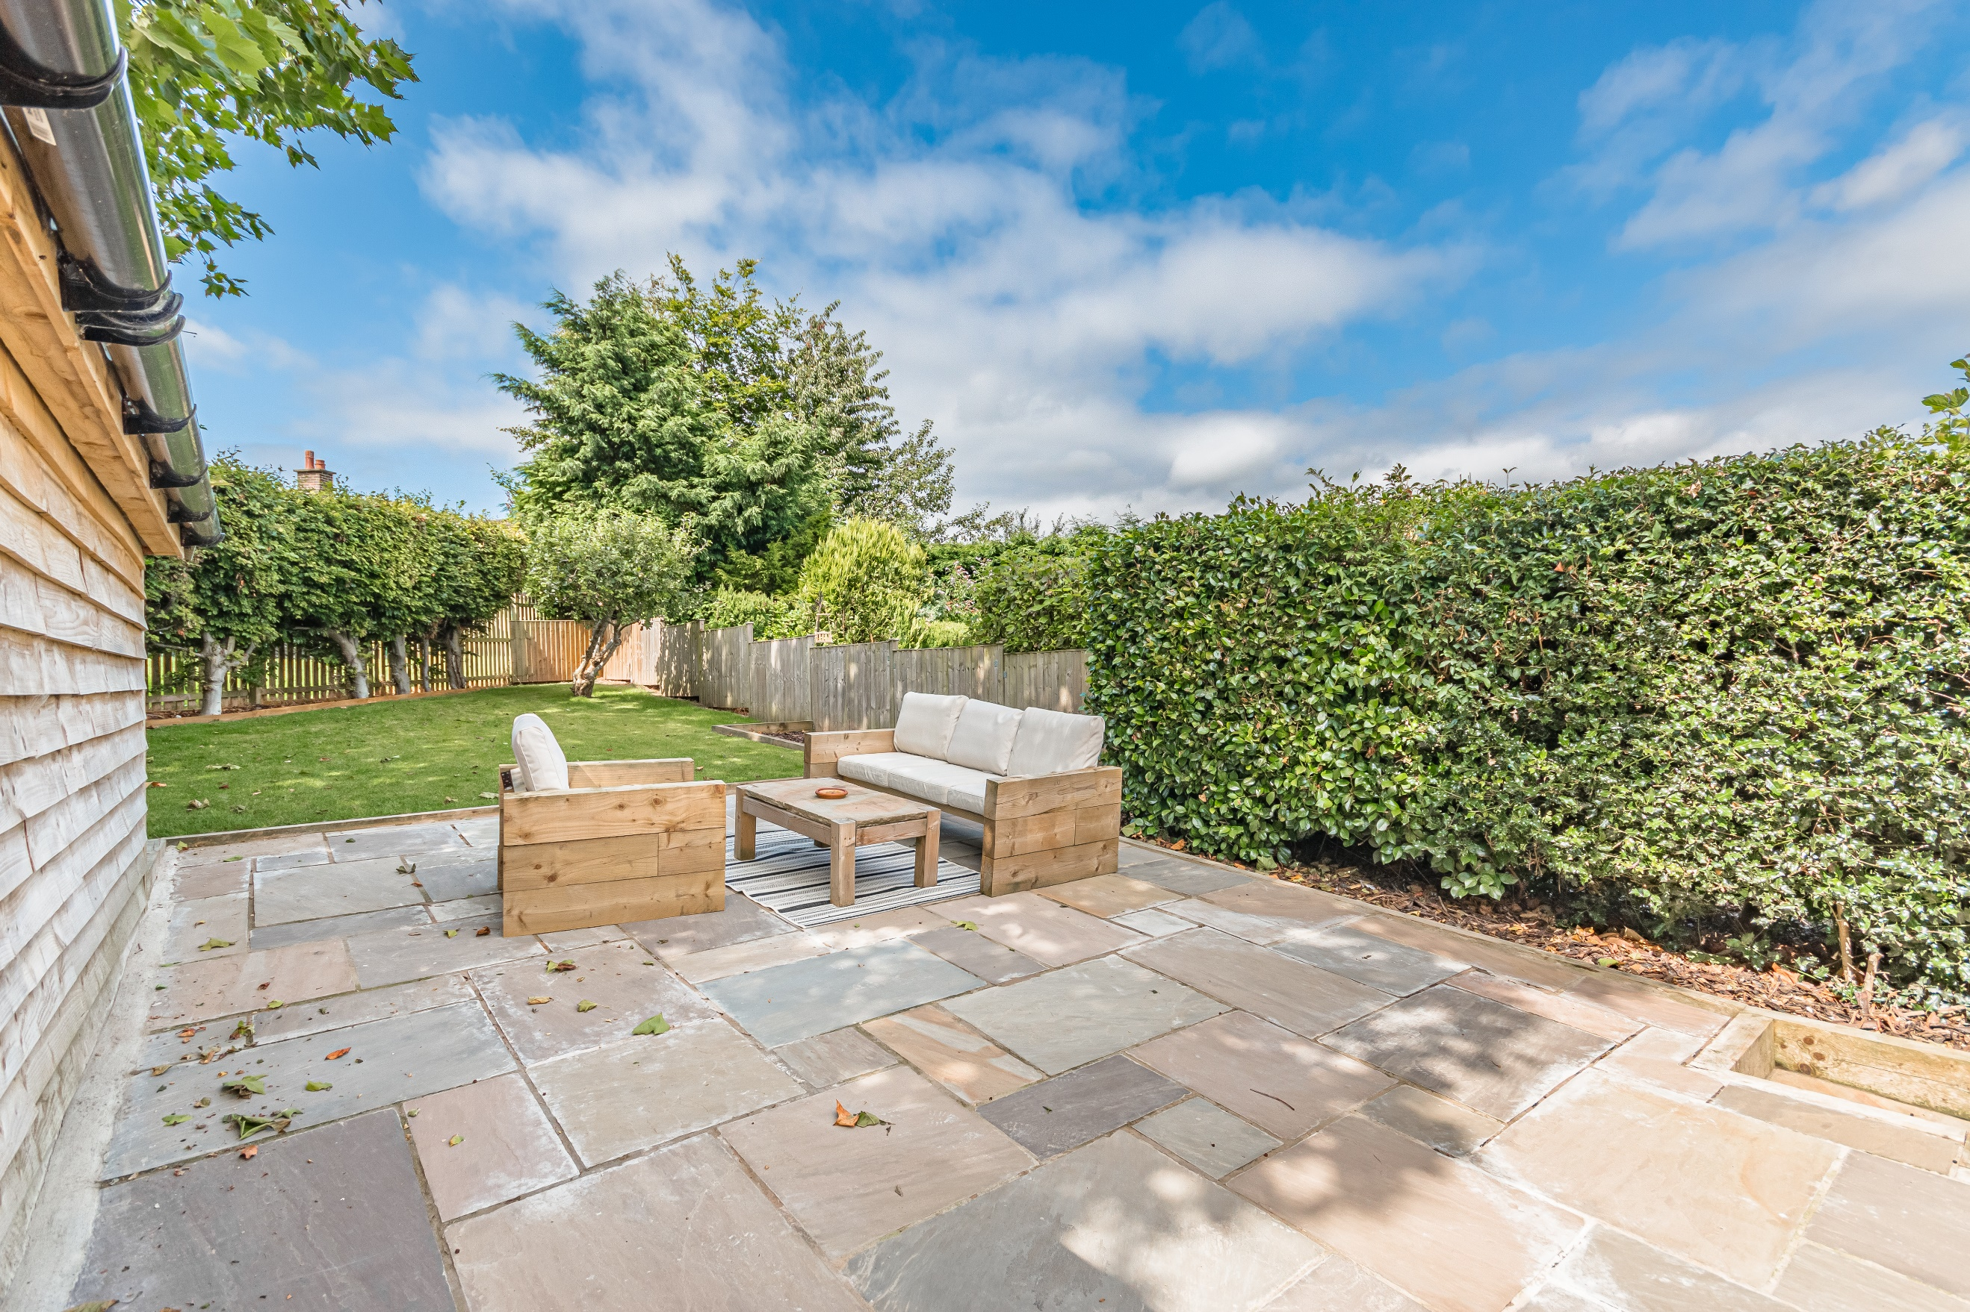
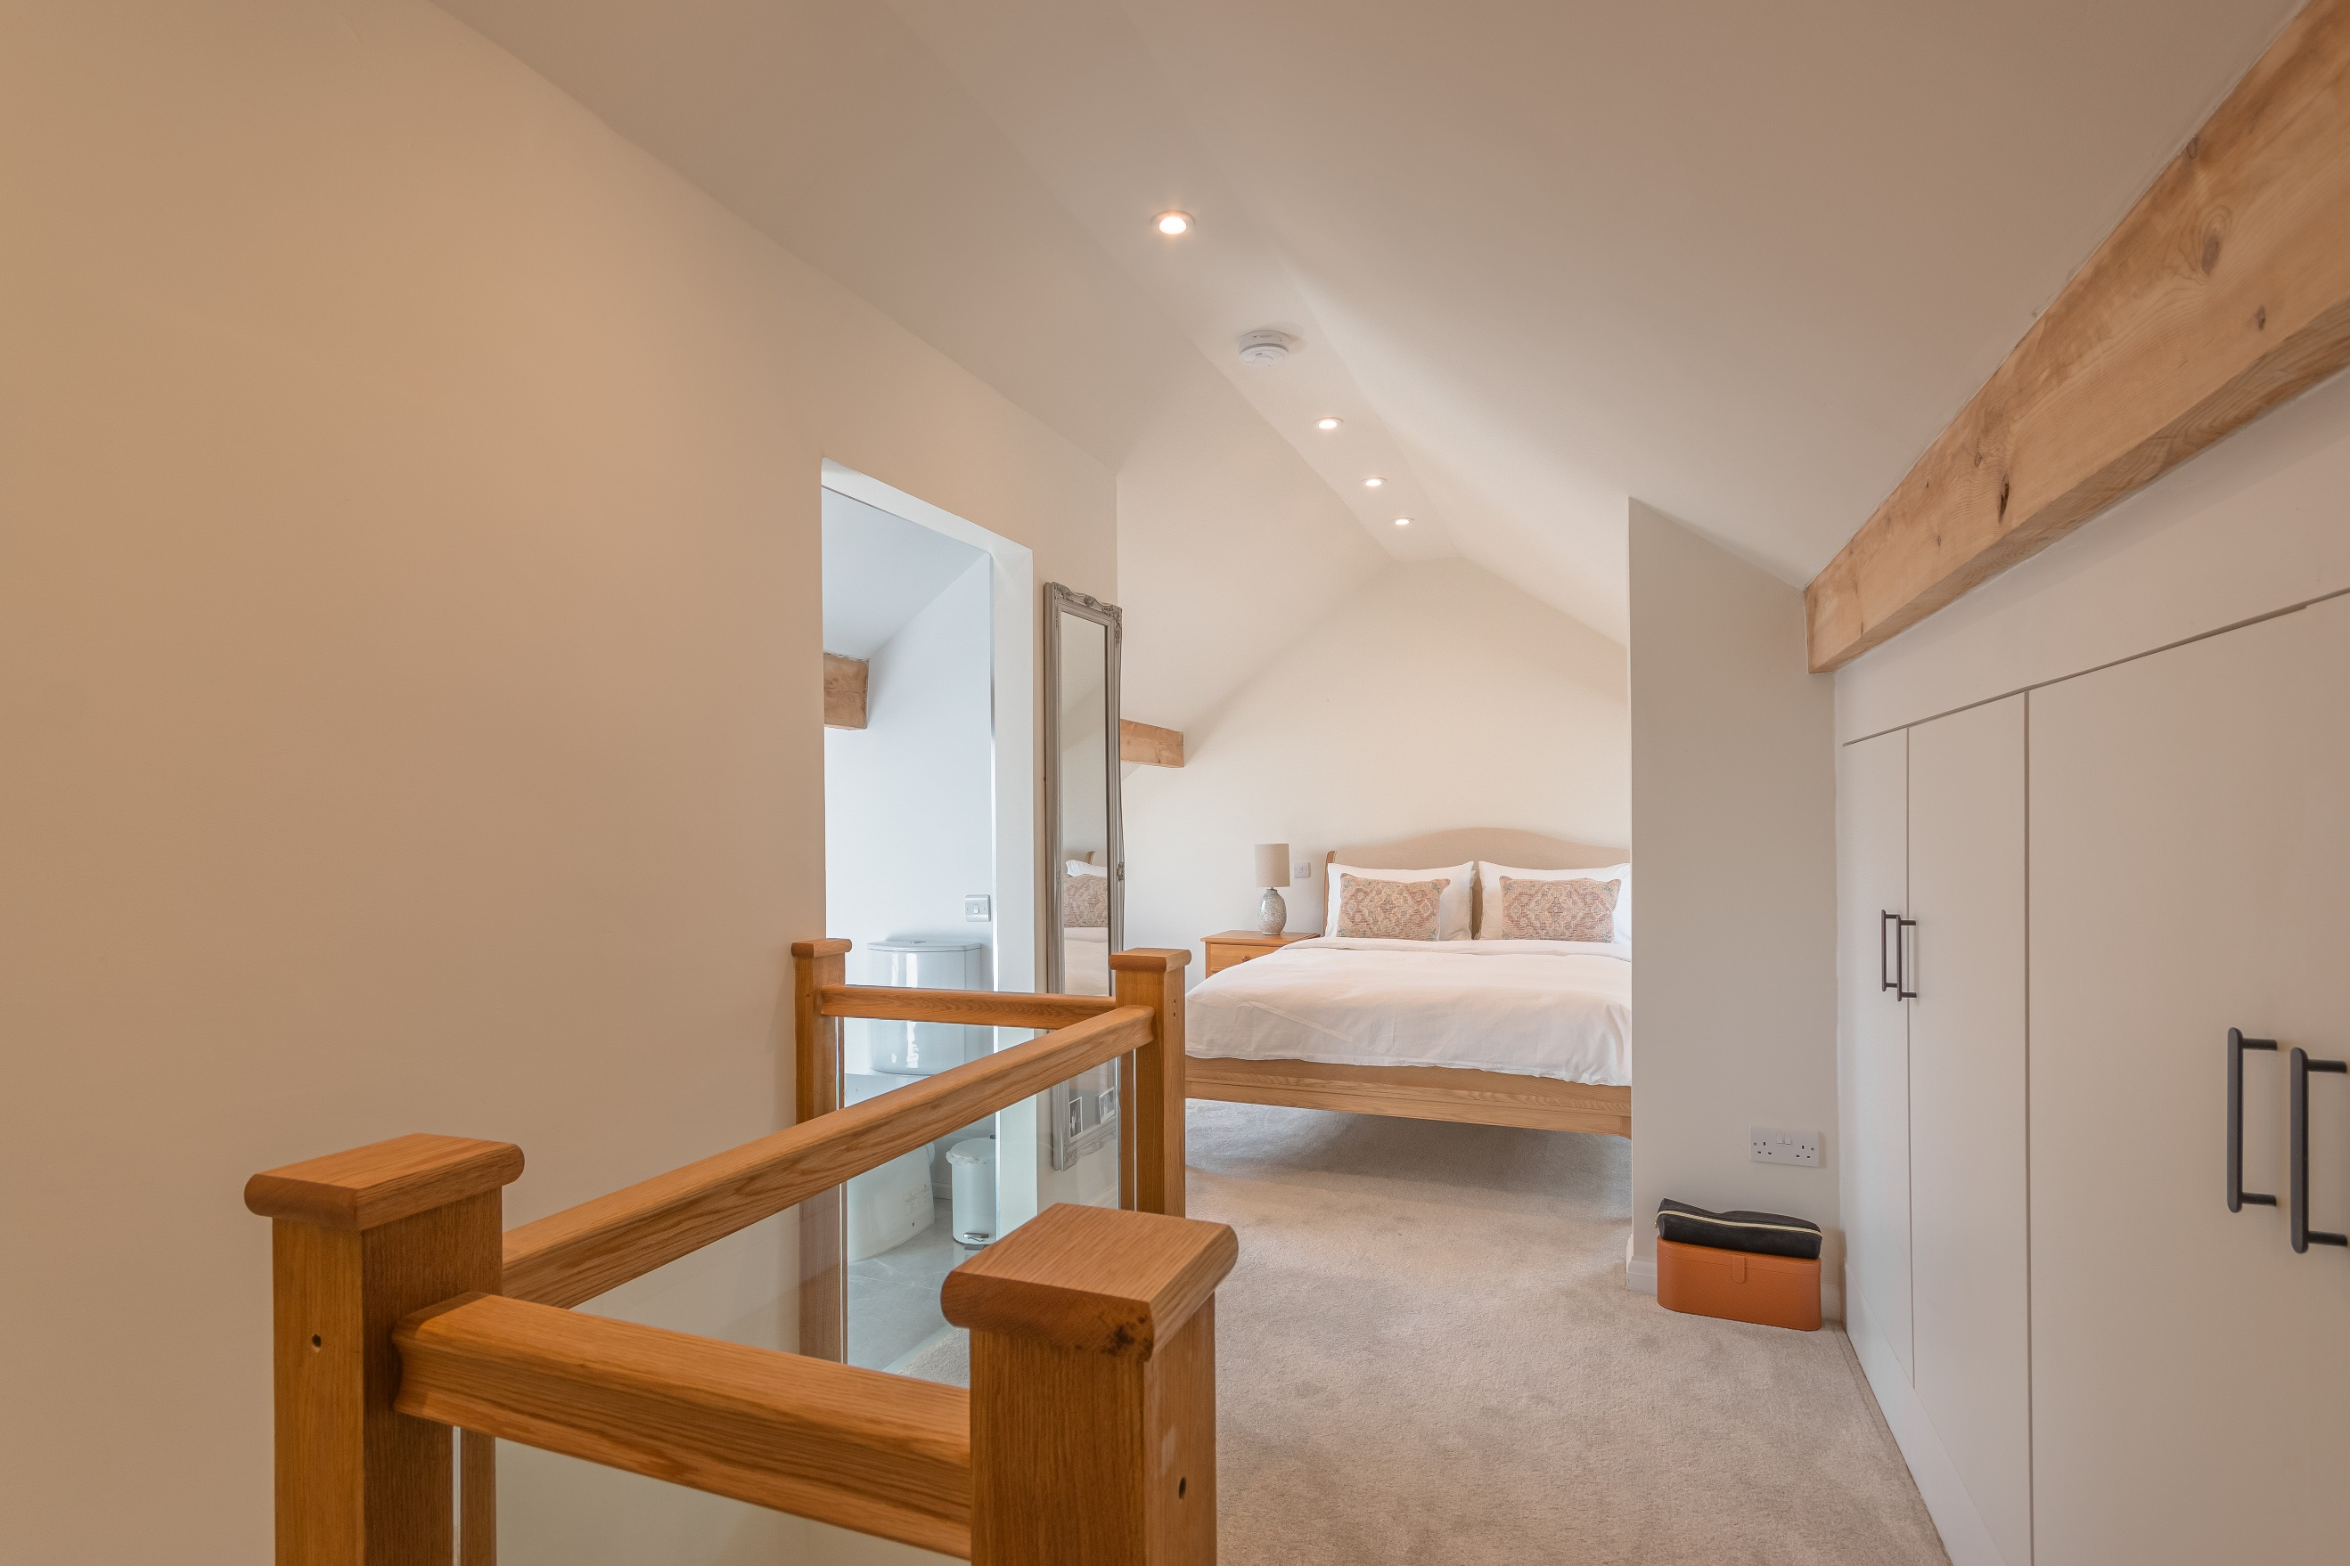
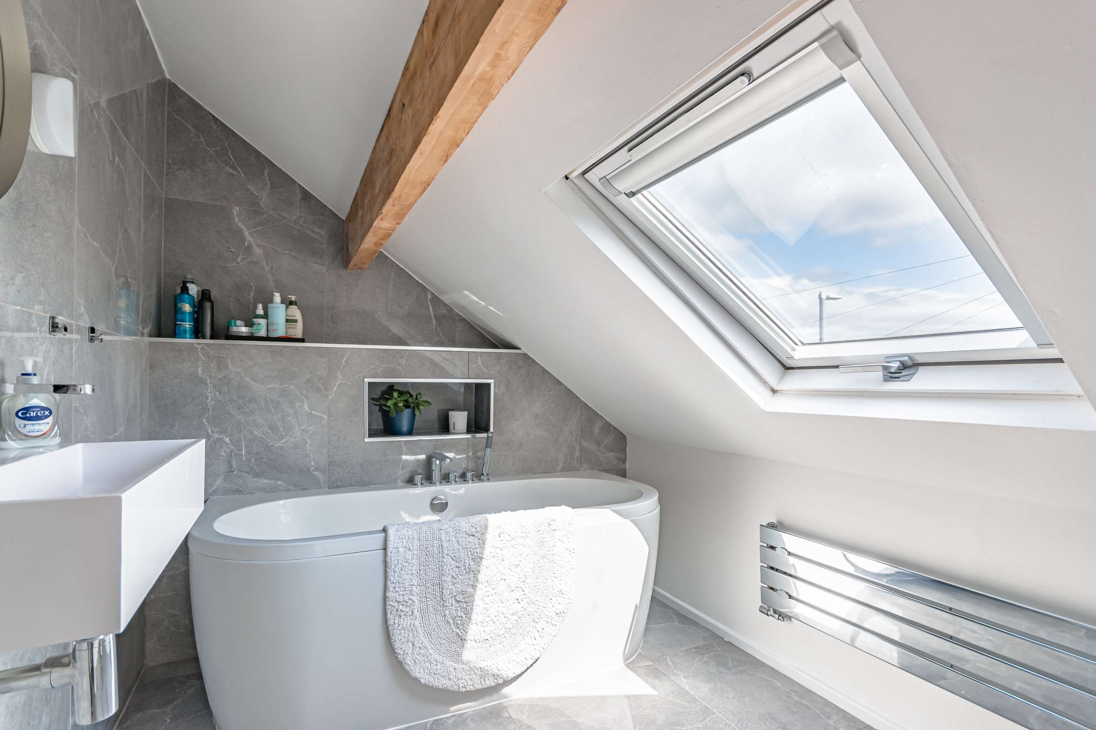
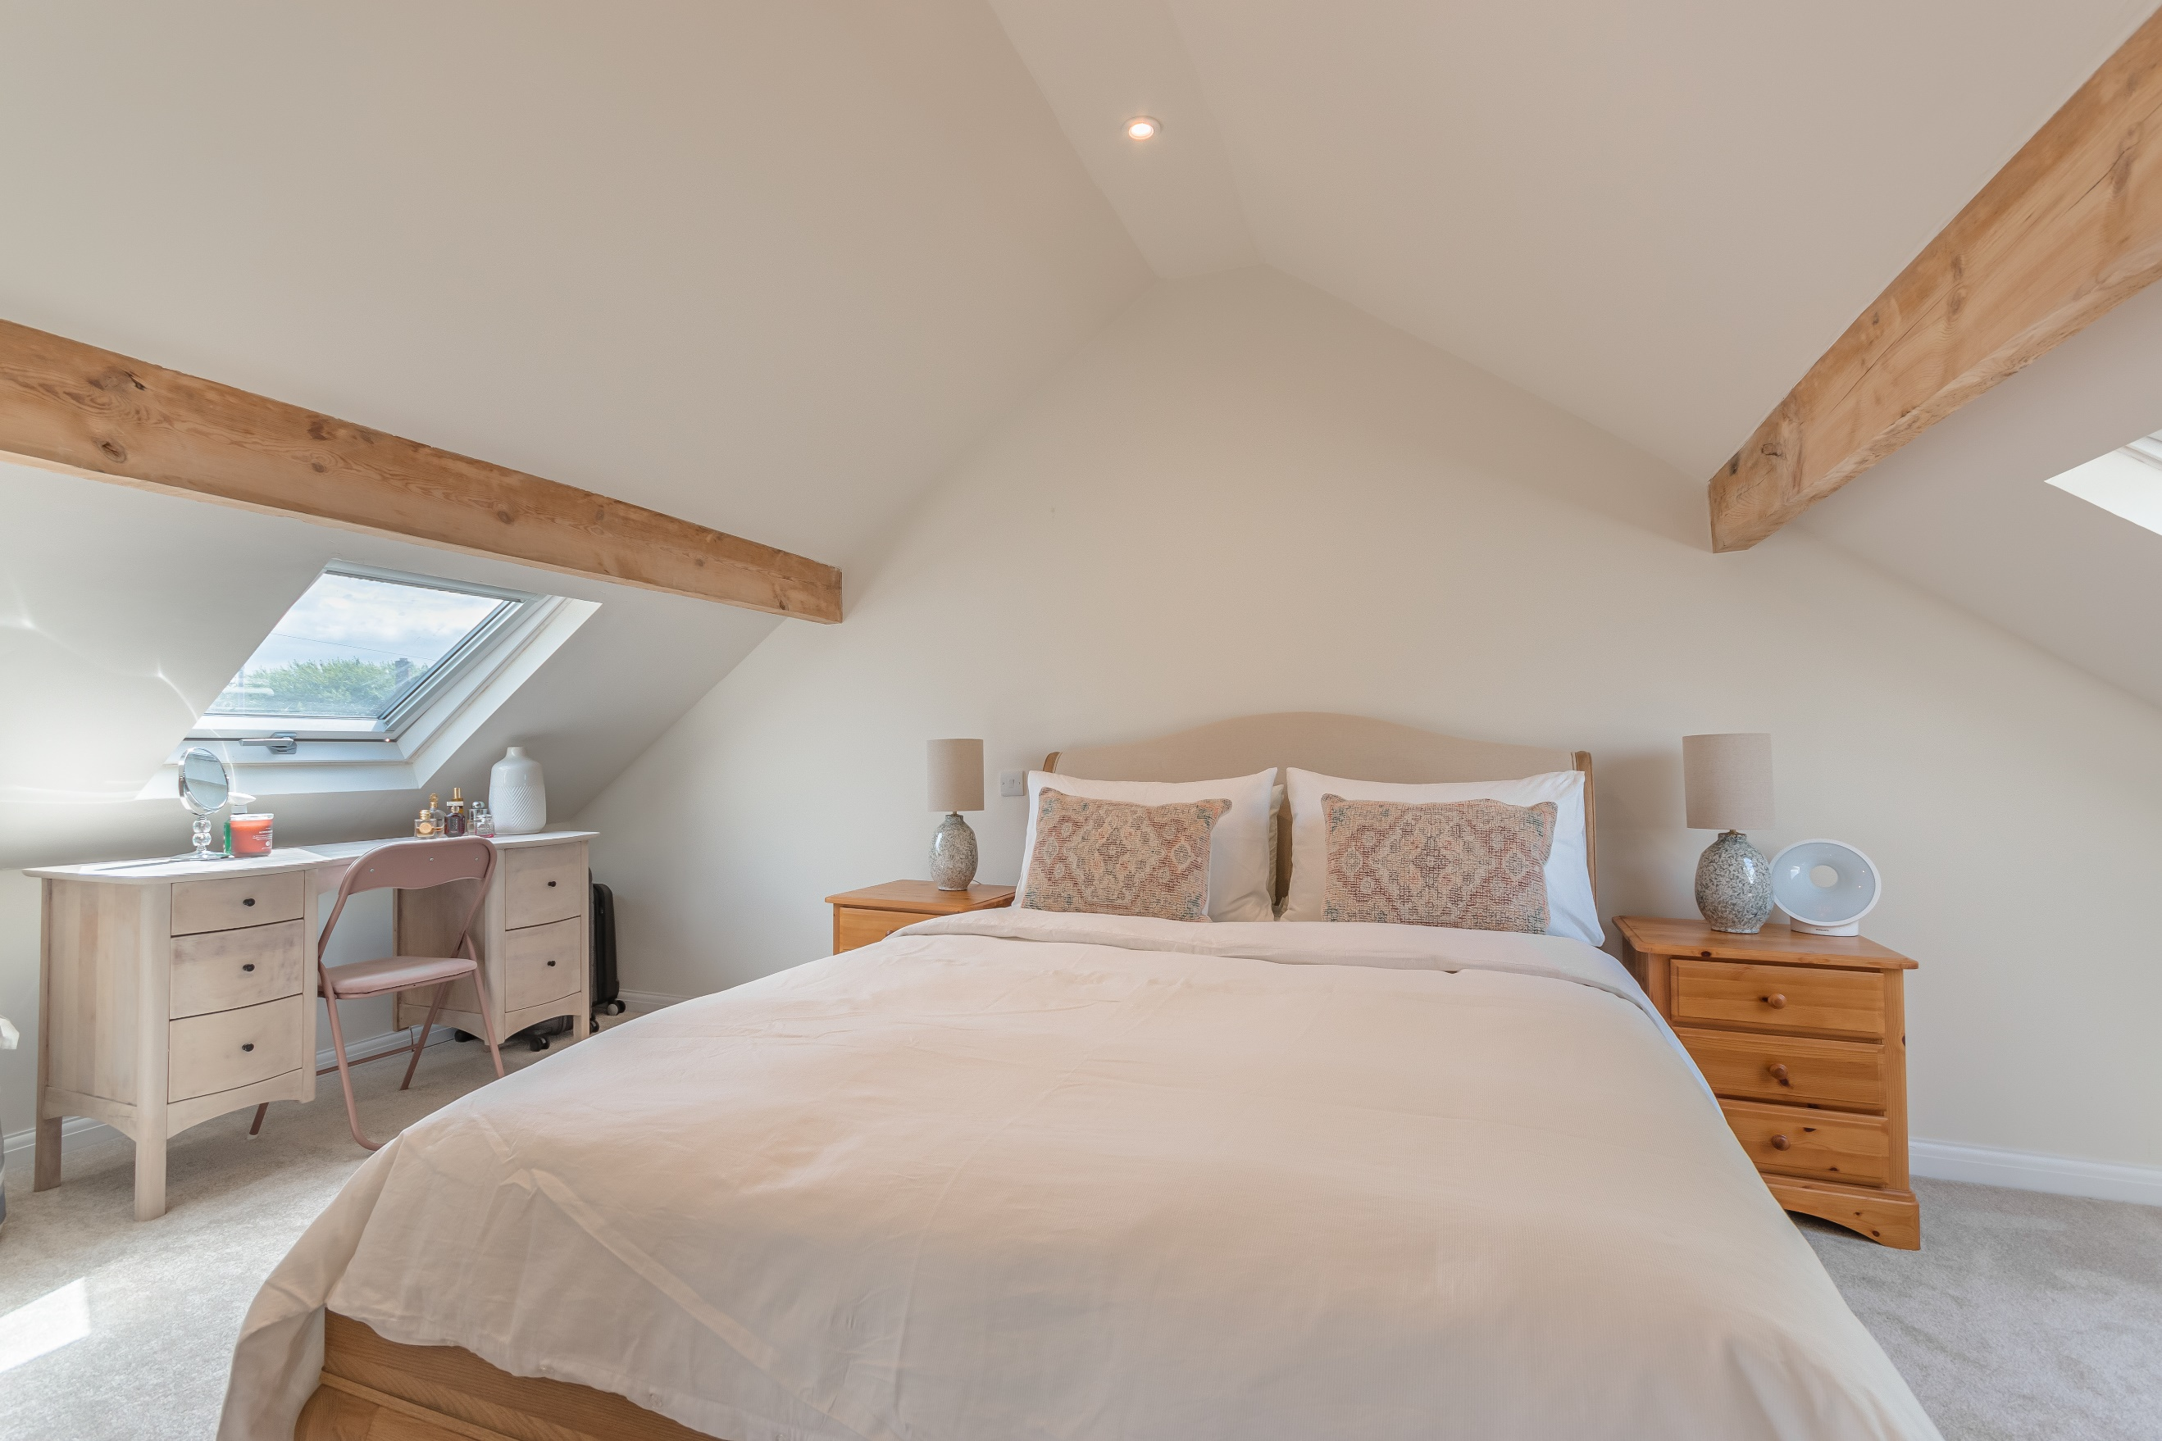

Entrance Hall
Via entrance door.

Kitchen
Fitted with a range of wall, base and drawer units with worktops over. Integrated double oven with 4-ring hob and extractor hood over. 1.5 bowl sink with mixer tap and drainer. Space for washing machine. Inset ceiling spotlights. uPVC double glazed window to rear.

Sitting Room
Light and airy living area with feature open fireplace ideal for log burning stove. Tall gas central heating radiator.

Dining Area/Sun Room
Opening from the living area, boasting ample natural light through uPVC double glazed windows to three sides. uPVC double glazed doors leading out to the rear garden. Inset ceiling spotlights.

Bedroom
Double bedroom with uPVC double glazed window to front. Gas central heating radiator.

Bedroom
Second bedroom with uPVC double glazed window to front. Gas central heating radiator.

Shower Room
Stylish shower room fitted with a walk in shower cubicle, vanity wash hand basin and WC. Tiled walls and floor. wall mounted heated towel rail. uPVC double glazed window.

First Floor

Master Bedroom
Master double bedroom with exposed beams and Velux windows to front and rear. Inset ceiling spotlights. Under eaves storage cupboards.

En-Suite Bathroom
Fitted with a three piece white suite comprising; bath with mixer tap and hand held shower, wash hand basin and WC. Tiled walls and floor. Velux window. Chrome gas central heating radiator.

Outside the Property
The low maintenance gardens are a particular feature of this property. To the front of the property there is a driveway providing off street parking for a number of vehicles and a bed with plants and shrubs. To the rear there is an enclosed garden with a spacious Indian stone paved patio area with a garden beyond, the raised garden has been mainly laid to lawn with borders of wood chippings. Detached garage with up and over door.

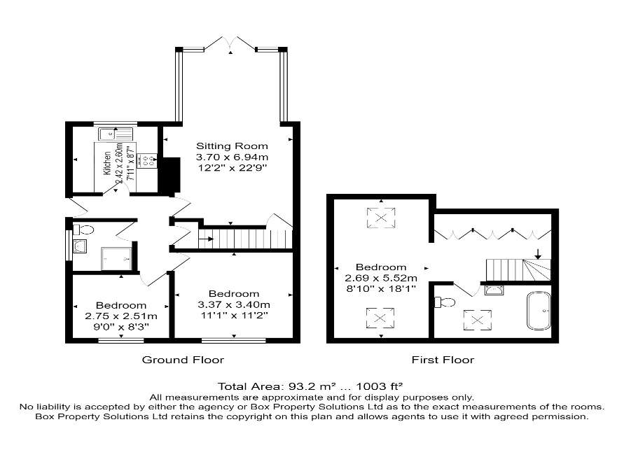

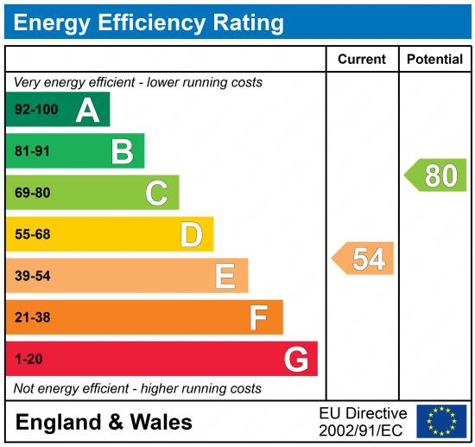

These particulars are intended to give a fair description of the property, but their accuracy cannot be guaranteed, and they do not constitute an offer of contract. Intending purchasers must rely on their own inspection of the property. None of the above appliances/services have been tested by ourselves. We recommend purchasers arrange for a qualified person to check all appliances/services before legal commitment.

Property Ref: 3387

For more information, please contact

0113 258 1150 | sales@adairpaxton.co.uk | www.adairpaxton.co.uk

