

**0113 258 1150**

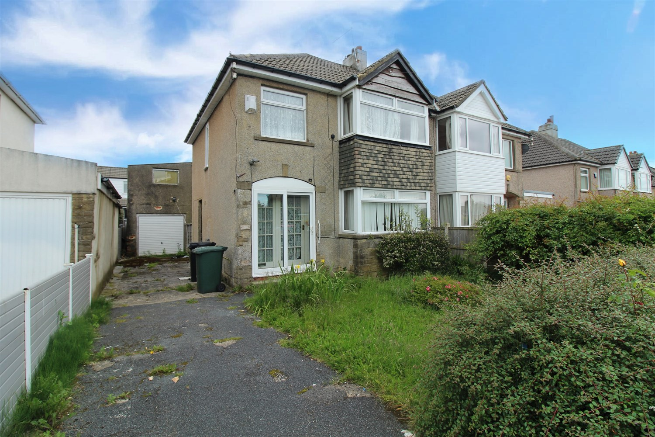



**For Sale £139,950.00**

**Goose Cote Lane, Oakworth**

**THREE BEDROOM SEMI-DETACHED HOUSE IN NEED OF A FULL RENOVATION** The property is well placed for access to both Oakworth village amenities and Keighley town centre. The property is now in need of updating and briefly comprises; Entrance hall, lounge, dining room and kitchen to the ground floor. To the first floor there are two double bedrooms, a single bedroom and a house bathroom. Externally, the property has a driveway offering off street parking and an enclosed garden to the rear.

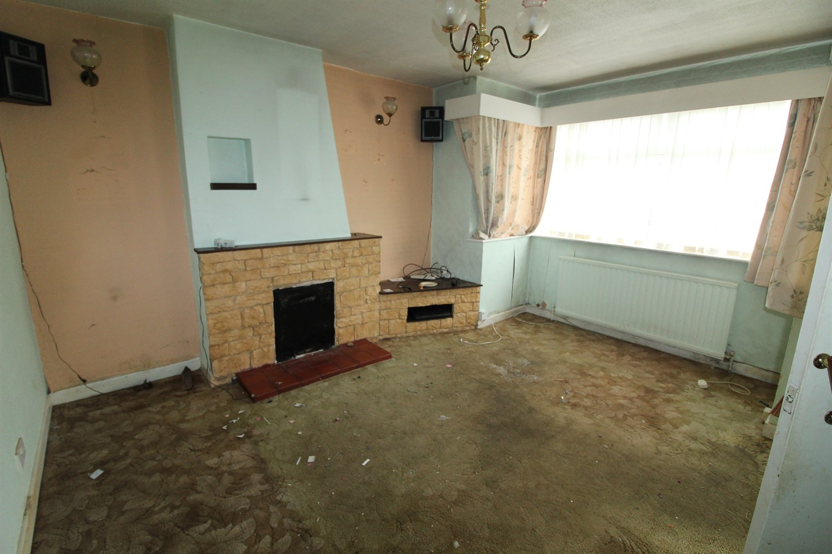

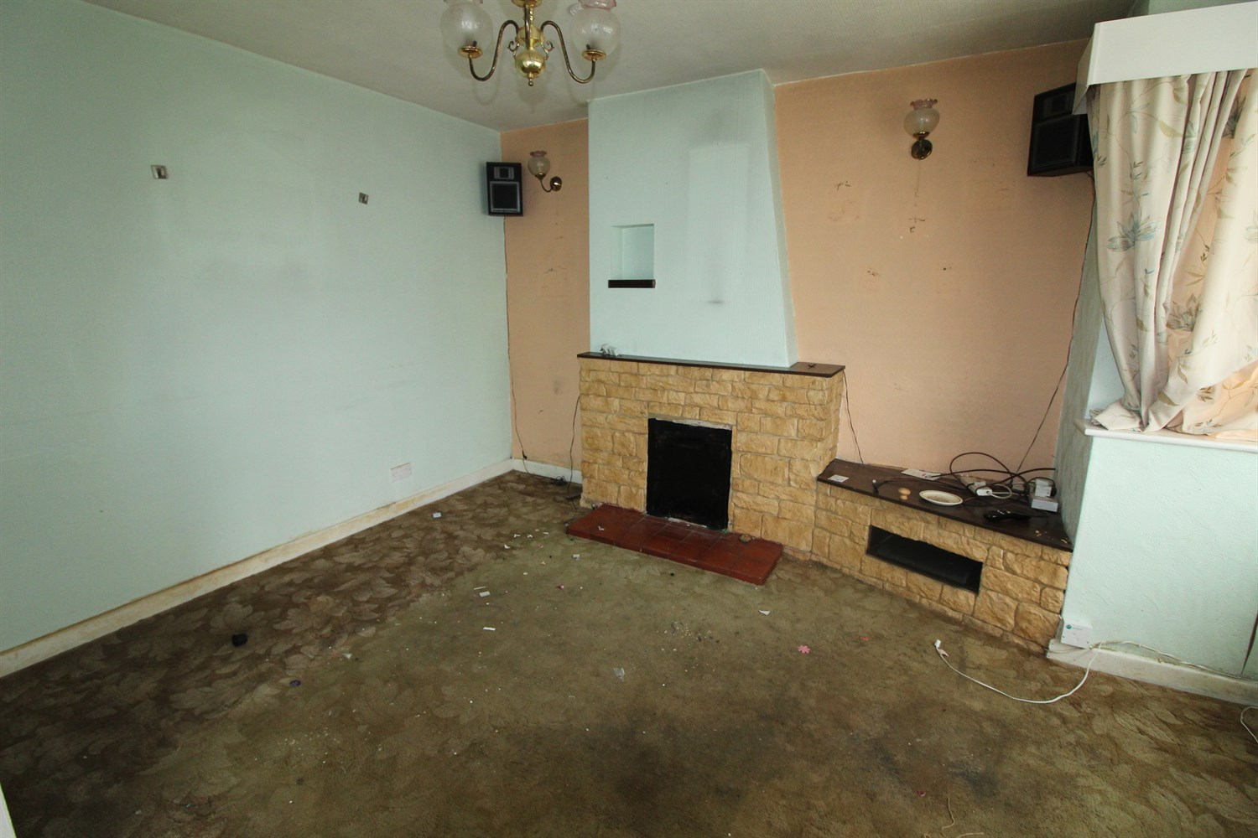

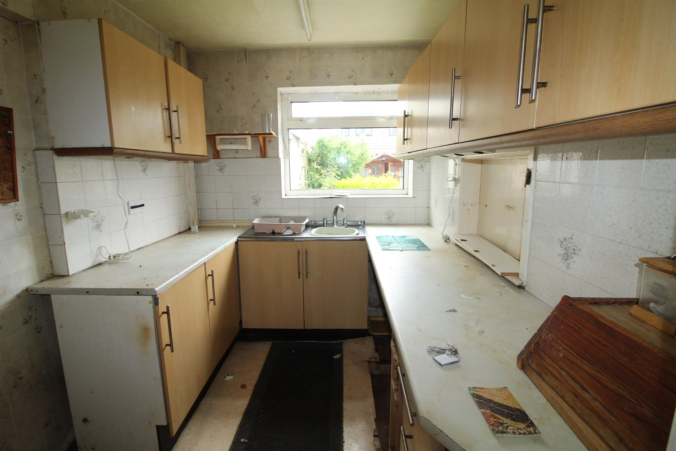

1 Bathroom(s)

2 Reception(s)

3 Bedroom(s)

00

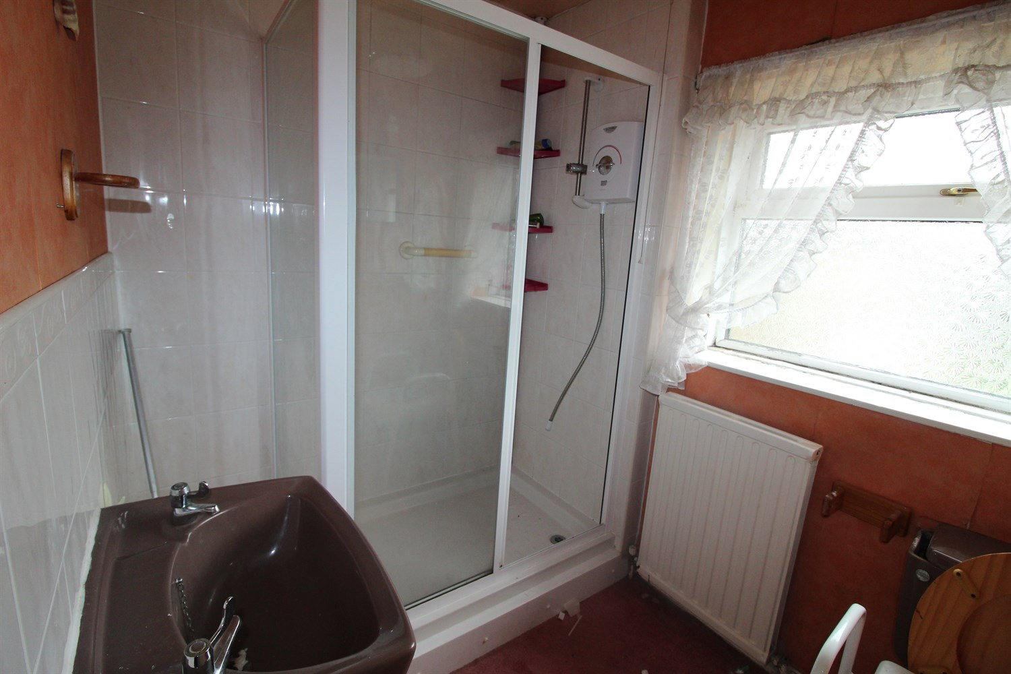

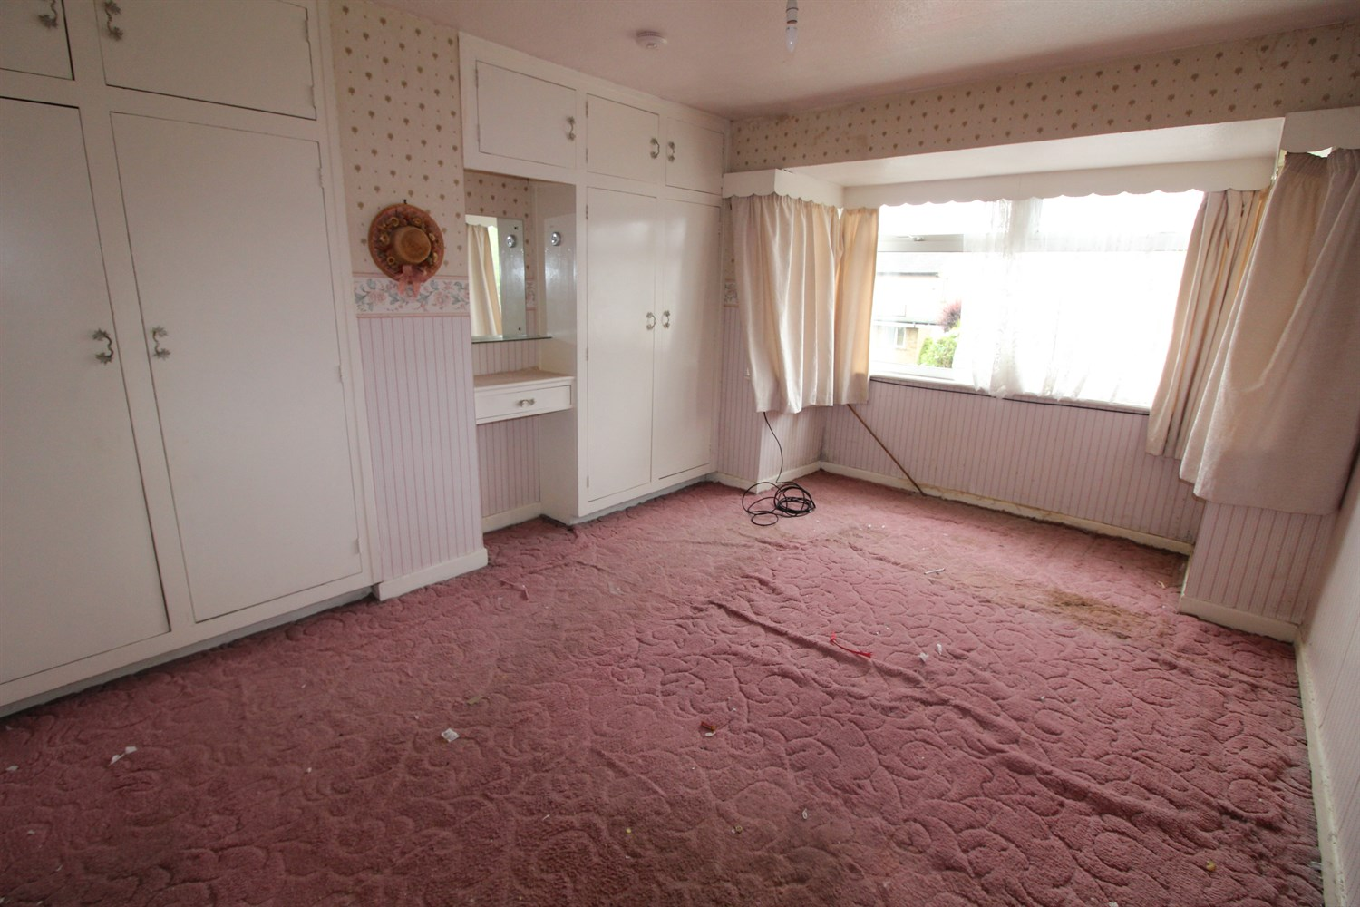

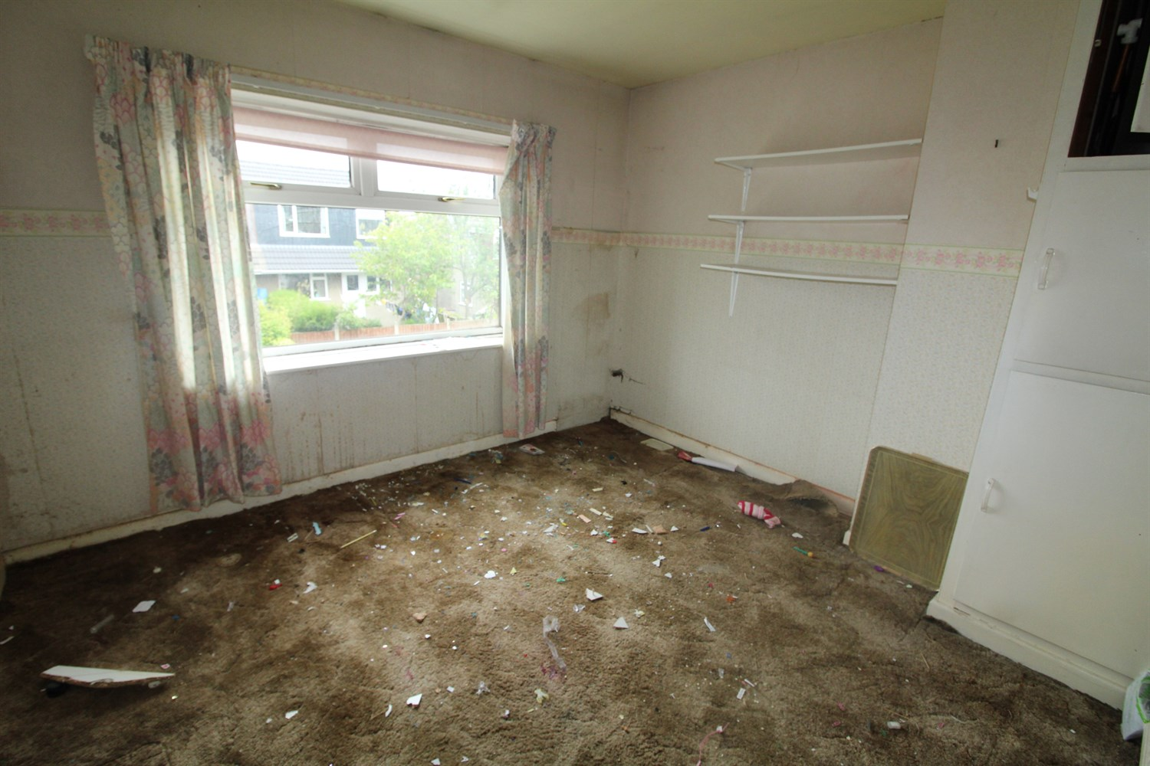

|  |
| --- |
| **Entrance Hall**  Via front entrance door. Stairs to first floor. |
| **Lounge 3.65m (12') x 4.21m (13'10)**  Light and Airy living area with double glazed window to front. Gas central heating radiator. |
| **Dining Room 3.1m (10'2) x 2.57m (8'5)**  Second reception room with double glazed window to rear. |
| **Kitchen**  Fitted with a range of wall, base and drawer units with worktops over. Stainless steel sink with mixer tap and drainer. Tiled walls. Double glazed window to rear and door to side. |
| **Bedroom 1 3.26m (10'8) x 3.76m (12'4)**  Double bedroom with Double glazed window to front. Built in wardrobes. |
| **Bedroom 2 3.26m (10'8) x 3.04m (10')**  Second double bedroom with double glazed window to rear. |
| **Bedroom 3 2.23m (7'4) x 2.83m (9'3)**  Third bedroom with double glazed window to front. |
| **Bathroom**  Fitted with a three piece suite comprising; walk in shower cubicle, wash hand basin and WC. |
| **Outside**  To the front of the property is a lawned garden and a driveway leading to a detached garage. To the property is an enclosed garden. |

|  |  |
| --- | --- |
| These particulars are intended to give a fair description of the property, but their accuracy cannot be guaranteed, and they do not constitute an offer of contract. Intending purchasers must rely on their own inspection of the property. None of the above appliances/services have been tested by ourselves. We recommend purchasers arrange for a qualified person to check all appliances/services before legal commitment.  **Property Ref:** 3235  **For more information, please contact**  0113 258 1150 **|** [sales@adairpaxton.co.uk](mailto:sales@adairpaxton.co.uk) **|** www.adairpaxton.co.uk |  |