

**Station Road, Scholes**

**For Sale £325,000.00**

**Bungalow**

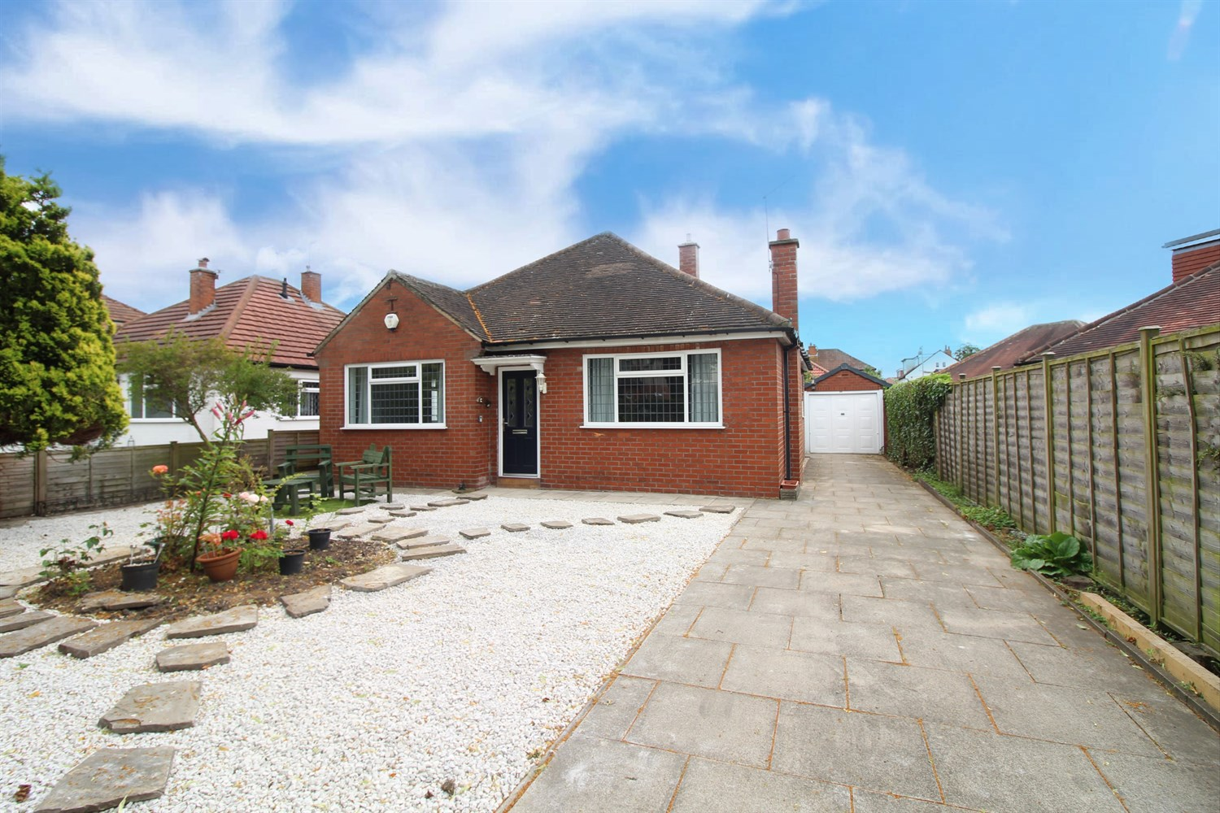

1 Bathroom(s)

1 Reception(s)

2 Bedroom(s)

***WELL PRESENTED DETACHED TWO BEDROOM BUNGALOW - NO ONWARD CHAIN*** This delightful LARGER STYLE bungalow simply MUST BE VIEWED to be appreciated. Extremely well kept & presented throughout, the accommodation briefly comprises: entrance hall, spacious lounge opening to a dining area, kitchen, utility, two double bedrooms and a house shower room. Externally, to the front of the property there is low maintenance gravelled garden with trees and plants, and a driveway which provides off-street parking and leads to a detached garage. To the rear there is an equally fantastic garden with fruit trees, plants and shrubs. The property is ready to move into and further benefits include gas central heating and UPVC double glazing throughout. Situated in this much sought after village of Scholes, this property is convenient for the A64 and a number of other major road links to the A1/M1. There is also good access to York, central Leeds, Wetherby and Harrogate. There are a number of local amenities close by.



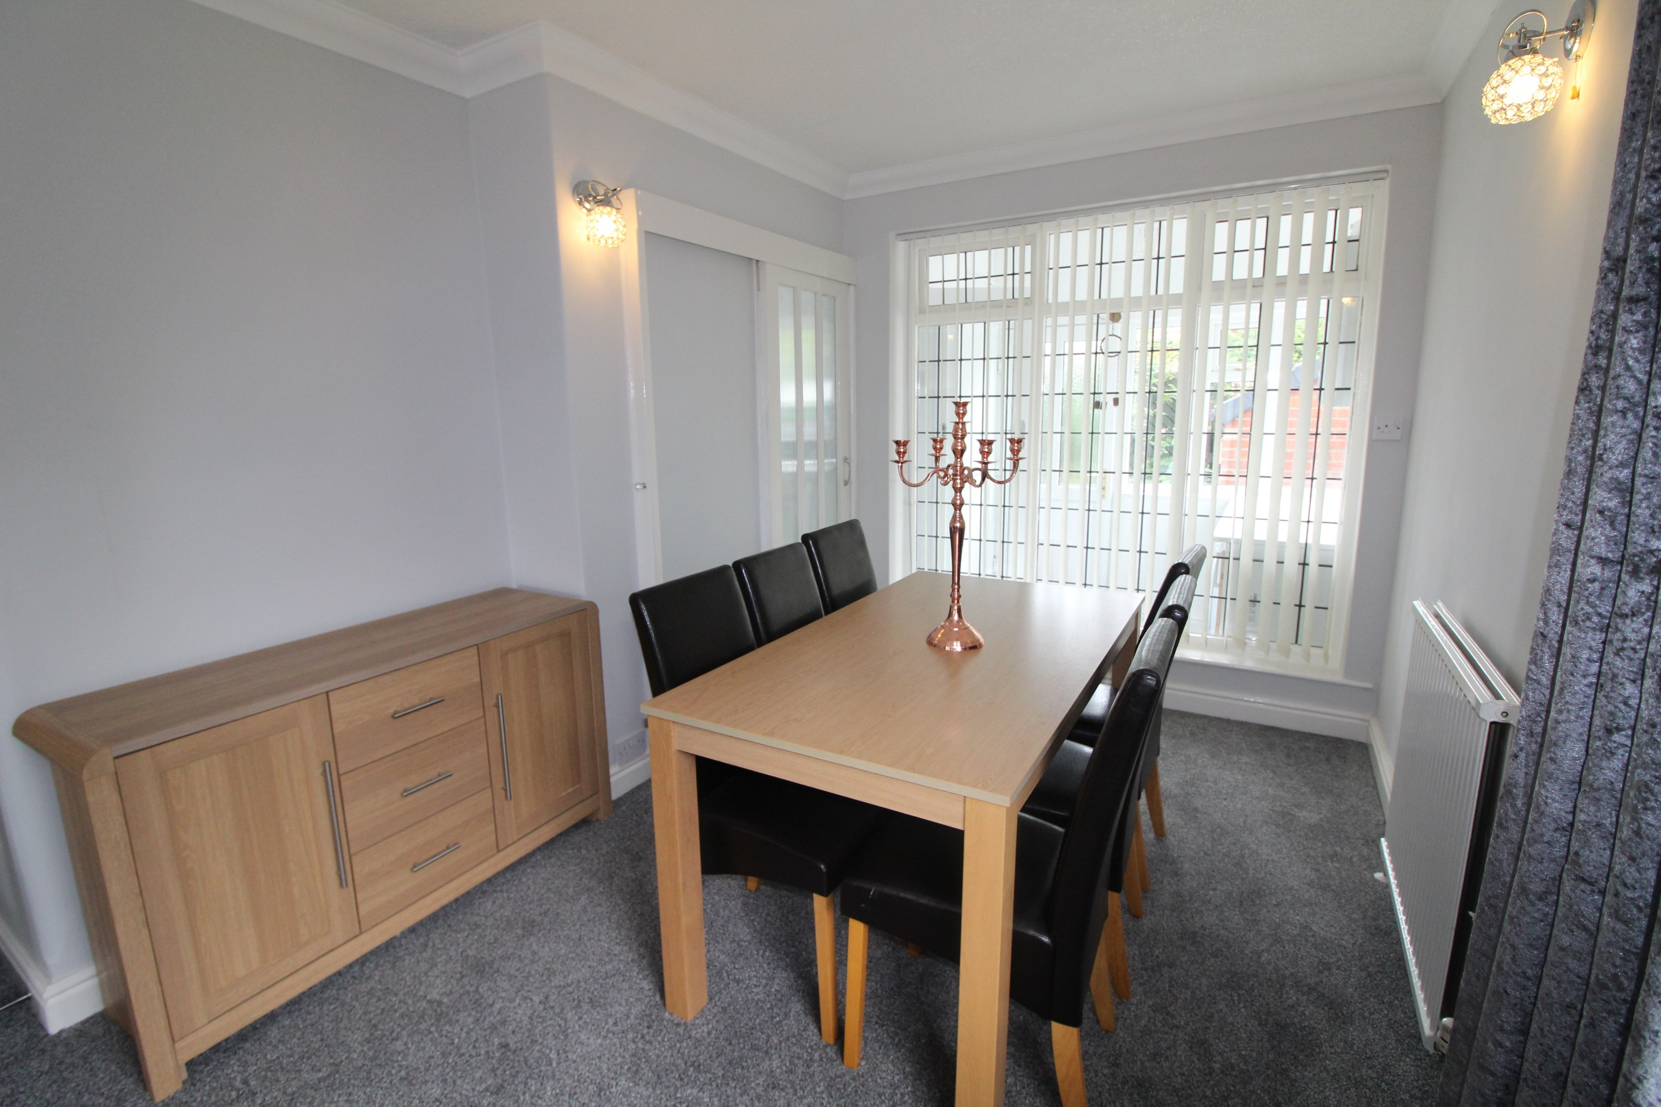

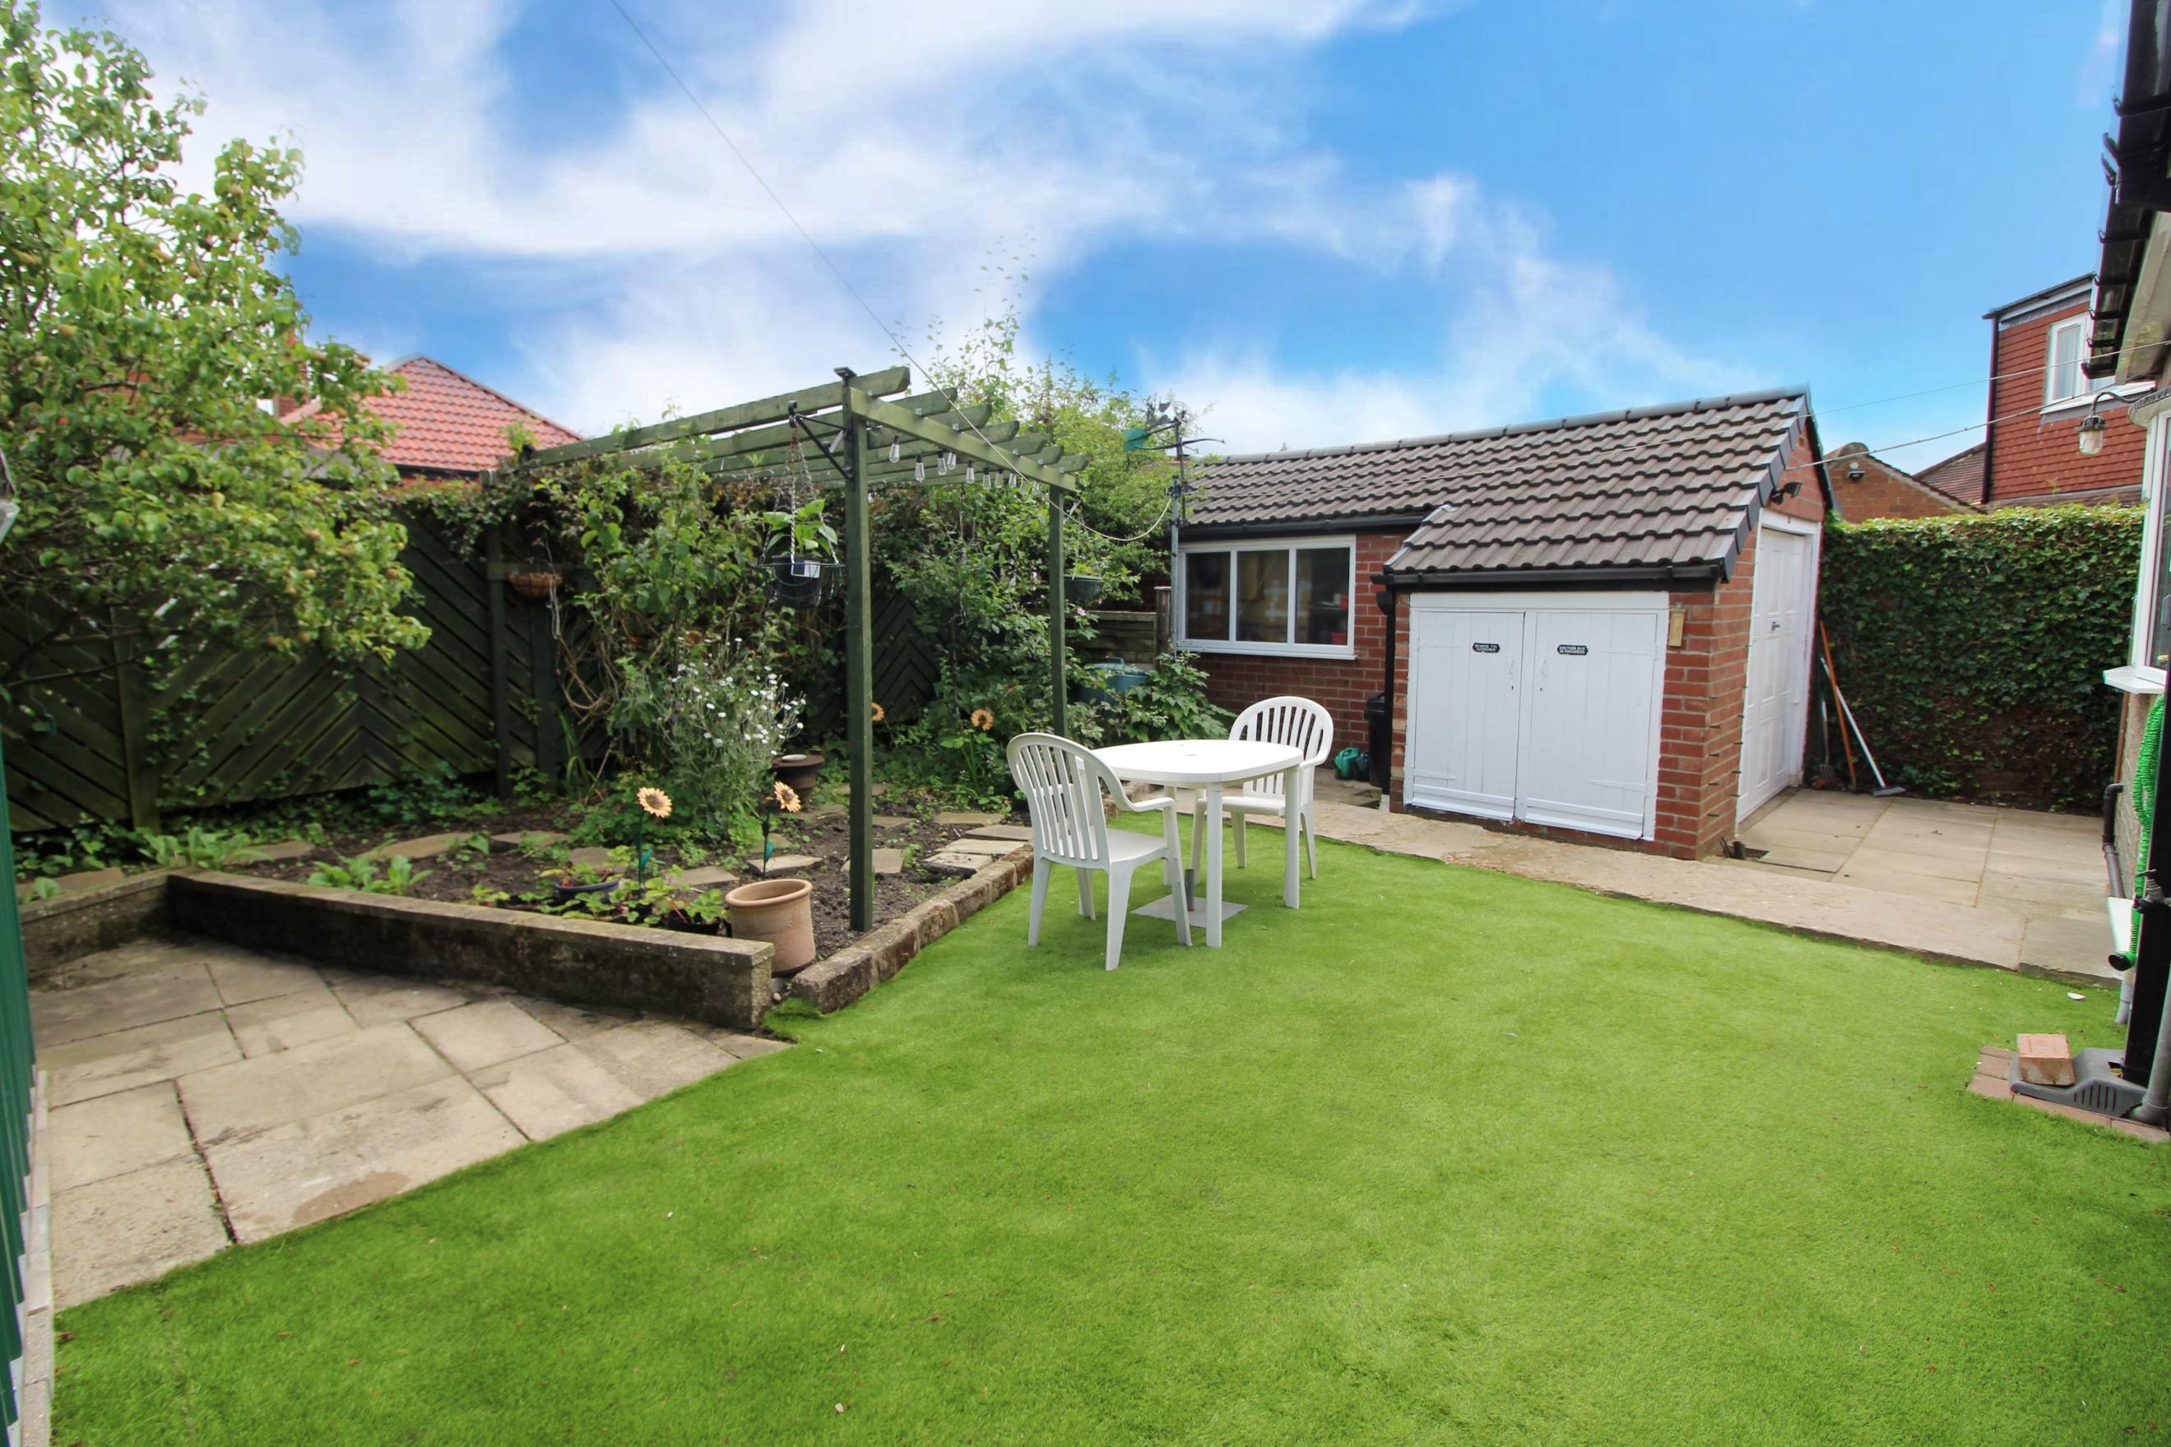

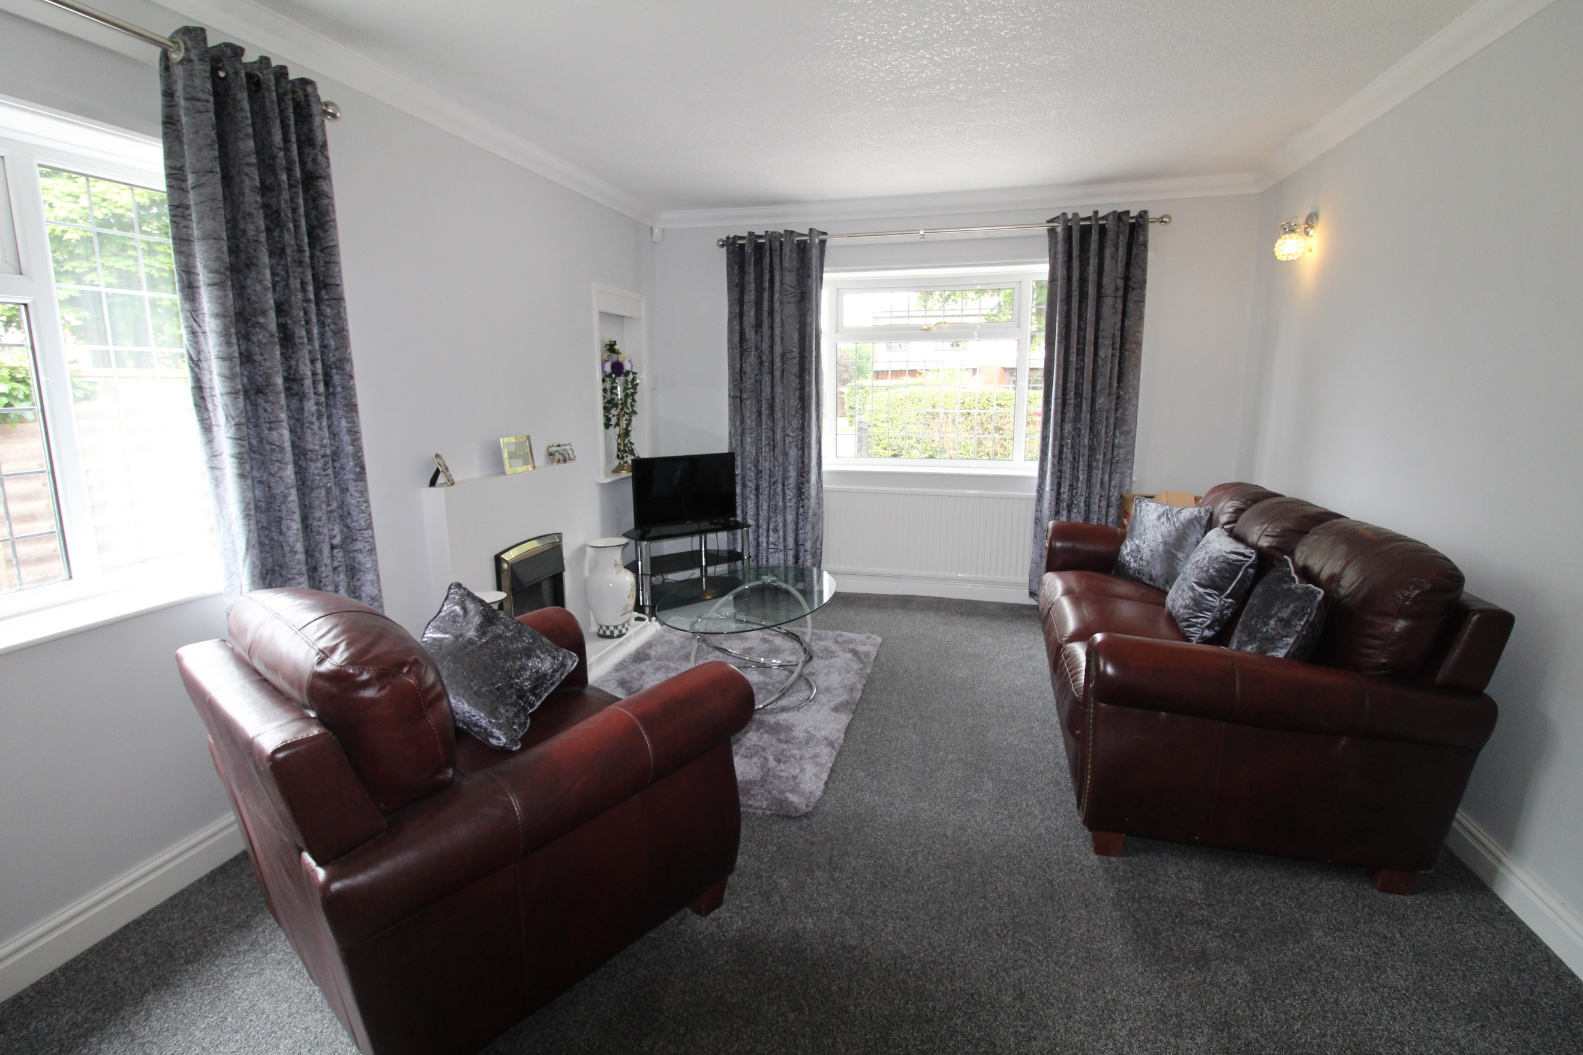

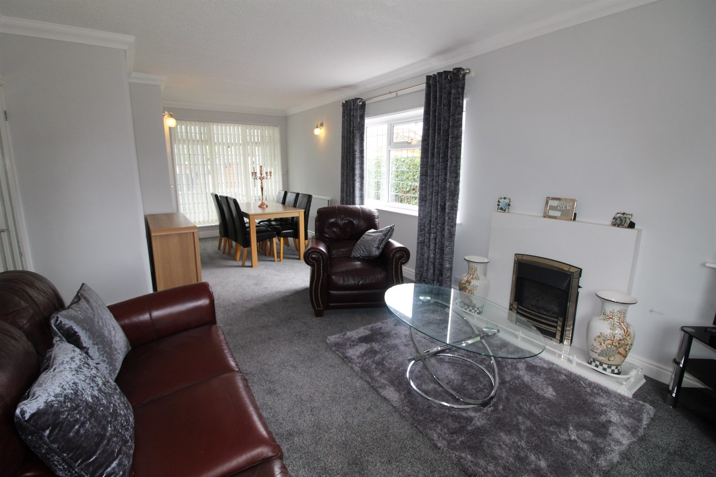

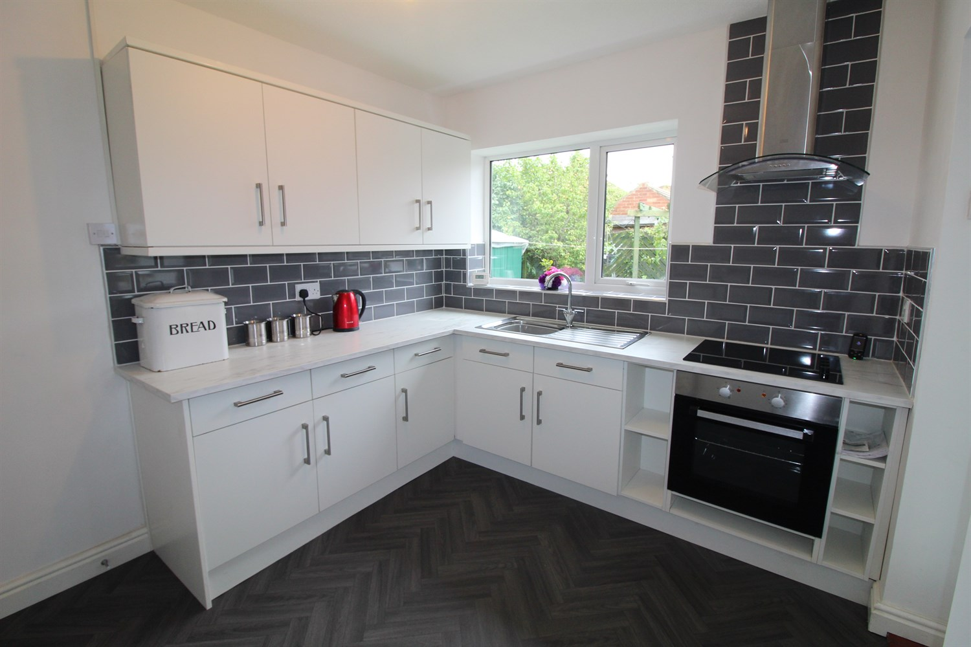

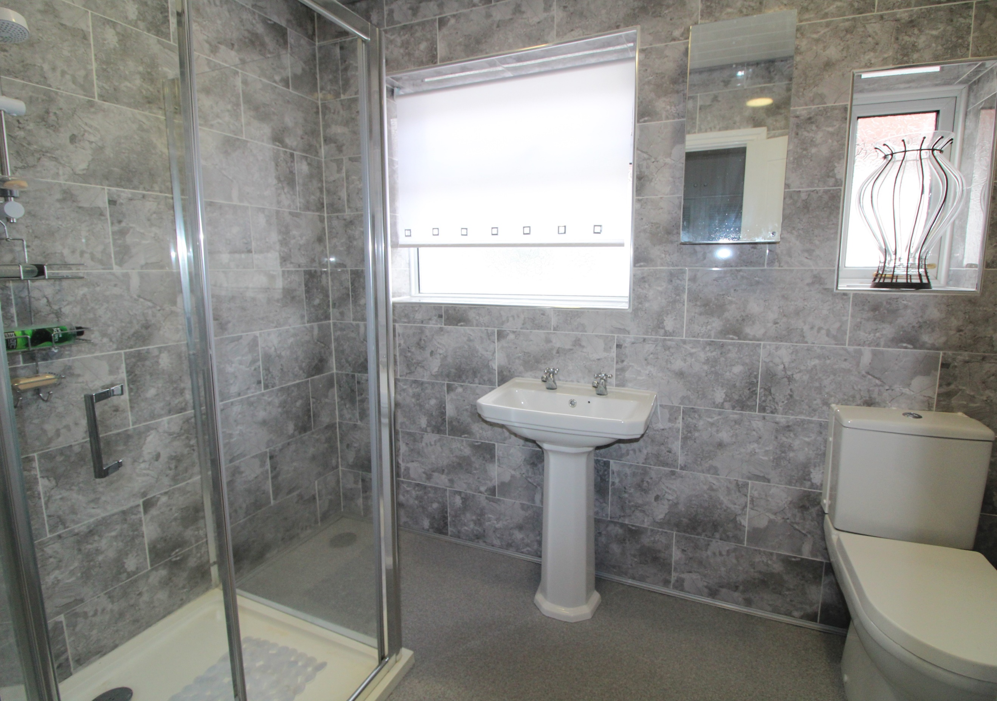

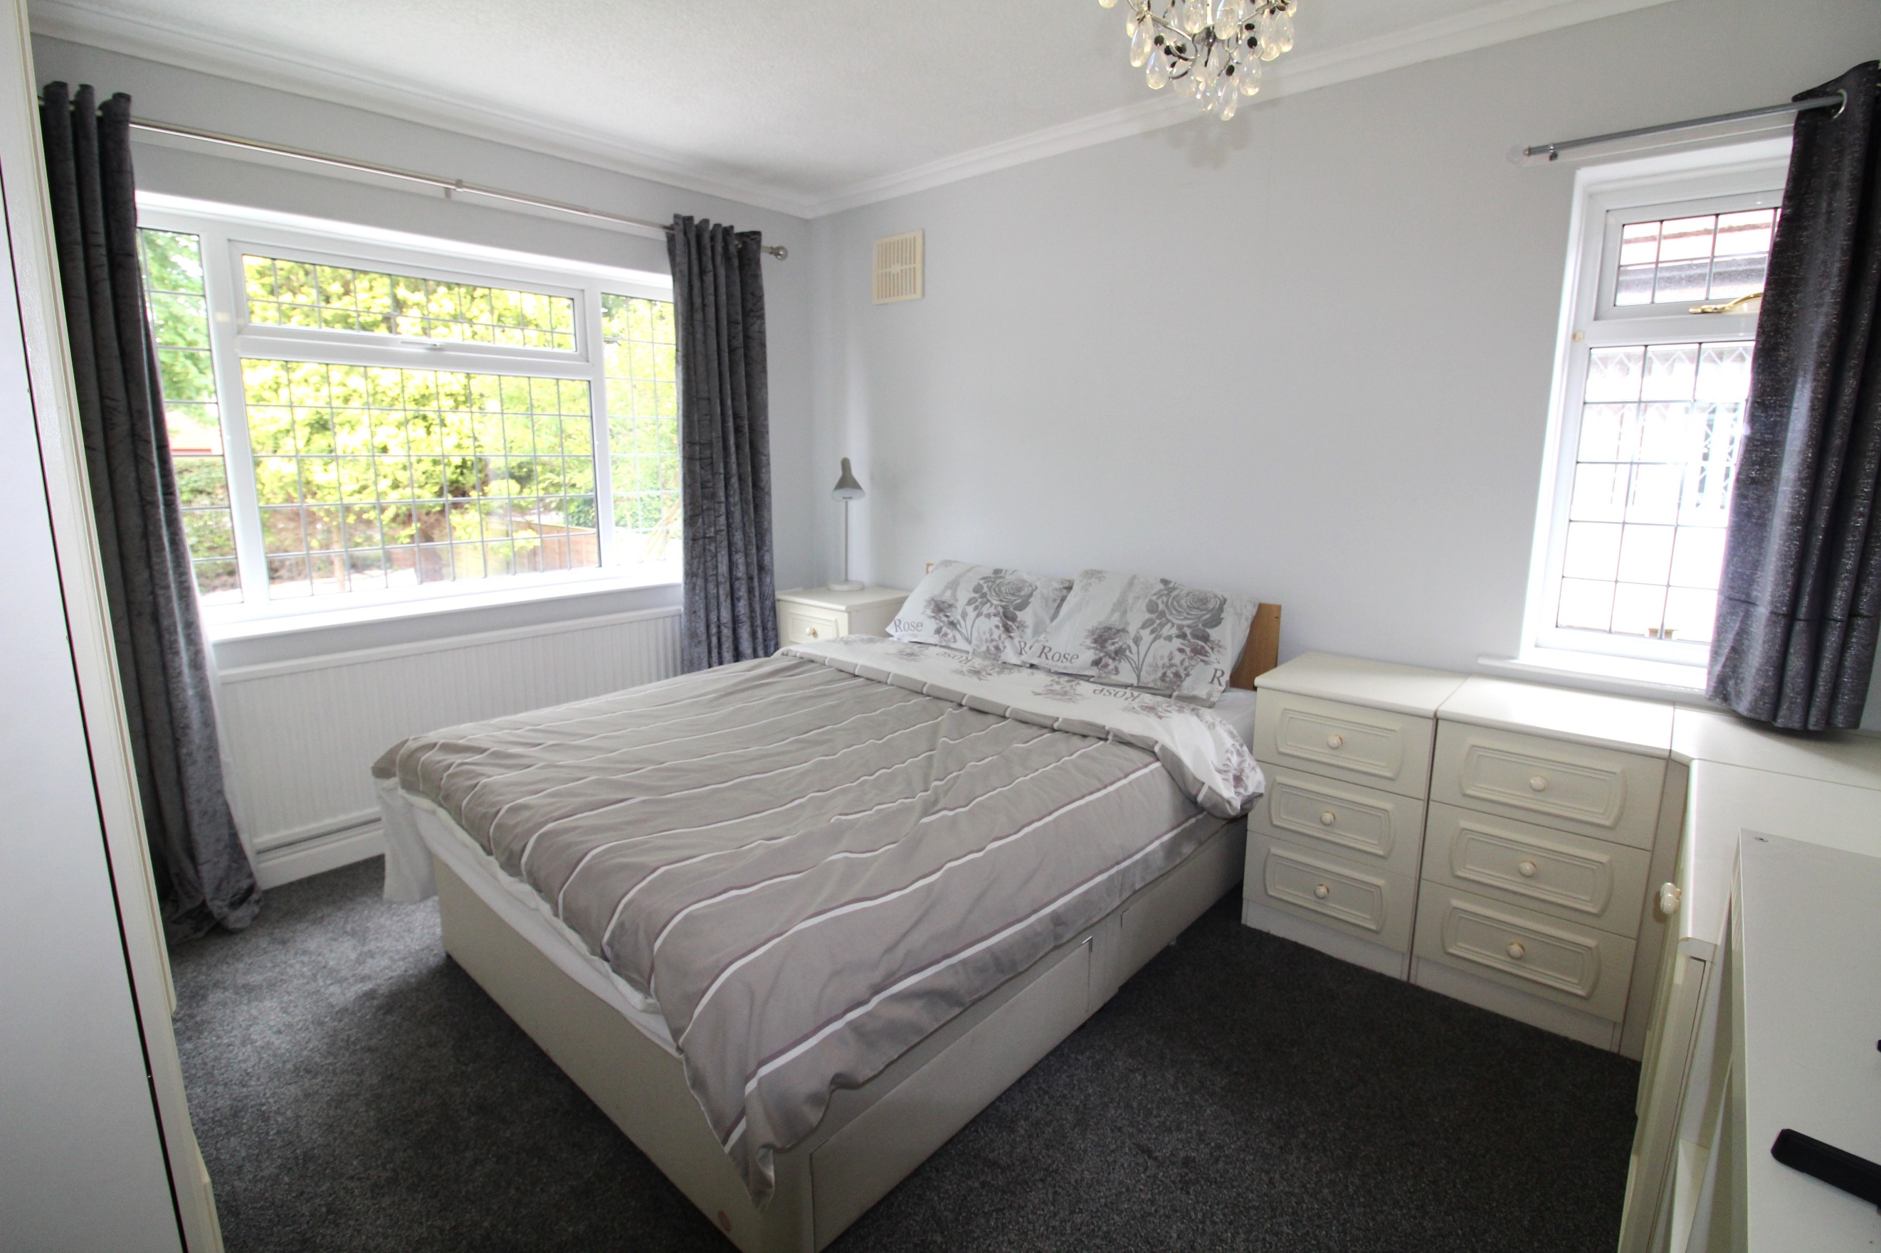

|  |
| --- |
| **Porch**  Entrance Porch via front entrance door. |
| **Entrance Hallway**  Via double doors. Gas central heating radiator. Storage cupboard. |
| **Lounge**  Spacious, light and airy living area with uPVC double glazed window to front and side. Gas central heating radiator. Gas fire with modern surround. Opening to the dining area with uPVC double glazed window to side. Gas central heating radiator. |
| **Kitchen**  Fitted with a range of wall, base and drawer units with worktops over. Stainless steel sink with mixer tap and drainer. Integrated electric oven with 4-ring hob and extractor hood over. Space for fridge and freezer. Part tiled walls. uPVC double glazed window to rear. |
| **Utility**  Fitted with matching units to the kitchen. Plumbing for washing machine. uPVC double glazed door leading to rear garden. |
| **Bedroom 1**  Double bedroom with uPVC double glazed window to front and uPVC double glazed window to side. Built in wardrobes and drawers. Gas central heating radiator. |
| **Bedroom 2**  Second double bedroom with uPVC double glazed window to rear. Gas central heating radiator. |
| **Bathroom**  Modern shower room fitted with a three piece suite comprising; shower cubicle, WC and wash hand basin. Wall mounted heated towel rail. Two double glazed windows to rear. Tiled walls. |
| **Outside**  To the front of the property is a low maintenance gravelled garden with a driveway offering off street parking and leading to a detached garage with up and over door. The rear garden offers a good deal of privacy has been designed for ease maintenance with fruit trees, plants and shrubs. |

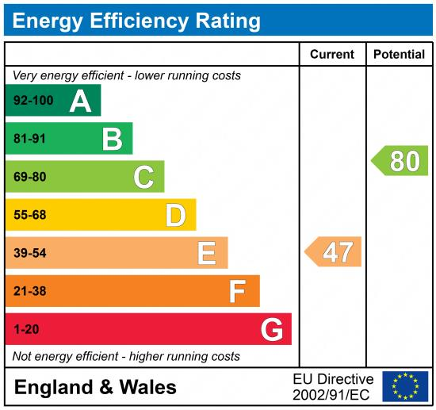

|  |
| --- |
|  |

These particulars are intended to give a fair description of the property, but their accuracy cannot be guaranteed, and they do not constitute an offer of contract. Intending purchasers must rely on their own inspection of the property. None of the above appliances/services have been tested by ourselves. We recommend purchasers arrange for a qualified person to check all appliances/services before legal commitment.

**Property Ref:** 3166

**For more information, please contact**

0113 258 1150 **|** [sales@adairpaxton.co.uk](mailto:sales@adairpaxton.co.uk) **|** www.adairpaxton.co.uk