

**0113 258 1150**

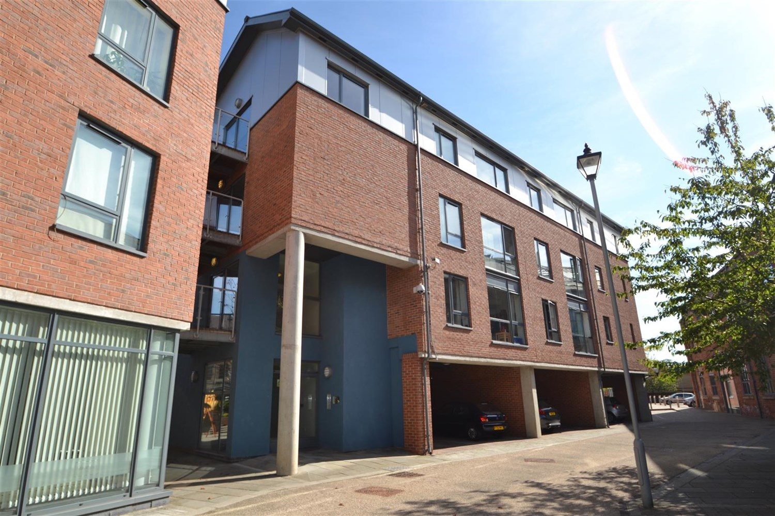



**For Sale £135,000.00**

**39 Butcher Street, Leeds, LS11 5WF**

***INVESTORS OPPORTUNITY***A popular development in a highly sought after part of Leeds City Centre, we have the pleasure of offering this first floor apartment with one bedroom accommodation in one of our favourite developments in the city! The flat benefits from a lovely MODERN finish, FLOOR TO CEILING WINDOWS give this property a wonderful LIGHT and airy feeling and a partially separated kitchen; so rare in City Centre properties!  
  
The immediate area surrounding Butcher Street is not short of entertainment. The Midnight Bell and Cross Keys pubs are on the doorstep, along with The Round Foundry Wine Bar, Out of the Woods and David Street Café.   
  
Butcher Street is located just around the corner from Bridgewater Place and Granary Wharf - making it very close to some of Leeds' best bars, restaurants and amenities. The brand new south entrance to Leeds Train Station is only a five minute walk away, and the centre of the City is also easily accessible on foot. Tenanted at £775pcm until February 2026.

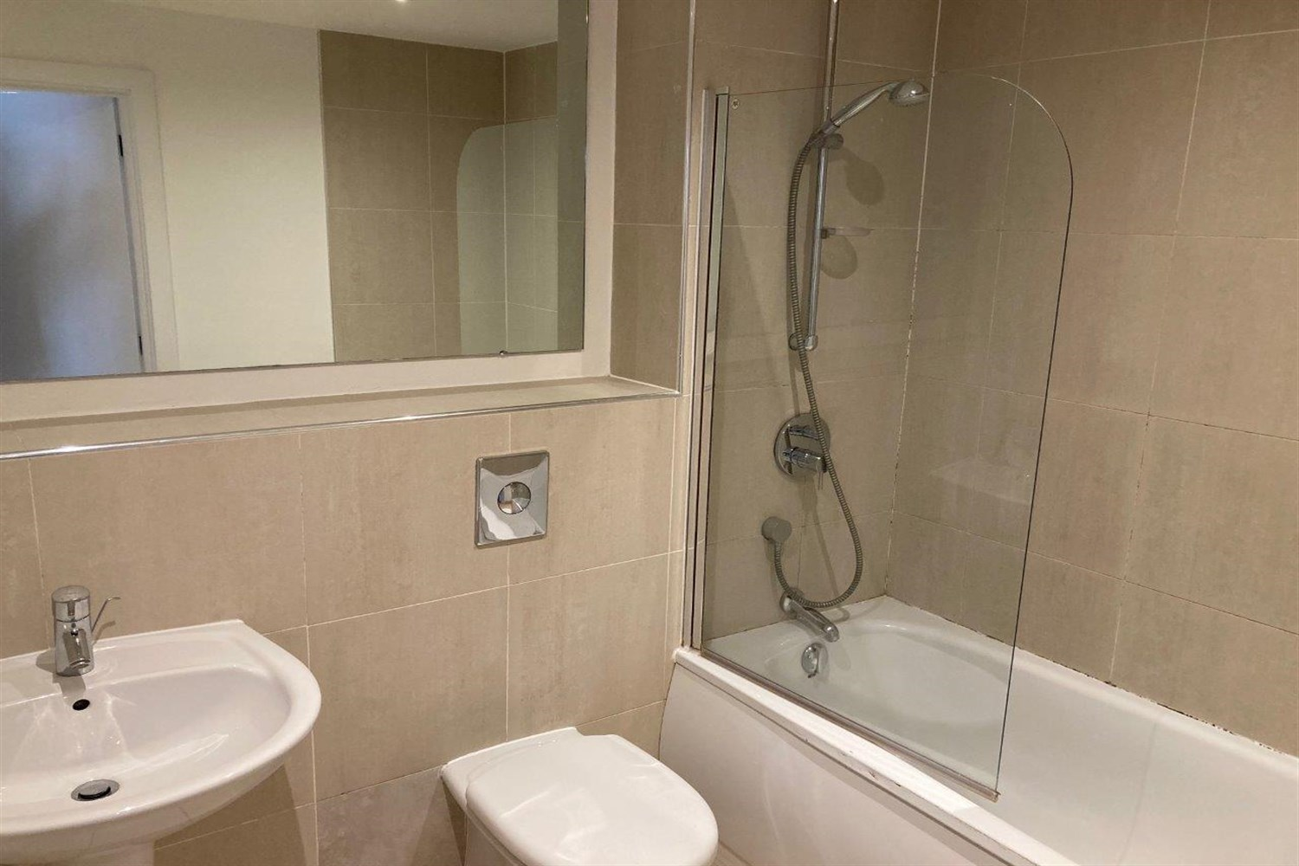

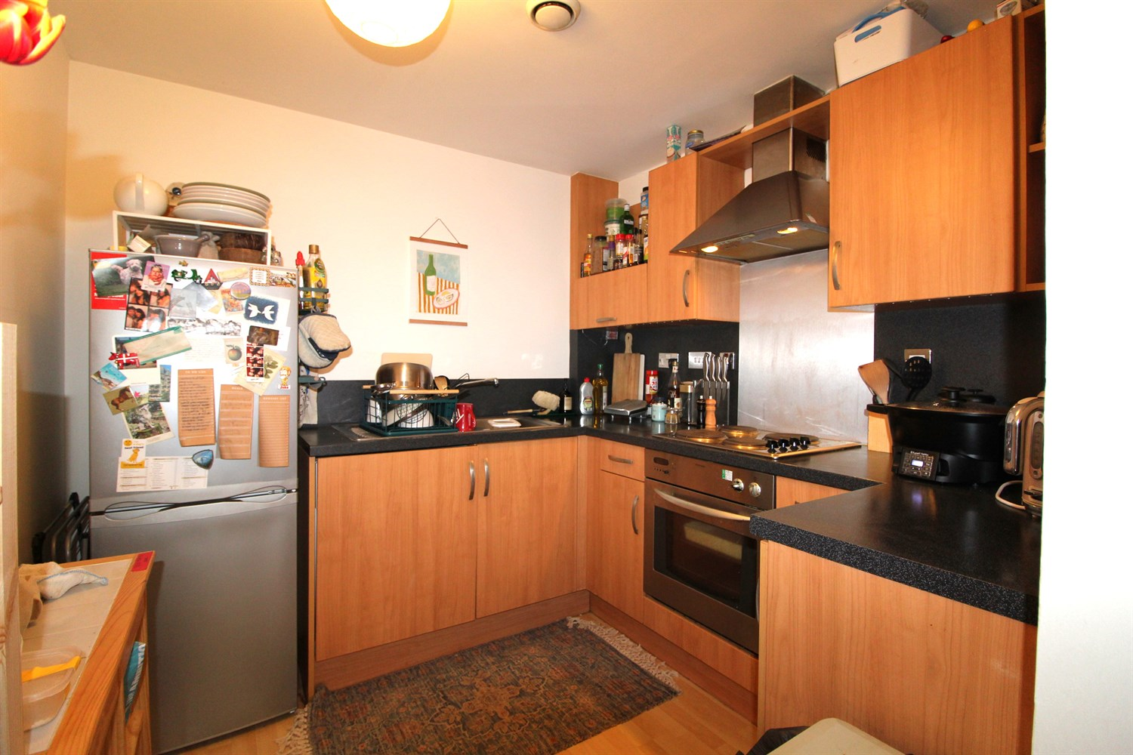

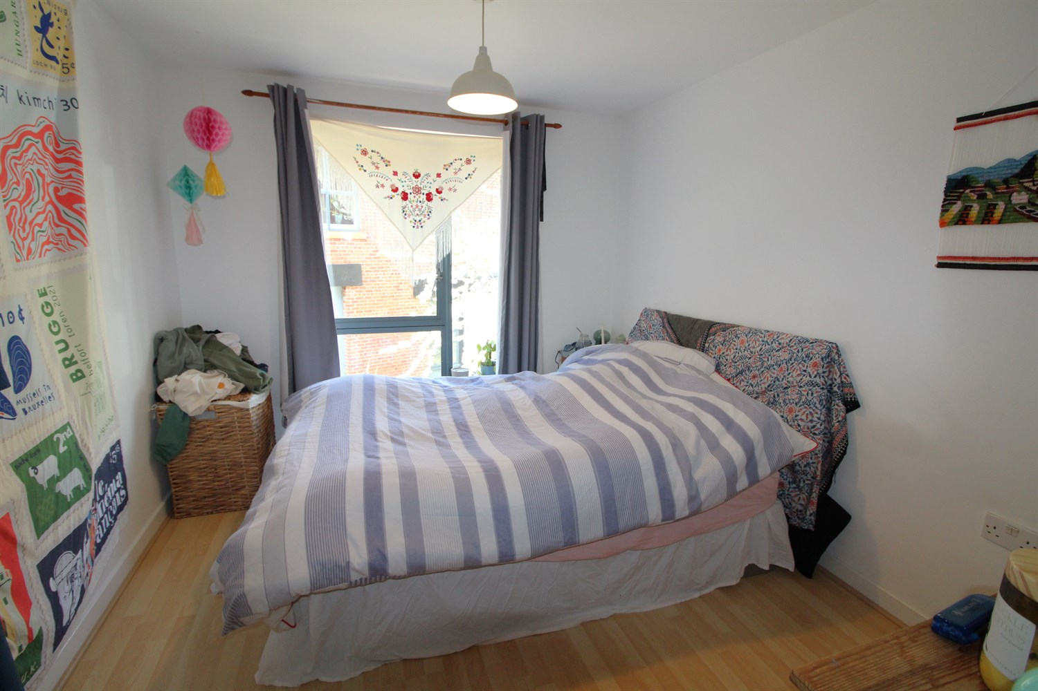

0 Bathroom(s)

1 Reception(s)

1 Bedroom(s)

00

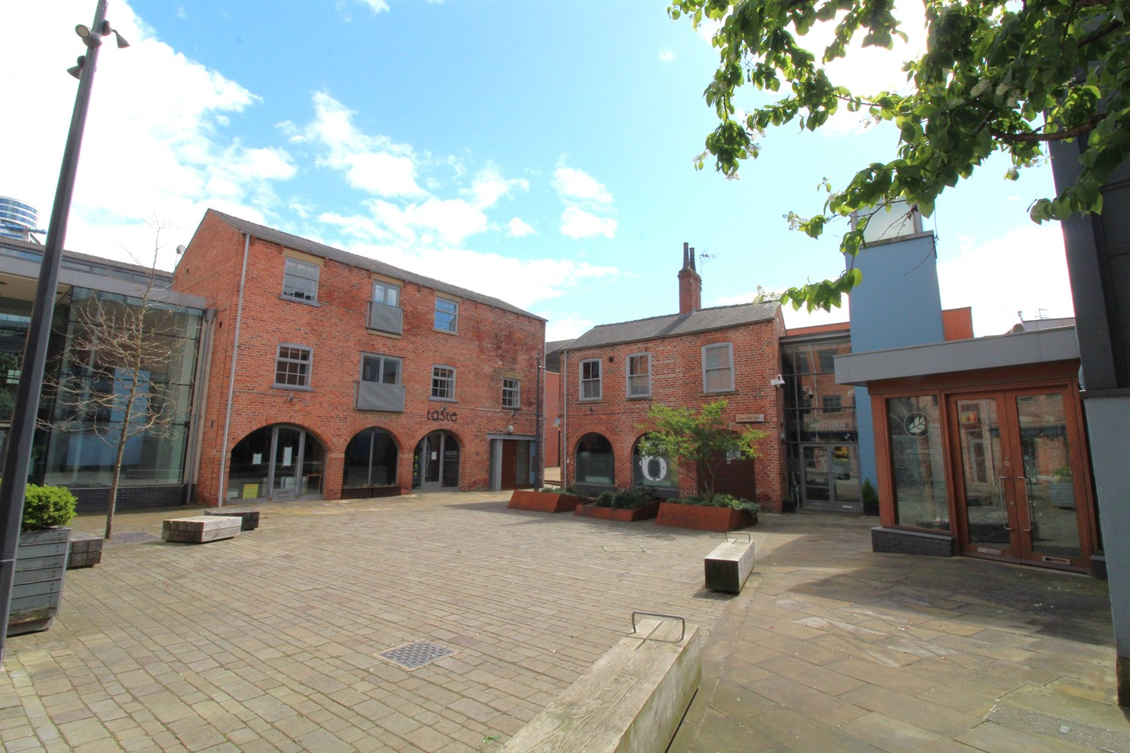

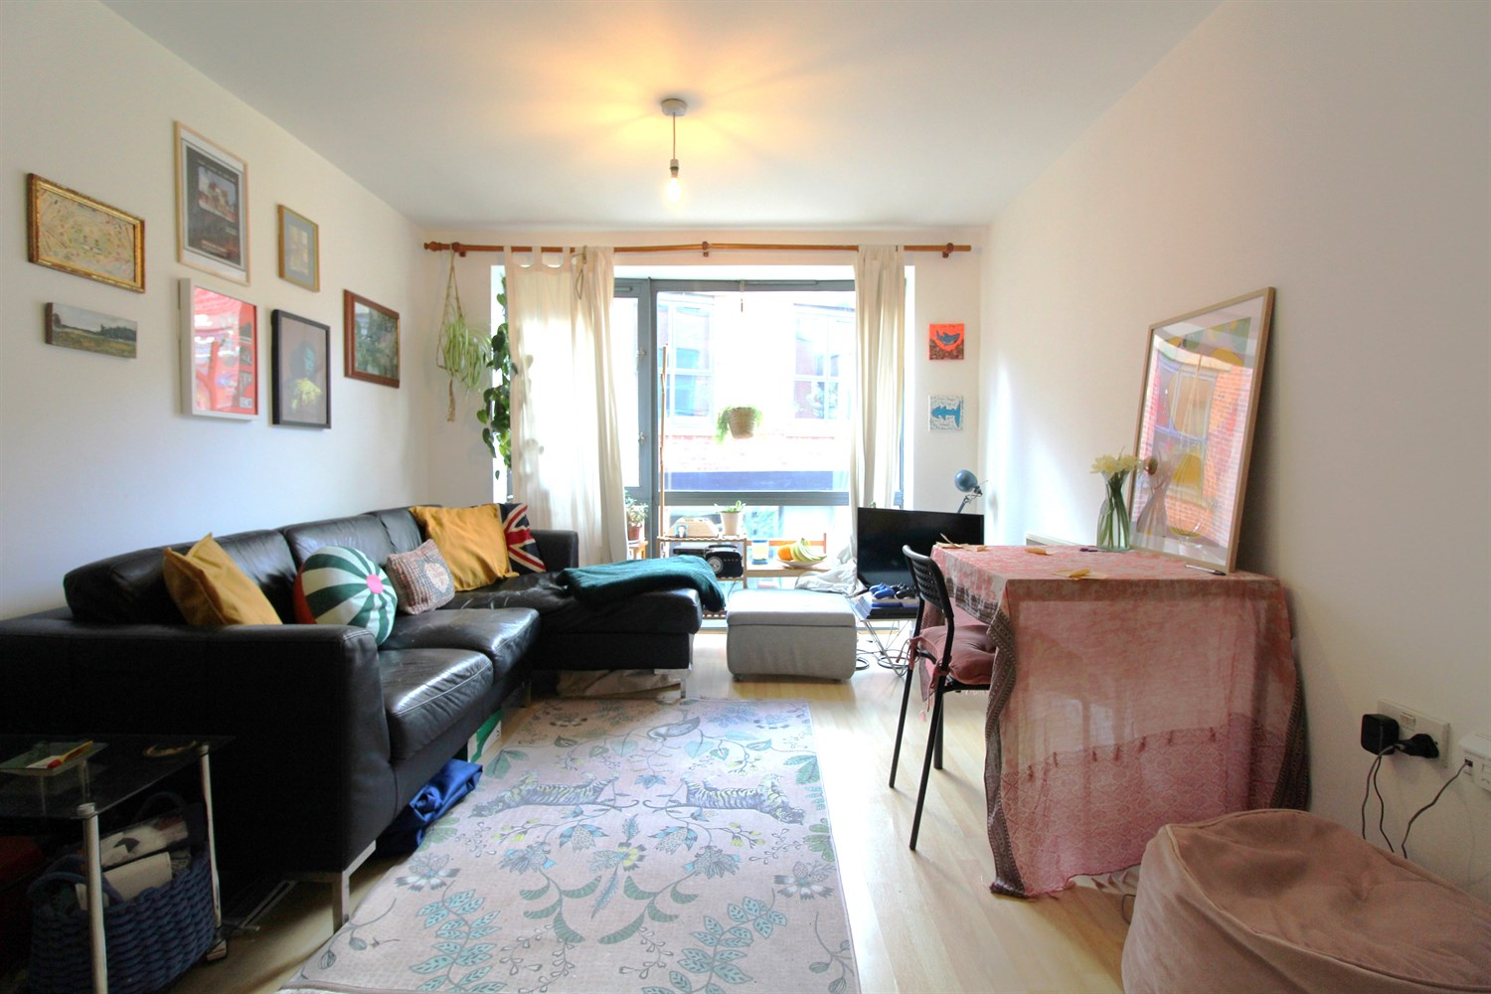

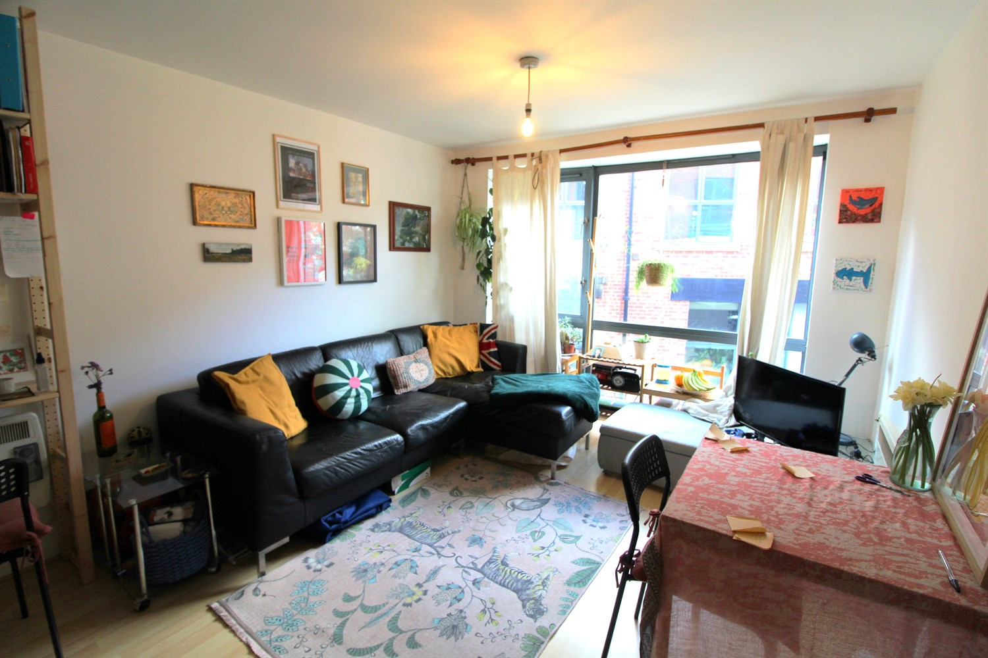

|  |
| --- |
| **Hallway**  Video entry phone. |
| **Lounge**  Light and airy living area. Wall mounted electric heater. |
| **Kitchen**  Fitted with a range of wall, base and drawers units with work tops over. Integrated oven with 4-ring hob and extractor above. |
| **Bedroom**  Double bedroom with window. Wall mounted electric radiator. |
| **Tenure**  Leasehold - 199 years from 2001. Ground rent is £200 |
| **Service Charge**  Service charge is £2460 per annum |

|  |  |
| --- | --- |
| These particulars are intended to give a fair description of the property, but their accuracy cannot be guaranteed, and they do not constitute an offer of contract. Intending purchasers must rely on their own inspection of the property. None of the above appliances/services have been tested by ourselves. We recommend purchasers arrange for a qualified person to check all appliances/services before legal commitment.  **Property Ref:** 197  **For more information, please contact**  0113 258 1150 **|** [sales@adairpaxton.co.uk](mailto:sales@adairpaxton.co.uk) **|** www.adairpaxton.co.uk |  |