

**0113 258 1150**

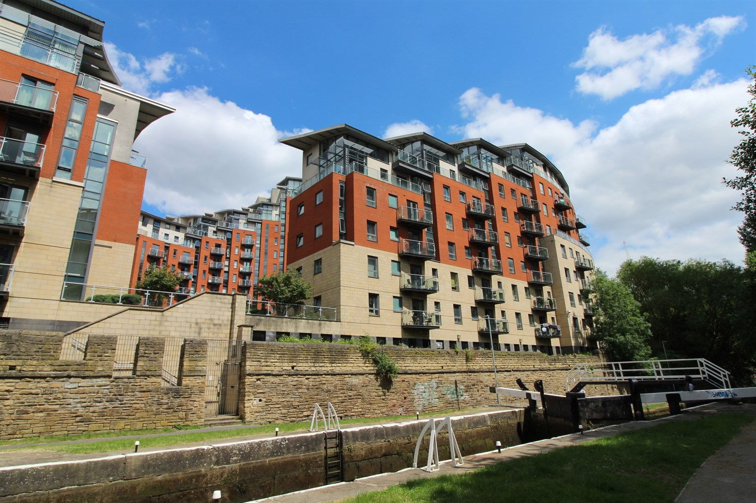



**For Sale £125,000.00**

**Flat 30 Catalina, City Island, Leeds, LS12 1DH**

**SPACIOUS ONE BEDROOM APARTMENT with NO ONWARD CHAIN** Situated on the fourth floor, this one bedroom apartment is offered to the market with no onward chain and briefly comprises; Communal entrance, hallway, open plan kitchen/lounge, a double bedroom and house bathroom. City Island is a superb waterfront location with onsite concierge, secure fob entry and lift access to all floors. The property is a short walk from Leeds train station and is ideally located for convenient transport links.

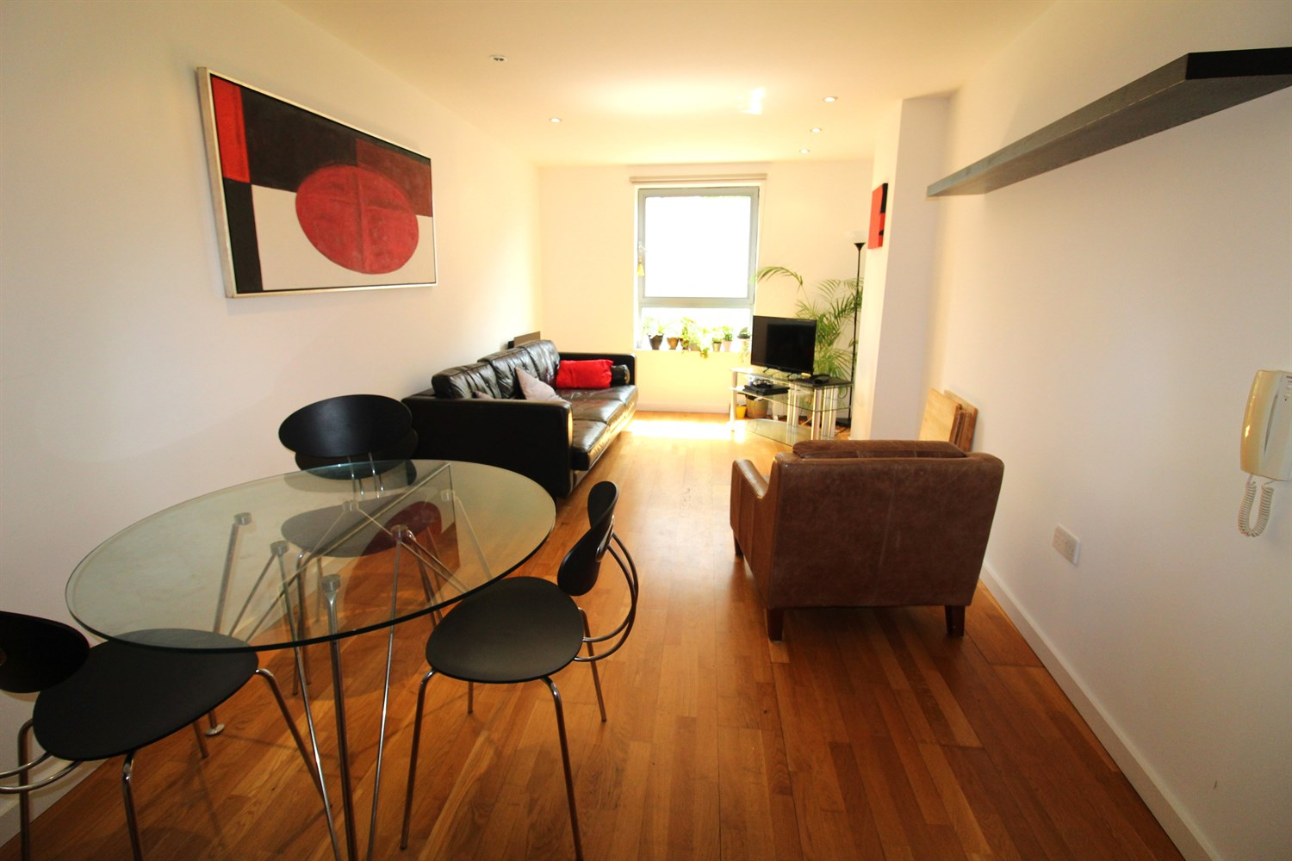

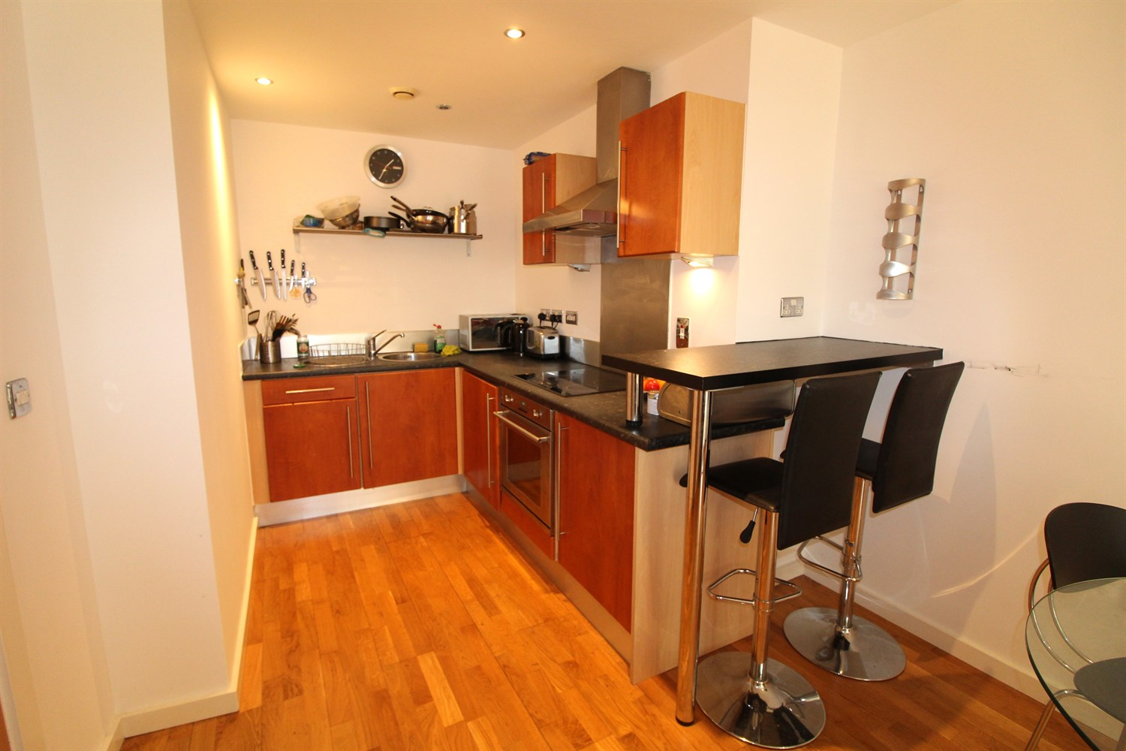

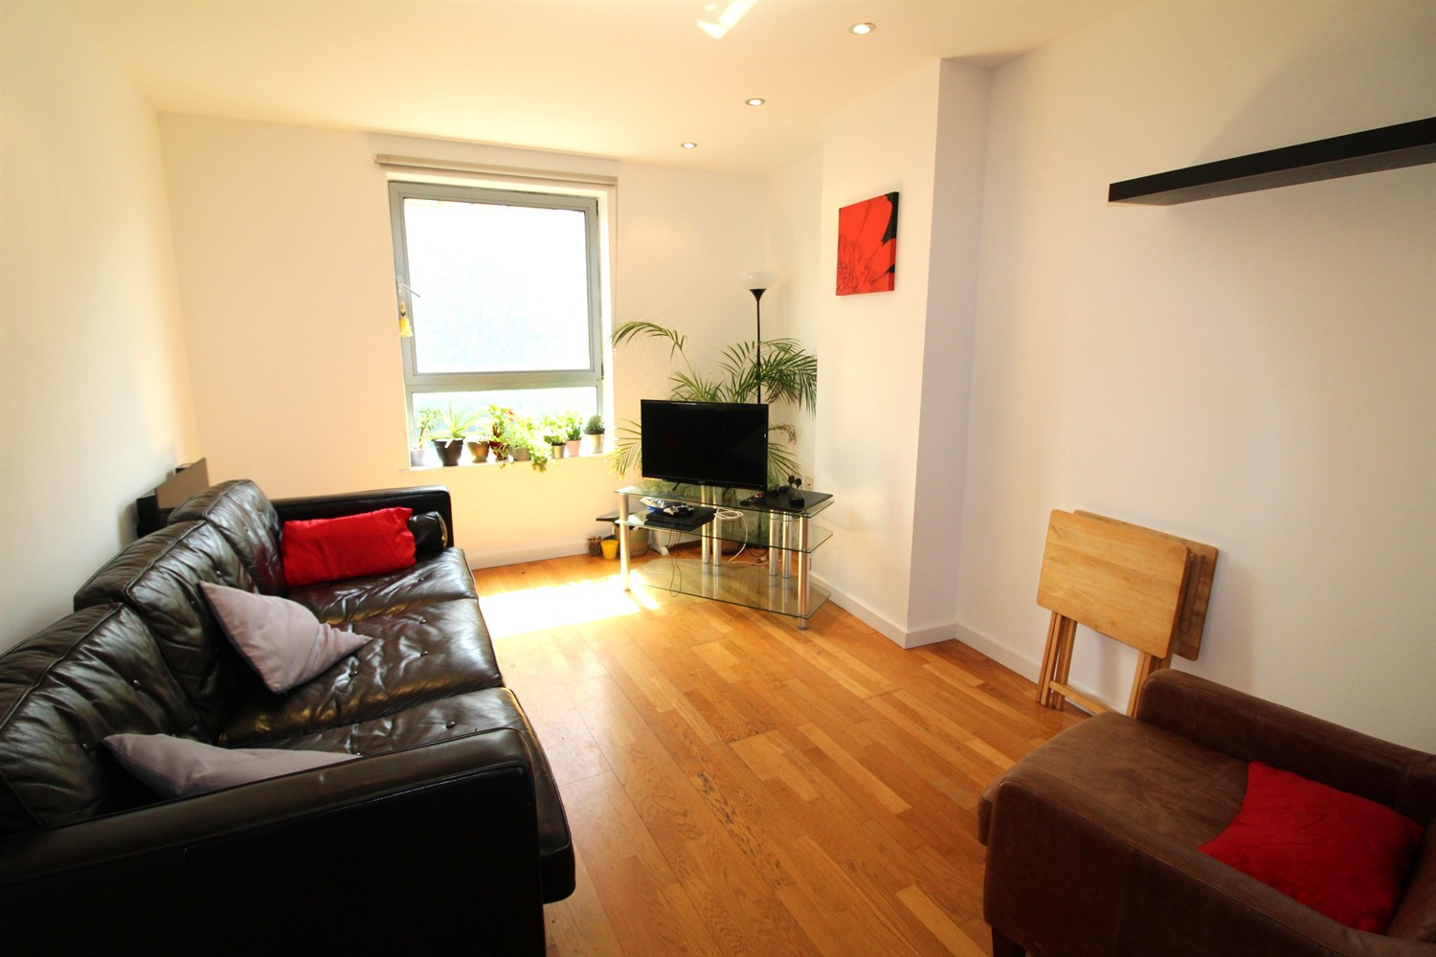

1 Bathroom(s)

1 Reception(s)

1 Bedroom(s)

00

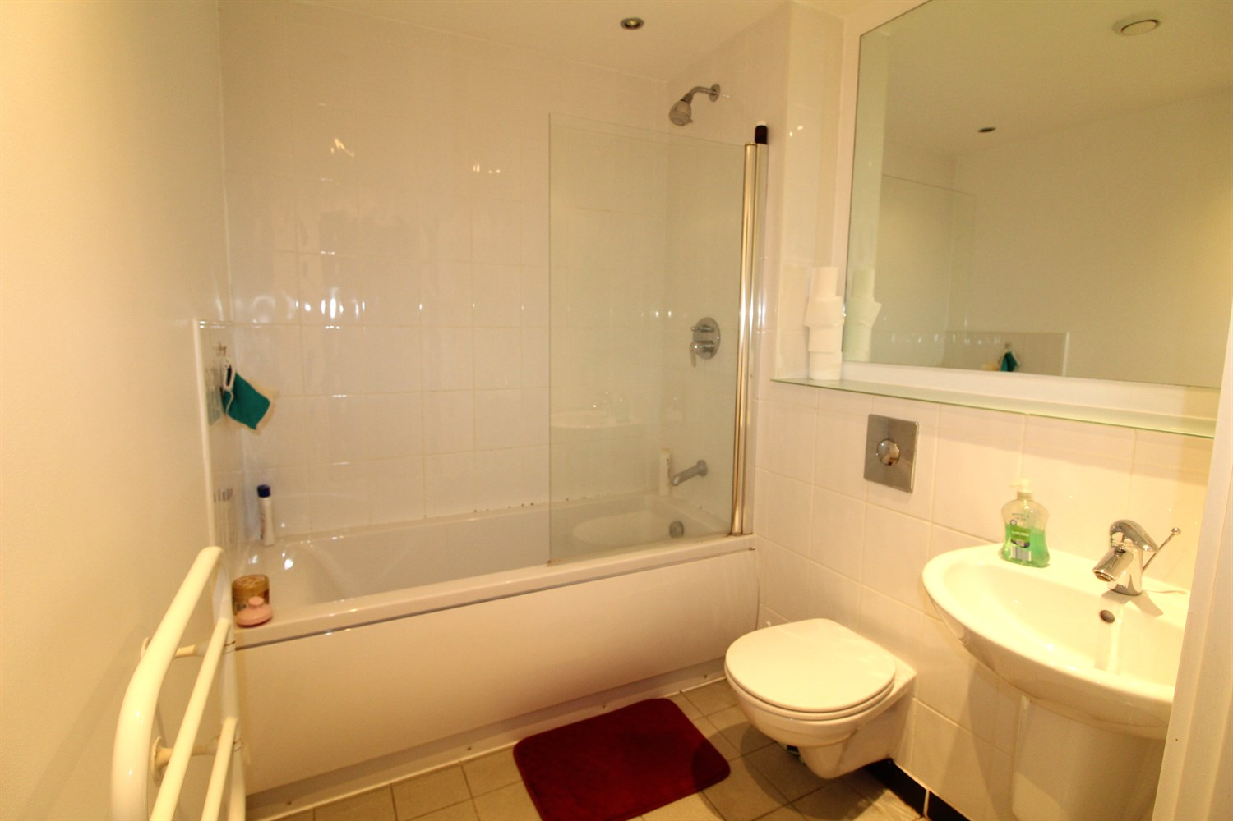

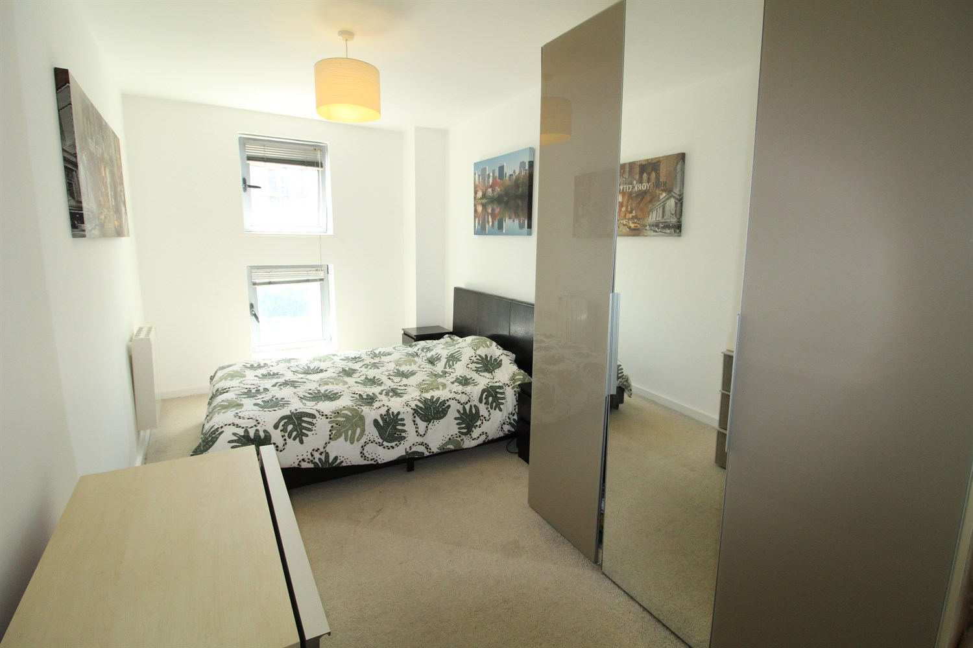

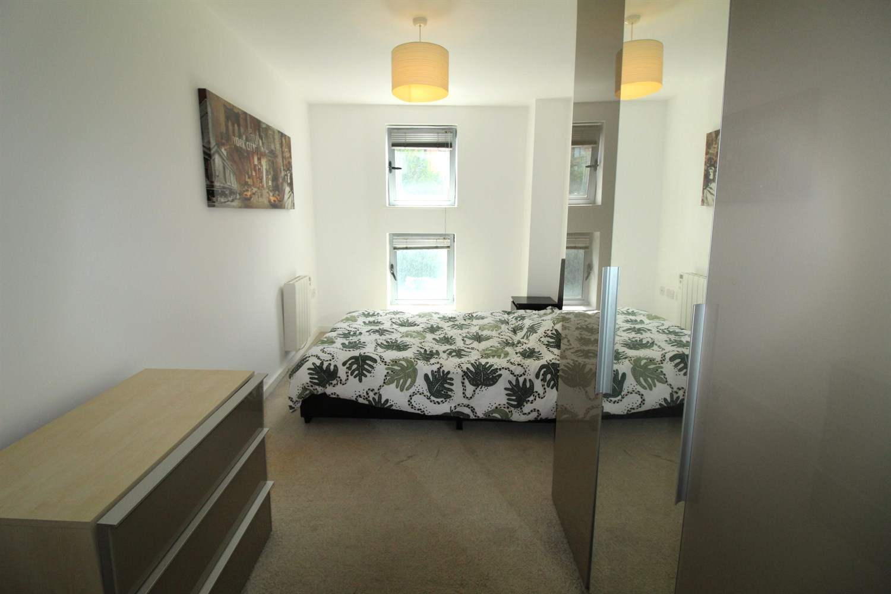

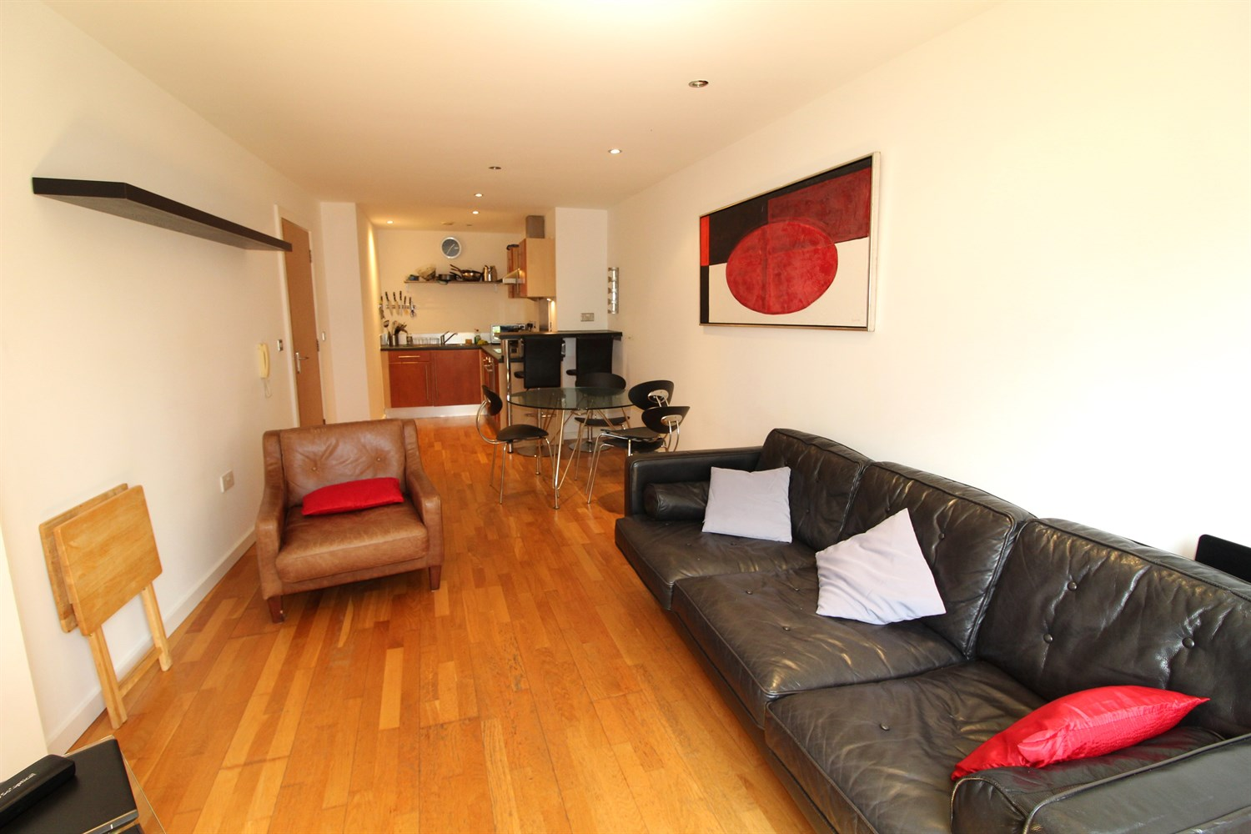

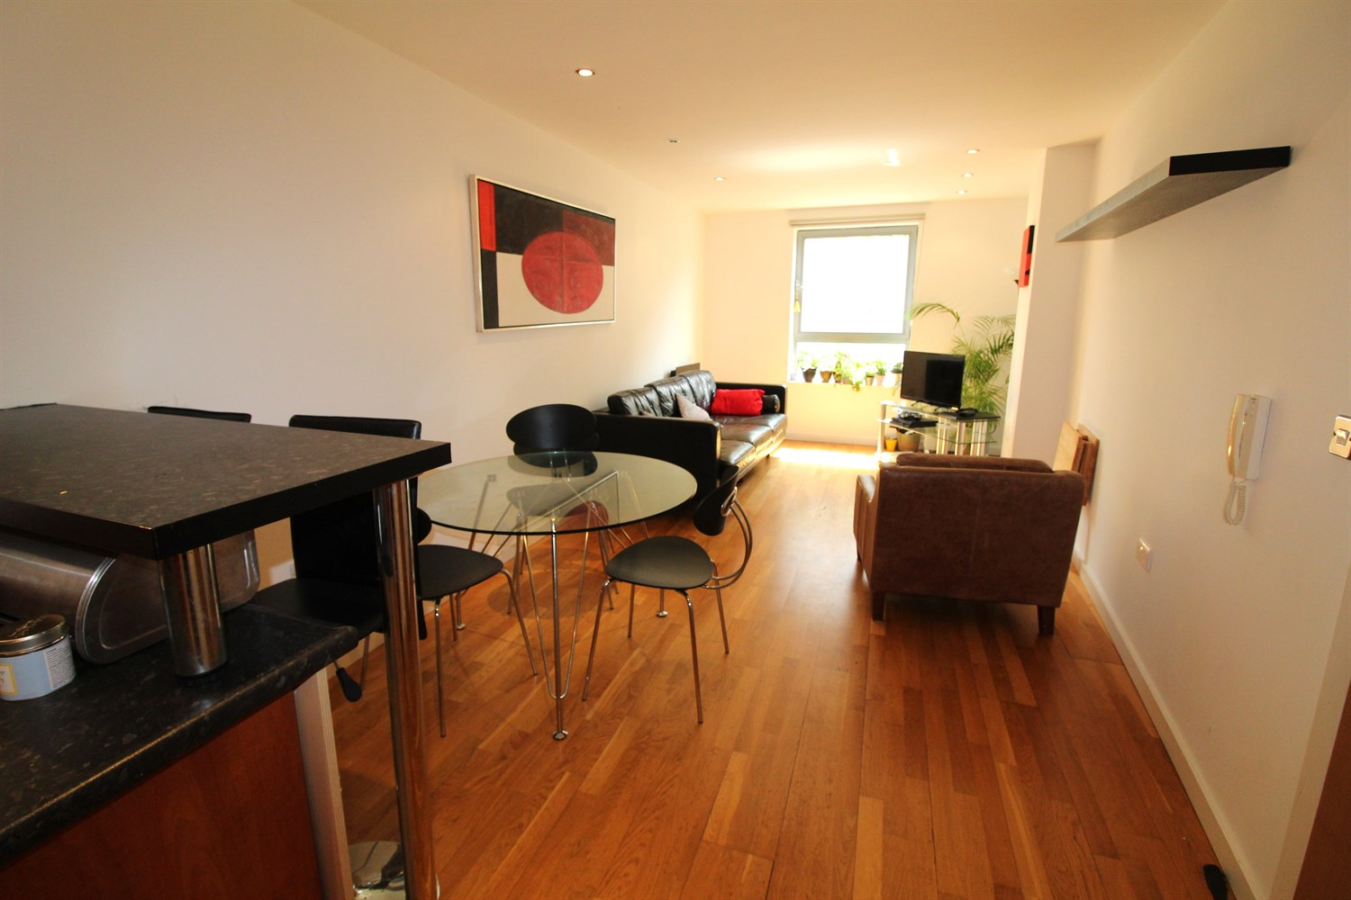

|  |
| --- |
| **Communal Entrance**  Secure entry phone system. Lift to all floors. |
| **Hallway**  Via front entrance door. |
| **Living Area**  Light and Airy living area with double glazed window. Wall mounted electric radiator. Inset ceiling spotlights. |
| **Kitchen**  Fitted with a range of wall, base and drawer units with worktops over and a breakfast bar. Integrated washing machine and dishwasher. Integrated electric oven with 4-ring hob and extractor hood over. |
| **Bedroom 1**  Double bedroom with double glazed window. Wall mounted electric radiator. |
| **Bathroom**  Fitted with a three piece white suite comprising; bath with shower over, WC and wash hand basin. Heated towel rail. Tiled walls and floor. |
| **Service Charge**  The service charge is £1649.16 per annum |
| **Tenure**  Leasehold - 999 years from 2003 Ground rent - £200 per annum |

|  |  |
| --- | --- |
| These particulars are intended to give a fair description of the property, but their accuracy cannot be guaranteed, and they do not constitute an offer of contract. Intending purchasers must rely on their own inspection of the property. None of the above appliances/services have been tested by ourselves. We recommend purchasers arrange for a qualified person to check all appliances/services before legal commitment.  **Property Ref:** 2790  **For more information, please contact**  0113 258 1150 **|** [sales@adairpaxton.co.uk](mailto:sales@adairpaxton.co.uk) **|** www.adairpaxton.co.uk |  |